2023-2028
Consolidated Plan

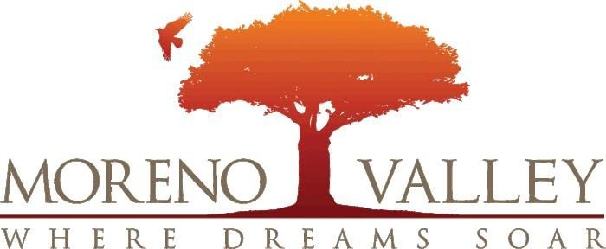
Financial and Management Services
14177 Frederick St.
Moreno Valley, CA 92552

Presented to City Council on May 16, 2023
TABLE OF CONTENTS

Executive Summary 4
ES-05 Executive Summary - 24 CFR 91.200(c), 91.220(b) 4
The Process 7
PR-05 Lead & Responsible Agencies 24 CFR 91.200(b) 7
PR-10 Consultation – 91.100, 91.110, 91.200(b), 91.300(b), 91.215(I) and 91.315(I) 8
PR-15 Citizen Participation – 91.105, 91.115, 91.200(c) and 91.300(c) 15
Needs Assessment 19
NA-05 Overview 19
NA-10 Housing Needs Assessment - 24 CFR 91.205 (a, b, c) 20
NA-15 Disproportionately Greater Need: Housing Problems – 91.205 (b)(2) 36
NA-20 Disproportionately Greater Need: Severe Housing Problems – 91.205 (b)(2) 40
NA-25 Disproportionately Greater Need: Housing Cost Burdens – 91.205 (b)(2) 44
NA-30 Disproportionately Greater Need: Discussion – 91.205(b)(2) 46
NA-35 Public Housing – 91.205(b) 48
NA-40 Homeless Needs Assessment – 91.205(c) 53
NA-45 Non-Homeless Special Needs Assessment - 91.205 (b, d) 58
NA-50 Non-Housing Community Development Needs – 91.215 (f) 62
Housing Market Analysis 64
MA-05 Overview 64
MA-10 Number of Housing Units – 91.210(a)&(b)(2) 65
MA-15 Housing Market Analysis: Cost of Housing - 91.210(a) 71
MA-20 Housing Market Analysis: Condition of Housing – 91.210(a) 76
MA-25 Public and Assisted Housing – 91.210(b) 83
MA-30 Homeless Facilities and Services – 91.210(c) 86
MA-35 Special Needs Facilities and Services – 91.210(d) 89
MA-40 Barriers to Affordable Housing – 91.210(e) 92
MA-45 Non-Housing Community Development Assets – 91.215 (f) 93
MA-50 Needs and Market Analysis Discussion 102
MA-60 Broadband Needs of Housing occupied by Low- and Moderate-Income Households - 91.210(a)(4), 91.310(a)(2) 111
MA-65 Hazard Mitigation - 91.210(a)(5), 91.310(a)(3) 114
Strategic Plan 115
SP-05 Overview 115
SP-10 Geographic Priorities – 91.215 (a)(1) 117
SP-25 Priority Needs - 91.215(a)(2) 119
SP-30 Influence of Market Conditions – 91.215 (b) 124
SP-35 Anticipated Resources - 91.215(a)(4), 91.220(c) (1,2) 125
SP-40 Institutional Delivery Structure – 91.215(k) 130
SP-45 Goals Summary – 91.215(a)(4) 133
SP-50 Public Housing Accessibility and Involvement – 91.215(c) 138
SP-55 Barriers to affordable housing – 91.215(h) 139
SP-60 Homelessness Strategy – 91.215(d) 140
SP-65 Lead based paint Hazards – 91.215(i) 142
SP-70 Anti-Poverty Strategy – 91.215(j) 143
SP-80 Monitoring – 91.230 144
Annual Action Plan 145
AP-15 Expected Resources – 91.220(c) (1,2) 145
AP-20 Annual Goals and Objectives 150
AP-35 Projects – 91.220(d) 153
AP-38 Project Summary 156
AP-50 Geographic Distribution – 91.220(f) 177
AP-55 Affordable Housing – 91.220(g) 178
AP-60 Public Housing – 91.220(h) 179
AP-65 Homeless and Other Special Needs Activities – 91.220(i) 181
AP-75 Barriers to affordable housing – 91.220(j) 184
AP-85 Other Actions – 91.220(k) 185
Program Specific Requirements 188
AP-90 Program Specific Requirements – 91.220(l)(1,2,4) 188

Executive Summary

ES-05 Executive Summary - 24 CFR 91.200(c), 91.220(b)
1. Introduction
Moreno Valley is located approximately 52 miles east of downtown Los Angeles and 42 miles west of
Palm Springs. The City is located near the eastern edge of the Los Angeles metropolitan area. Moreno
Valley is situated along two major freeways. The Moreno Valley Freeway (State Route 60) connects directly to downtown Los Angeles and the regional freeway system. State Route 60 connects to Orange County via the Riverside Freeway (State Route 91). To the east, State Route 60 connects with Interstate 10, running to Palm Springs, Phoenix, and beyond. Interstate 215 runs by the westerly city limits and is an important north‐south link from San Diego through western Riverside and San Bernardino counties and beyond.

As a recipient of Community Development Block Grant (CDBG), HOME Investment Partnership (HOME), and Emergency Solutions Grant (ESG) funds Moreno Valley is required to prepare a Consolidated Plan. The Consolidated Plan serves four functions. These functions include the development of a planning document that encourages citizen participation, a consolidated application to HUD, a strategy to be followed in carrying out HUD programs, and an action plan that provides a basis for assessing performance. The Consolidated Plan outlines the community’s needs, the strategies for addressing those needs, citizen participation and a one‐year action plan, which is subsequently updated annually. The Consolidated Plan is a five‐year community development plan covering the period July 1, 2023 to June 30, 2028.

2. Summary of the objectives and outcomes identified in the Plan Needs Assessment Overview
The overall goals of the CDBG, HOME and ESG Programs, as included in the Consolidated Plan, are to develop viable urban communities by providing (1) decent housing, (2) a suitable living environment, and (3) expanded economic opportunities principally for low and moderate‐income persons.
Decent housing includes assisting homeless persons, retention of the affordable housing stock, increasing the availability of permanent housing in standard condition and affordable cost to low‐ income and moderate‐income persons.
A suitable living environment includes improving the safety and livability of neighborhoods, increasing access to quality public and private facilities and services, and the revitalization of deteriorating or deteriorated neighborhoods.
Expanded economic opportunities include job creation and retention, as well as establishment, stabilization, and expansion of small businesses. The primary means towards this end is to extend and strengthen partnerships among all levels of government and the private sector, including for‐profit and non‐profit organizations, in the production and operation of affordable housing.
3. Evaluation of past performance
The description of past performance is based on the most recent available data which includes the period from FY 2018-2019 through FY 2021-2022. The last year (FY 2022-2023) of the 2018-2023 Consolidated Plan cycle is still ongoing at the time of preparation of this plan, therefore that data is not included in this evaluation. However, the City anticipates meeting most of its accomplishments outlined in its 2018-2023 Consolidated Plan at the end of FY 2022-2023.

Below is a summary of the goals outlined in the 2018-2023 Consolidated Plan followed by performance through FY 21-22.

Achieve Fair Housing for All
- 5‐Yr Goal: Provide fair housing and landlord/tenant rights and responsibilities counseling services to 23,500 households.
- Cumulative Actual at End of FY 21-22: The City assisted 19,614 households.

Address Homelessness:
- 5‐Yr Goal: To assist 800 homeless persons and persons threatened with homelessness.
- Cumulative Actual at End of FY 21-22: The City provided homelessness prevention services to 66 to persons.

Improve the condition of existing housing stock:
- 5‐Yr Goal: Construct 80 new affordable rental units; Rehabilitate 16 rental units; rehabilitate 90 homeowner housing.
- Cumulative Actual at End of FY 21-22: The City constructed 80 new affordable rental units; rehabilitated 4 rental units and rehabilitated 137 homeowner housing units.

Improve the well‐being of persons:
- 5‐Yr Goal: Assist 290,000 persons.
- Cumulative Actual at End of FY 21-22: The City has assisted 393,324 individuals through public services.

Promote Economic Development Activities:
- 5‐Yr Goal: To create or retain 100 low‐to moderate income jobs and assist 390 businesses.
- Cumulative Actual at End of FY 21-22: The City has helped retained or create 50 jobs and assisted 426 businesses.

Public Facilities and Infrastructures:
- 5‐Yr Goal: To assist 55,000 persons through public facility/improvement projects aimed at improving ADA standards and City streets.
- Cumulative Actual at End of FY 21-22: The City carried out public facilities and infrastructure improvement projects that benefited 578,458 cumulative persons.

4. Summary of citizen participation process and consultation process
Citizen participation for the development of the Consolidated Plan and Annual Action Plan was accomplished through a series of public notices, announcements, public meetings, and public hearings. The City staff also distributed a survey to residents and non‐profit organizations to solicit input on the community’s needs. Public hearings were conducted to determine priority needs, review funding applications, and approve the 5‐Year 2023-2028 Consolidated Plan and the FY 2023-2024 Annual Action Plan. In addition, the public was provided a 30‐day period to review and comment on the Draft Consolidated Plan/Annual Action Plan. The citizen participation outreach effort is described in greater detail in part PR‐15 Citizen Participation.
5. Summary of public comments
TBD, pending close of public hearing.
6. Summary of comments or views not accepted and the reasons for not accepting them
TBD, pending close of public hearing.
7. Summary
The City of Moreno Valley has undertaken diligent and good faith efforts in outreaching to all segments of the community that may benefit from the CDBG, HOME and ESG Programs.

The Process

PR-05 Lead & Responsible Agencies 24 CFR 91.200(b)
1. Describe agency/entity responsible for preparing the Consolidated Plan and those responsible for administration of each grant program and funding source
The following are the agencies/entities responsible for preparing the Consolidated Plan and those responsible for administration of each grant program and funding source.
Agency Role | Name | Department/Agency
Lead Agency | MORENO VALLEY
CDBG Administrator | MORENO VALLEY | FINANCIAL & MGMT SERVICES DEPT.
HOME Administrator | MORENO VALLEY | FINANCIAL & MGMT SERVICES DEPT.
ESG Administrator | MORENO VALLEY | FINANCIAL & MGMT SERVICES DEPT.

Table 1 – Responsible Agencies

Narrative
The City of Moreno Valley is the Lead Agency for the CDBG, HOME, and ESG entitlement programs. The city’s Financial & Management Services Department is responsible for the administration and preparation of the Consolidated Plan, Annual Action Plans, Consolidated Annual Performance Evaluation Report, and all other related reports.

Consolidated Plan Public Contact Information
The primary contact for matters regarding this plan is:
- Brian Mohan, Assistant City Manager
- Dena Heald, Deputy Finance Director
- Felicia London, Purchasing & Sustainability Division Manager

PR-10 Consultation – 91.100, 91.110, 91.200(b), 91.300(b), 91.215(I) and 91.315(I)
1. Introduction
This part describes the consultation that was completed by the City during the development of the Consolidated Plan. City staff consistently work closely with outside agencies in both the public and private sectors. Through working with nonprofit agencies and other public institutions, the City hopes to achieve all the goals set forth in the Consolidated Plan.
Provide a concise summary of the jurisdiction’s activities to enhance coordination between public and assisted housing providers and private and governmental health, mental health, and service agencies (91.215(I)).
The City enjoys a cooperative relationship with surrounding jurisdictions and agencies, as well as nonprofit organizations. The City meets on a regular basis with the Riverside County Department of Public Social Services as part of the Continuum of Care process. The City utilizes a variety of nonprofit organizations to address community needs, such as homelessness, special needs, and fair housing. In addition, the City also works with state and federal agencies through several grant programs to facilitate services and programs, which meet housing and safety needs in the community.
As a result of cooperating with surrounding jurisdictions, the City can address a wide variety of community needs including housing rehabilitation, housing programs, public services, and public safety. To facilitate the coordination and cooperation, the City will continue to work with these entities though meetings, correspondence, and joint endeavors. The City has been and will continue to be supportive of direct applications for funds from housing providers as well as local Community Housing and Development Organizations (CHDO’s) and other entities. In addition, the City will continue to support funding applications for local nonprofit service providers.
Describe coordination with the Continuum of Care and efforts to address the needs of homeless persons (particularly chronically homeless individuals and families, families with children, veterans, and unaccompanied youth) and persons at risk of homelessness.
The City participates in the Riverside County Continuum of Care (CoC). The CoC consists of local government agencies as well as non‐profit agencies that work together to address homeless issues in the region. Funding is provided to local public and non‐profit agencies to provide homeless services and shelter. Monthly and quarterly meetings provide an opportunity for networking and working towards the common goal. In addition, the City continues to locally participate in the Riverside County Homeless Count. Participating in these counts provides staff with a firsthand knowledge of homeless needs through direct interaction with potential recipients of homeless services. Data from the homeless count is utilized to determine homeless service needs and levels in the City.

Describe consultation with the Continuum(s) of Care that serves the jurisdiction's area in determining how to allocate ESG funds, develop performance standards and evaluate outcomes, and develop funding, policies and procedures for the administration of HMIS.
The City staff serves as a representative on the Board of Governance for the Continuum of Care (CoC). The Board provides governance and strategic oversight to the CoC, monitors the established goals of the 10 Year Plan to End Homelessness, and serves as the planning body for the County's submission of the Riverside County Consolidated Application for HUD funds such as ESG. City staff has historically participated in rating grantee applications for ESG funding and have been instrumental in helping making determinations for the allocation of funds. The CoC developed a Homeless Management Information System (HMIS) working group to develop policies and procedures for the administration of the HMIS in the region. The working group has been instrumental in gaining compliance from HMIS users throughout the region. City staff attends the regional HMIS conference hosted by the CoC and Riverside County Department of Public Social Services
2. Describe Agencies, groups, organizations, and others who participated in the process and describe the jurisdictions consultations with housing, social service agencies and other entities.
Table 2 – Agencies, groups, organizations who participated
1 | Agency/Group/Organization | HOUSING AUTHORITY OF RIVERSIDE COUNTY
1 | Agency/Group/Organization Type | Housing PHA Other government ‐ County
1 | What section of the Plan was addressed by Consultation? | Housing Need Assessment Public Housing Needs Non‐Homeless Special Needs
1 | How was the Agency/Group/Organization consulted and what are the anticipated outcomes of the consultation or areas for improved coordination? | Throughout the year, the City reviews proposed development sites, the comprehensive plan of the PHA, and any proposed demolition or disposition of public housing developments. In reviewing PHA comprehensive plan the City can determine regional housing needs as established by the PHA. It is anticipated this continued relationship with the PHA will allow the City to identify needs and gaps in service to improve service delivery.
2 | Agency/Group/Organization | RIVERSIDE COUNTY CONTINUUM OF CARE
2 | Agency/Group/Organization Type | Housing  PHA  Services ‐ Housing  Services‐Persons with HIV/AIDS  Services‐Victims of Domestic Violence  Services‐homeless  Other government ‐ County  Regional organization  Planning organization  Civic Leaders
2 | What section of the Plan was addressed by Consultation? | Housing Need Assessment  Public Housing Needs  Homeless Needs ‐ Chronically homeless  Homeless Needs ‐ Families with children Homelessness Needs ‐ Veterans  Homelessness Needs ‐ Unaccompanied youth Homelessness Strategy  Anti‐poverty Strategy
2 | How was the Agency/Group/Organization consulted and what are the anticipated outcomes of the consultation or areas for improved coordination? | The City is a member of the regional CoC. As a result of membership, the City regularly consults with various city, county, and local homeless service providers about all matter of homeless affecting the area. The City coordinates with the CoC for the Veterans, Youth, and general Point in Time Homeless Count in Moreno Valley.
3 | Agency/Group/Organization | FAIR HOUSING COUNCIL OF RIVERSIDE COUNTY, INC.
3 | Agency/Group/Organization Type | Service‐Fair Housing
3 | What section of the Plan was addressed by Consultation? | Housing Need Assessment
3 | How was the Agency/Group/Organization consulted and what are the anticipated outcomes of the consultation or areas for improved coordination? | The City outreached to the Fair Housing Council of Riverside County (FHCRC) to assist the City in the development of the Consolidated. FHCRC was also instrumental in providing the City with key fair housing data to complete the Consolidated Plan.
4 | Agency/Group/Organization | HABITAT FOR HUMANITY RIVERSIDE INC.
4 | Agency/Group/Organization Type | Housing
4 | What section of the Plan was addressed by Consultation? | Housing Need Assessment  Non‐Homeless Special Needs  Anti‐poverty Strategy
4 | How was the Agency/Group/Organization consulted and what are the anticipated outcomes of the consultation or areas for improved coordination? | The City regularly engages with the organization and discusses the coordination of local housing programs for low/moderate income and special needs populations (elderly and disabled).
5 | Agency/Group/Organization | FAMILY SERVICE ASSOCIATION OF WESTERN RIVERSIDE COUNTY (FSA)
5 | Agency/Group/Organization Type | Services‐Children  Services‐Elderly Persons  Services‐Persons with Disabilities  Services‐Persons with HIV/AIDS  Services‐Victims of Domestic Violence  Services‐Homeless  Services‐Health  Services‐Education  Services‐Employment
5 | What section of the Plan was addressed by Consultation? | Housing Need Assessment Homeless Needs ‐ Chronically homeless  Homeless Needs ‐ Families with children Homelessness Needs ‐ Veterans  Homelessness Needs ‐ Unaccompanied youth Homelessness Strategy  Non‐Homeless Special Needs  Anti‐poverty Strategy
5 | How was the Agency/Group/Organization consulted and what are the anticipated outcomes of the consultation or areas for improved coordination? | The City has had a long relationship with Family Services Association (FSA) and meets with the organization periodically to discuss community needs. It is anticipated that the City will continue to collaborate with FSA on meeting the needs of Moreno Valley residents.
6 | Agency/Group/Organization | RIVERSIDE UNIVERSITY HEALTH SYSTEM‐PUBLIC HEALTH AND BEHAVIORAL HEALTH
6 | Agency/Group/Organization Type | Services‐Health  Health Agency
6 | What section of the Plan was addressed by Consultation? | Housing Need Assessment  Non‐Homeless Special Needs
6 | How was the Agency/Group/Organization consulted and what are the anticipated outcomes of the consultation or areas for improved coordination? | The City outreached and reviewed information related to needs assessment and the obtained Mental Health Services Act.
7 | Agency/Group/Organization | RIVERSIDE COUNTY OFFICE ON AGING
7 | Agency/Group/Organization Type | Services‐Elderly Persons  Services‐Persons with Disabilities
7 | What section of the Plan was addressed by Consultation? | Housing Need Assessment  Non‐Homeless Special Needs  Anti‐poverty Strategy
7 | How was the Agency/Group/Organization consulted and what are the anticipated outcomes of the consultation or areas for improved coordination? | The City obtained information on the elderly needs assessment, priority needs, and affordable housing developments serving seniors and disabled persons.
8 | Agency/Group/Organization | CALIFORNIA DEPARTMENT OF PUBLIC HEALTH
8 | Agency/Group/Organization Type | Services‐Health  Other government ‐ State
8 | What section of the Plan was addressed by Consultation? | Housing Need Assessment  Non‐Homeless Special Needs
8 | How was the Agency/Group/Organization consulted and what are the anticipated outcomes of the consultation or areas for improved coordination? | The Departments Health Facilities Consumer System was consulted for purposes of developing an inventory of Intermediate Care Facilities for Developmentally Disabled Persons and Congregate Care Facilities for the Elderly.

Identify any Agency Types not consulted and provide rationale for not consulting.
All relevant housing, social services and other entities were consulted. Other local/ regional/ state/ federal planning efforts considered when preparing the Plan are listed in the table below.

Other local/regional/state/federal planning efforts considered when preparing the Plan
Name of Plan | Lead Organization | How do the goals of your Strategic Plan overlap with the goals of each plan?
Continuum of Care | Riverside County Department of Public Social Services | The CoC plan and the City’s Consolidated Plan are very consistent in their goals for the Region and are in agreement that a regional effort is required.
2020‐2024 Area Plan | Riverside County Office on Aging | The 2020‐2024 Area Aging Plan provided guidance to the needs assessment, priorities, and goals of the Consolidated Plan
General Plan | City of Moreno Valley | The General Plan was consulted to ensure that the goals of the Consolidated Plan align with the overall City goals.
Housing Element | City of Moreno Valley | The Housing Element was consulted to review the goals, policies, and programs related to housing conditions and needs.
Table 3 – Other local / regional / federal planning efforts

Describe cooperation and coordination with other public entities, including the State and any adjacent units of general local government, in the implementation of the Consolidated Plan (91.215(l)).
The City coordinated efforts and consulted with several public entities including local governmental agencies such as the relevant County Departments, public housing organizations, and State government departments during the development of the Consolidated Plan. The Riverside County Public Housing Authority provided information regarding public and assisted housing in Moreno Valley. Entities were engaged via surveys, email and follow up correspondence, public meetings, and public hearings.

PR-15 Citizen Participation – 91.105, 91.115, 91.200(c) and 91.300(c)
1. Summary of citizen participation process/Efforts made to broaden citizen participation
Summarize citizen participation process and how it impacted goal setting.

The city’s citizen participation process and efforts were comprised of those noted in Table 4-Citizen Participation Outreach. Input received during the public participation process contributed to the goal setting for the Consolidated Plan.
Citizen Participation Outreach
Sort  Order | Mode of  Outreach | Target of  Outreach | Summary of  Response/  Attendance | Summary of  Comments Received | Summary of Comments Not Accepted and Reasons | URL (If applicable)
1 | Online Survey | Non-target/  broad  Community  All interested persons | 140 responses received | All comments were considered and incorporated in the appropriate sections of the Consolidated Plan | N/A | https://www.surveymonkey.com/r/MorenoValley-ConPlan
2 | Public Meeting  No. 1 –  Nov. 22, 2022 | Non-target/  broad  Community  All interested persons | A newspaper ad was published announcing Public Meeting 1: Finance Subcommittee to Review FY 23-24 AAP & Con Plan Calendar and objectives/ Policies.  The ad was published on November 4, 2022. | No public comments received. | N/A
3 | Public Hearing  No. 1 -  Dec. 6, 2022 | Non-target/  broad  Community  All interested persons | A newspaper ad was published to announce Public Hearing 1 to adopt Objectives/Policies and collect community needs comments.  The ad was published on November 4, 2022. | No public comments received. | N/A
4 | NOFA –  Dec. 15, 2022 | Non-target/  broad  Community  All interested persons | A newspaper ad was published to announce the FY 2023-24 Notice of Funding Availability (NOFA).  The ad was published on December 15, 2022. Applications were due on January 31, 2023. | N/A | N/A
5 | NOFA Technical Assistance Workshop –  Jan. 5, 2023 | Non-target/  broad  Community  All interested persons | A technical assistance workshop was held to discuss the objectives and policies related to CDBG, HOME and ESG funding.  The workshop was held on January 5, 2023. The workshop was attended by 23 potential applicants attended. | All questions were answered during the workshop. | N/A
6 | Public Meeting  No. 2 –  Mar. 28, 2023 | Non-target/  broad  Community  All interested persons | A newspaper ad was published announcing Public Meeting 2: For the Finance Subcommittee to review the applications received to be considered for funding for FY 23-34.  The ad was published on March 17, 2023.
7 | Public Hearing  No. 2 -  Apr. 18, 2023 | Non-target/  broad  Community  All interested persons | A newspaper ad was published to announce Public Hearing 2: To review the applications for FY 23-34.  The ad was published on March 17, 2023. | TBD, pending public hearing | TBD, pending public hearing
8 | Public Hearing  No. 3 -  May 16, 2023 | Non-target/  broad  Community  All interested persons | A newspaper ad was published to announce the opening of the 30-day public comment period for the Consolidated Plan and Annual Action Plan. The Notice also noted Public Hearing 3 to the 2023-2028 Consolidated Plan and Annual Action Plan and Analysis of Impediments.  The ad was published on April 14, 2023. | TBD, pending public hearing | TBD, pending public hearing

Table 4 – Citizen Participation Outreach

Needs Assessment

NA-05 Overview
Needs Assessment Overview
This section assesses the housing needs within Moreno Valley by analyzing various demographic and economic indicators. To understand the needs of the community, the broad trends in population, income, and household demographics must be analyzed first. Each of the sections that follow looks closely at specific housing factors and how they relate to the city’s population.

Data Note: Many fields in this document are populated automatically by the IDIS system. To provide the most accurate and up-to-date analysis, additional data sources are often used.

NA-10 Housing Needs Assessment - 24 CFR 91.205 (a, b, c)
Summary of Housing Needs
The housing needs of a community are, like all items in the market economy, a product of supply and demand. However, determining the factors that impact supply and demand is much more complicated than building one house for one household. Changes in population, household size, availability of rental housing, income, and the condition of a property all work to shift the community’s housing needs.
Overall, the city has experienced economic growth, but the growth has been relatively small. There is a need for affordable housing in Moreno Valley that meets the needs of the community. Not only will this likely require additional units, but the type of units must be taken into consideration. The quality of the city’s housing stock, which includes age, and the condition of the structure can contribute to housing problems, including housing affordability. The specific qualities needed by the community will be addressed throughout this document.
Demographics
Moreno Valley, like many communities throughout the country, has seen its population grow in recent years. Between 2010 and 2021, Moreno Valley’s population grew by 10%, which is over twice the statewide growth rate of 4.8%. During the same period, the number of households in the city increased by 6%. When the population grows more quickly than the number of households it indicates an increase in average household size. Larger households may be overcrowded or face other housing problems. This may indicate a housing market that is not meeting the needs of the community.
According to US Census data, the median household income increased from $56,507 to $73,635 (+23%) between 2010 and 2021. However, that figure does not reflect the true change of purchasing power in the community because it is not adjusted for inflation (real dollars). When inflation is factored in, the actual increase in purchasing power is 1.6%. Income growth is a positive indicator, but if housing costs have increased by more than 1.6% in real dollars then it is likely the number of cost burdened households is increasing. The change in housing costs is addressed later in this document in the Market Analysis.
Demographics | Base Year: 2010 | Most Recent Year: 2021 | % Change
Population | 187,428 | 208,371 | 10%
Households | 49,746 | 53,135 | 6%
Median Income | $56,507 | $73,635 | 23%
Table 5 - Housing Needs Assessment Demographics

Data Source: | 2006-2010 ACS, 2017-2021 ACS

The maps below display the geographic distribution of demographic trends in the city across a few key indicators, including population change, median household income, and poverty. The block groups shaded with lighter colors have fewer people, while darker block groups have a higher population.
Population
There is a fairly even distribution of the total population throughout the city with notably higher density in the smaller block groups that are zoned primarily residential (whether Suburban Residential, Multifamily, Residential 2 DU/AC). There are a few tracts in the city with relatively low populations, under 500 people. The lower population of some of these groups are due to large lot residential zoning in the northern parts of the city.
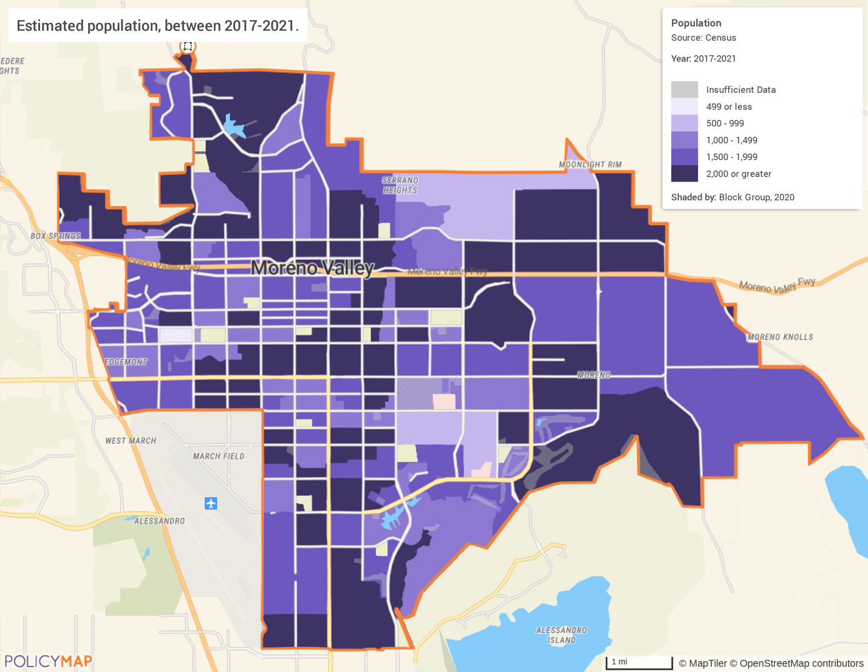
Source: 2017-2021 American Community Survey 5-Year Estimates

Population Density
Block groups with the highest density of population reside in the central and western parts of the city, with a higher density level west and northwest of the downtown center. Many of the city’s office space, commercial shopping, and mixed-use buildings are in these block groups.
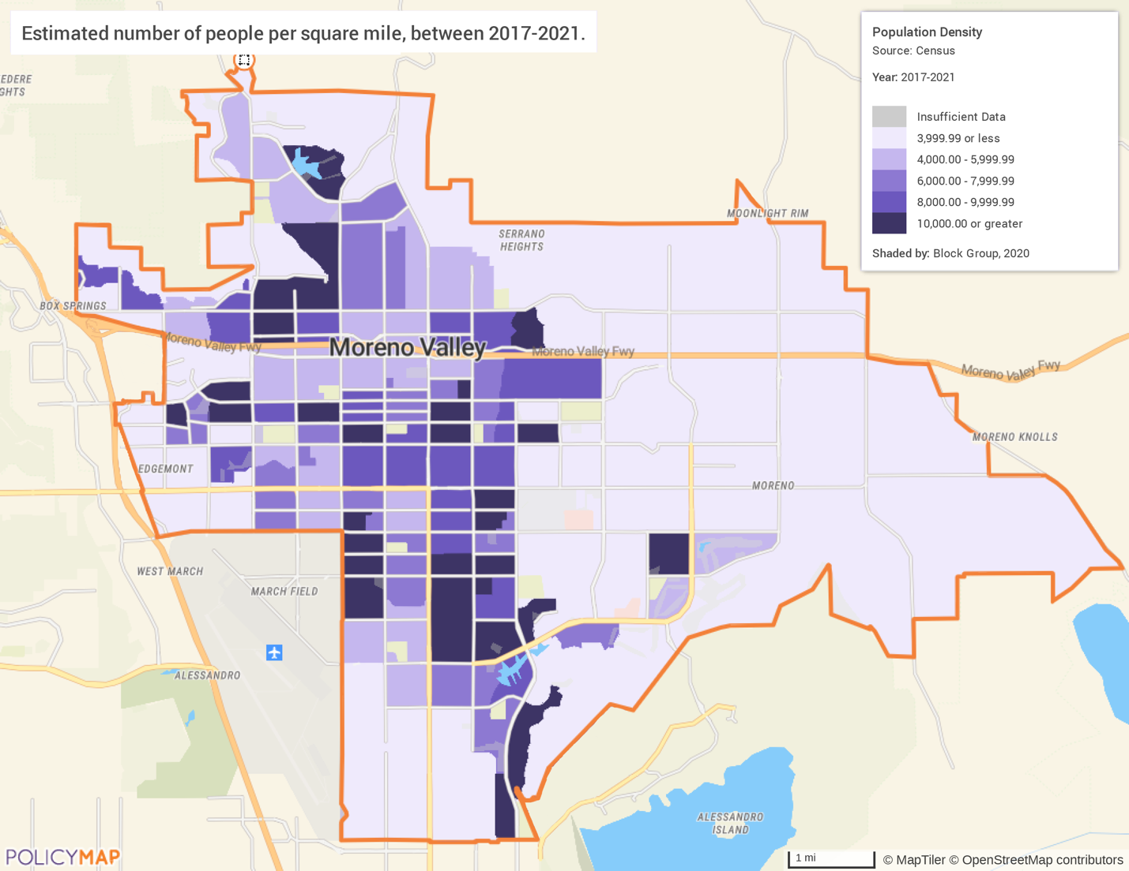
Source: 2017-2021 American Community Survey 5-Year Estimates

Median Household Income
As noted earlier, the median household income has grown in the city by 23% to over $70,000 (though purchasing power has only increased by an estimated 1.6%). High income households are heavily concentrated in the same tracts that are more densely populated. Areas on the northern, eastern, and southern edges of the city have much higher median household incomes—over $100,000, while just a few blocks away the median household income can be less than half that amount.
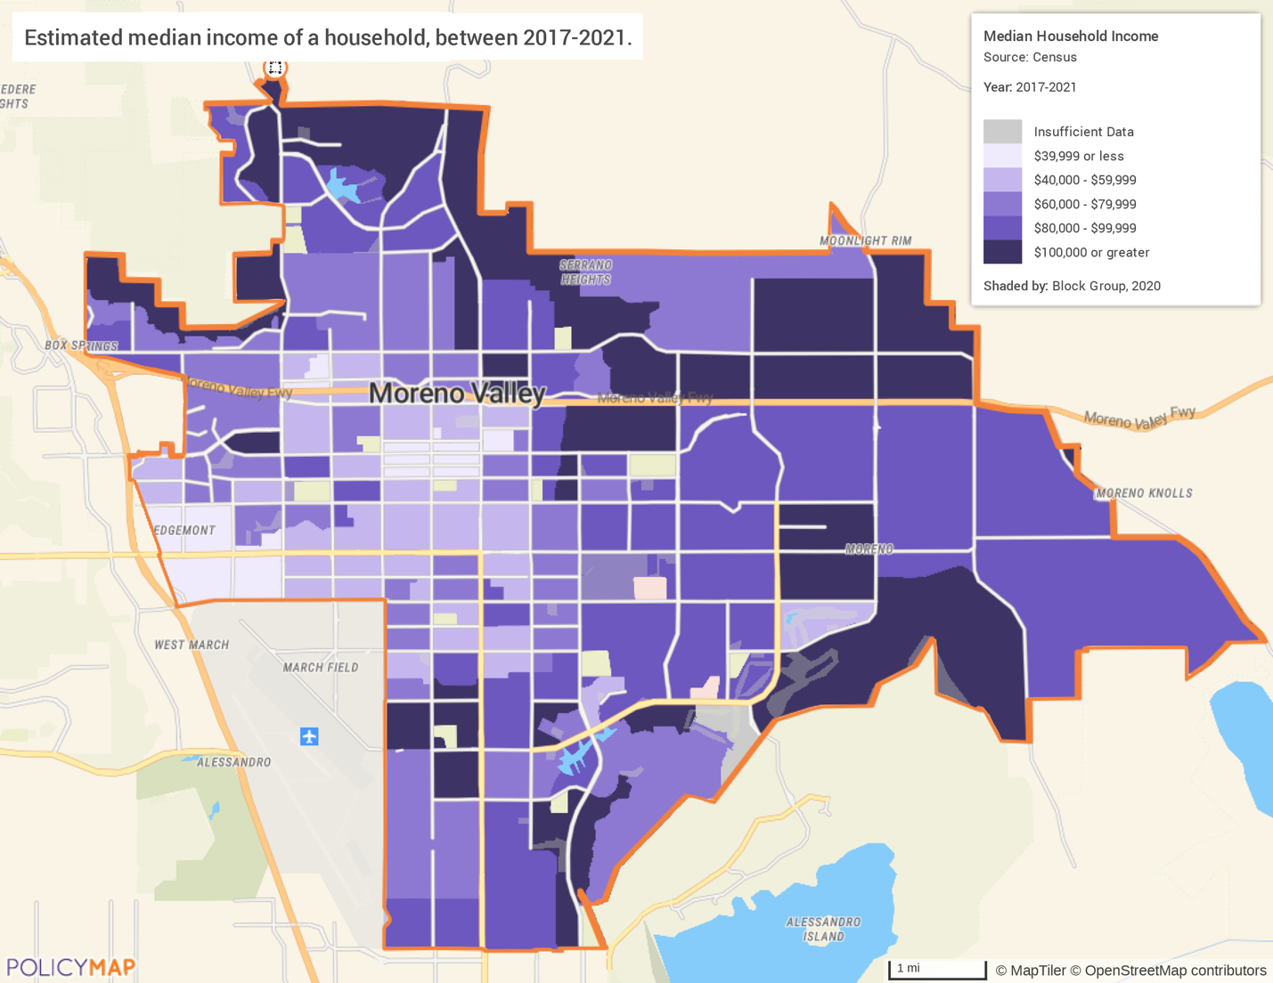
Source: 2017-2021 American Community Survey 5-Year Estimates

Poverty
The map below displays the percentage of the population who live below the poverty level by census tract. Unsurprisingly, areas that have higher median income tend to have lower levels of poverty. The census tracts on the northern, eastern, and southern edges of the city have poverty rates below 10%, while tracts in the central and eastern areas of the city have rates above 20%.
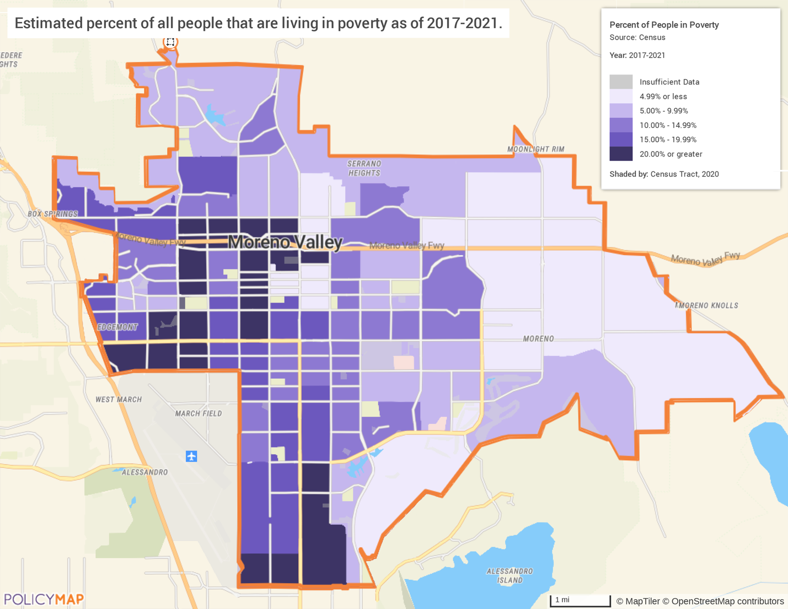
Source: 2017-2021 American Community Survey 5-Year Estimates

Number of Households Table
 | 0-30% HAMFI | >30-50% HAMFI | >50-80% HAMFI | >80-100% HAMFI | >100% HAMFI
Total Households | 6,070 | 6,155 | 10,775 | 6,025 | 21,860
Small Family Households | 2,680 | 2,910 | 4,945 | 2,925 | 11,555
Large Family Households | 1,110 | 1,635 | 3,440 | 1,685 | 5,055
Household contains at least one person 62-74 years of age | 1,180 | 1,360 | 2,065 | 1,120 | 5,330
Household contains at least one person age 75 or older | 600 | 460 | 870 | 369 | 1,345
Households with one or more children 6 years old or younger | 1,514 | 1,854 | 3,195 | 1,650 | 4,365

Table 6 - Total Households Table
Data Source:  Data Source Comments:
  2015-2019 CHAS
  HAMFI stands for HUD Area Median Family Income.

In addition to the median household income, an important economic indicator is the distribution of wealth in the community. The above table shows family dynamics and income in the jurisdiction using data from the 2015-2019 Comprehensive Housing Affordability Study (CHAS). Median numbers can show growth and change, but alone they can provide an inaccurate view. By looking at the number of households within different income groups, a clearer picture can be found. According to 2015-2019 CHAS data, Moreno Valley has approximately 50,885 households. Of this number of households, 23,000 (45%) have low/moderate incomes (LMI), meaning they earn 0-80% of the area median income (AMI). The percentage of the LMI households was similar in the 2006-2010 ACS (43.3%).
In Moreno Valley, small families are more prevalent than large families, like the household trends of the nation. There appears to be a correlation between household type and income. Small family households are more common among households earning over 80% than those earning less and are more likely to earn 80% AMI or more than large family households. The most common housing types associated with earning less than the AMI are large households, households with a member between 62 and 74 years old, and households with children 6 years or younger. These factors are all related, and it is likely that many large households have children or are multigenerational with elderly household members.
Housing Needs Summary Tables
1. Housing Problems (Households with one of the listed needs)
 | Renter |  |  |  |  | Owner
 | 0-30% AMI | >30-50% AMI | >50-80% AMI | >80-100% AMI | Total | 0-30% AMI | >30-50% AMI | >50-80% AMI | >80-100% AMI | Total
NUMBER OF HOUSEHOLDS
Substandard Housing - Lacking complete plumbing or kitchen facilities | 95 | 25 | 4 | 4 | 128 | 4 | 35 | 0 | 10 | 49
Severely Overcrowded - With >1.51 people per room (and complete kitchen and plumbing) | 120 | 150 | 130 | 90 | 490 | 4 | 130 | 160 | 45 | 339
Overcrowded - With 1.01-1.5 people per room (and none of the above problems) | 500 | 460 | 800 | 220 | 1980 | 35 | 235 | 595 | 270 | 1135
Housing cost burden greater than 50% of income (and none of the above problems) | 2680 | 1620 | 510 | 65 | 4875 | 1230 | 1275 | 740 | 95 | 3340
Housing cost burden greater than 30% of income (and none of the above problems) | 215 | 975 | 2,585 | 860 | 4,635 | 395 | 445 | 2,435 | 885 | 4,160
Zero/negative Income (and none of the above problems) | 225 | 0 | 0 | 0 | 225 | 130 | 0 | 0 | 0 | 130
Table 7 – Housing Problems Table
Alternate Data Source: | 2015-2019 CHAS

Housing Needs Summary
The table above provides information on housing problems in the city. Using 2015-2019 CHAS data, it provides the numbers of households experiencing each category of housing problem broken down by income ranges (up to 100% AMI) and owner/renter status. As defined by HUD in the Comprehensive Housing Affordability Strategy (CHAS) data, housing problems include:
- Units with physical defects (lacking complete kitchen or bathroom)
- Overcrowded conditions (housing units with more than one person per room)
- Housing cost burden (including utilities) exceeding 30% of gross income
- Severe housing cost burden (including utilities) exceeding 50% of gross income
Cost burden is by far the largest housing problem facing the city and is a common trend in many communities across the state and nation today. According to the 2015-2019 CHAS data there were 4,875 renters in the 0% to 100% AMI range spending more than 50% of their income on housing costs (100% AMI is the area median income) and an additional 4,635 spending 30-50% of their income on housing costs. This data also shows there were 3,340 homeowner households in the 0% to 100% AMI range spending more than 50% of their income on housing costs, and another 4,160 spending over 30% of their income on housing costs. These figures do not include households that earned more than 100% AMI, so the actual number of cost burdened households may be higher than the number shown in this table.
Housing problems in the city impact renter households more significantly than owner households. In general, renter-households experience substandard housing, overcrowding, and severe cost burdens to a greater extent than owner- households. Of these housing problems, the most common in Moreno Valley is housing cost burden. Nearly 4,500 low/mod income households are cost burdened and 7,885 are severely cost burdened.

2. Housing Problems 2 (Households with one or more Severe Housing Problems: Lacks kitchen or complete plumbing, severe overcrowding, severe cost burden)
 | Renter |  |  |  |  | Owner
 | 0-30% AMI | >30-50% AMI | >50-80% AMI | >80-100% AMI | Total | 0-30% AMI | >30-50% AMI | >50-80% AMI | >80-100% AMI | Total
NUMBER OF HOUSEHOLDS
Having 1 or more of four housing problems | 3,615 | 3,225 | 4,030 | 1,235 | 12,105 | 1,670 | 2,120 | 3,930 | 1,310 | 9,030
Having none of four housing problems | 345 | 185 | 735 | 1,120 | 2,385 | 90 | 620 | 2,080 | 2,360 | 5,150
Household has negative income, but none of the other housing problems | 225 | 0 | 0 | 0 | 225 | 130 | 0 | 0 | 0 | 130
Table 8 – Housing Problems 2
Alternate Data Source: | 2015-2019 CHAS

Severe Housing Problems
The data table above shows the number of households between 0% and 100% AMI that have one or more severe housing problems. Severe housing problems include lack of kitchen or complete plumbing, severe overcrowding, and severe cost burden. Severe housing problems are significantly less common than standard housing problems, but they are still present in the city. Low-income households 0-50% are most likely to have a severe housing problem. In total, approximately 21,000 households in the 0-100% AMI range have a severe housing problem.

3. Cost Burden > 30%
 | Renter |  |  |  | Owner
 | 0-30% AMI | >30-50% AMI | >50-80% AMI | Total | 0-30% AMI | >30-50% AMI | >50-80% AMI | Total
NUMBER OF HOUSEHOLDS
Small Related | 45 | 90 | 580 | 715 | 20 | 295 | 955 | 1,270
Large Related | 45 | 65 | 390 | 500 | 4 | 165 | 1,030 | 1,199
Elderly | 145 | 20 | 20 | 185 | 30 | 115 | 150 | 295
Other | 90 | 25 | 80 | 195 | 15 | 15 | 85 | 115
Total need by income | 325 | 200 | 1,070 | 1,595 | 69 | 590 | 2,220 | 2,879
Table 9 – Cost Burden > 30%
Alternate Data Source: | 2015-2019 CHAS

The table above displays 2015-2019 CHAS data on cost-burdened households with income that is 0% to 80%. Households are considered cost burdened if they spend over 30% of their income on housing costs. There are nearly 4,500 households that are cost burdened in the community and there appears to be a relationship between housing type and cost burden. Elderly households show the greatest difference between overall population and extremely low-income population. Despite making up only 11% of the LMI population they make up 45% of the extremely low-income population. This is true for both homeowners and renters.
Housing Cost Burdened
The following maps below display the percentage of the population who are cost-burdened by census tract using data from the 2017-2021 American Community Survey 5-Year Estimates. Despite higher median household incomes in the northern, western, and southern edges of the city, there are still high rates of cost burden, sometimes over 40% for homeowners and over 80% for renters.
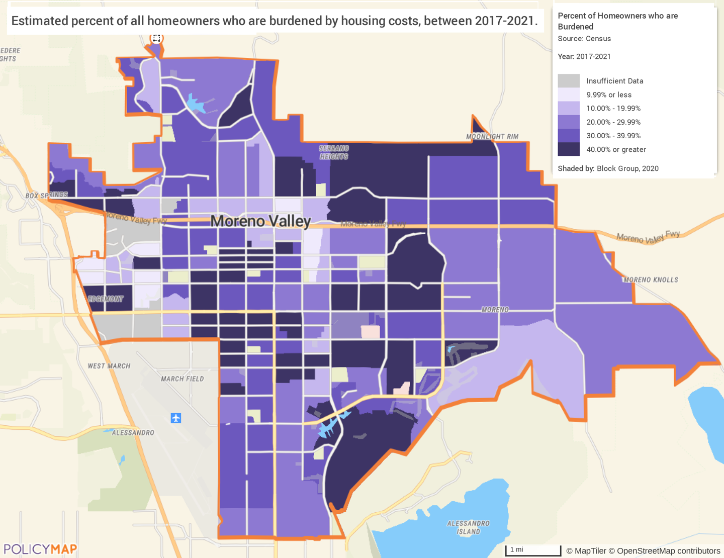
Source: 2017-2021 American Community Survey 5-Year Estimates
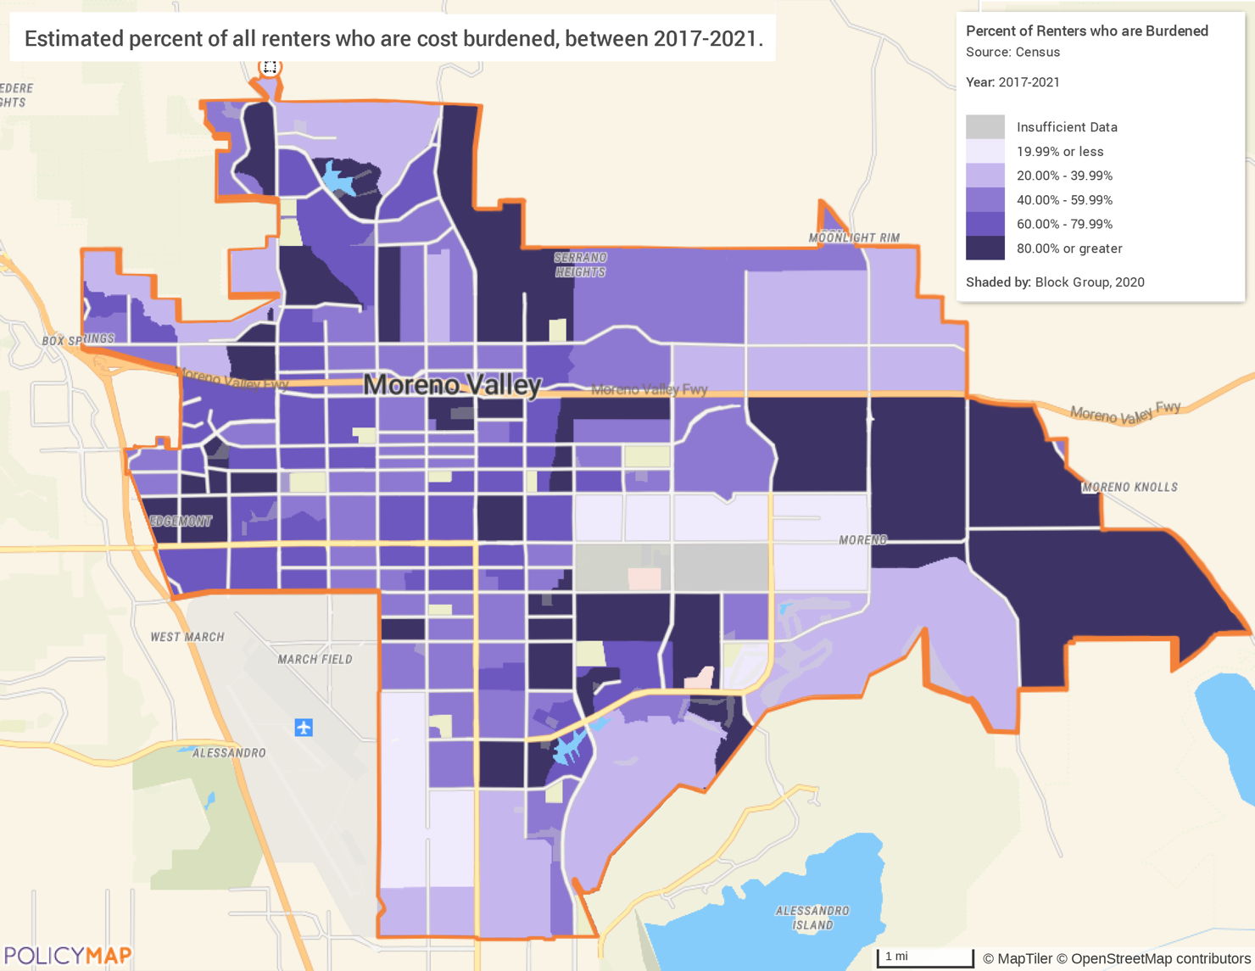
Source: 2017-2021 American Community Survey 5-Year Estimates

4. Cost Burden > 50%
 | Renter |  |  |  | Owner
 | 0-30% AMI | >30-50% AMI | >50-80% AMI | Total | 0-30% AMI | >30-50% AMI | >50-80% AMI | Total
NUMBER OF HOUSEHOLDS
Small Related | 1,735 | 915 | 285 | 2,935 | 630 | 630 | 305 | 1,565
Large Related | 755 | 65 | 15 | 835 | 170 | 405 | 40 | 615
Elderly | 230 | 20 | 60 | 310 | 210 | 110 | 130 | 450
Other | 395 | 310 | 165 | 870 | 130 | 85 | 90 | 305
Total need by income | 3,115 | 1,310 | 525 | 4,950 | 1,140 | 1,230 | 565 | 2,935
Table 10 – Cost Burden > 50%
Alternate Data Source: | 2015-2019 CHAS

Severe Cost Burden
The table above displays 2015-2019 CHAS data on cost-burdened households with income that is 0% to 80%. Households are considered severely cost burdened if they spend over 50% of their income on housing costs. There are no household types that are disproportionately likely to be extremely low income, but the sheer number of households with a severe cost burden is worth noting. There are nearly 8,000 households with a severe cost burden, which is 43% more than the number of households with just a standard cost burden. These 8,000 households are at the greatest risk of housing insecurity and homelessness, particularly renters who may face eviction if unexpected expenses arise.

5. Crowding (More than one person per room)
 | Renter |  |  |  |  | Owner
 | 0-30% AMI | >30-50% AMI | >50-80% AMI | >80-100% AMI | Total | 0-30% AMI | >30-50% AMI | >50-80% AMI | >80-100% AMI | Total
NUMBER OF HOUSEHOLDS
Single family households | 525 | 480 | 675 | 150 | 1,830 | 39 | 245 | 460 | 100 | 844
Multiple, unrelated family households | 105 | 130 | 260 | 155 | 650 | 0 | 125 | 295 | 220 | 640
Other, non-family households | 15 | 0 | 0 | 0 | 15 | 0 | 4 | 0 | 0 | 4
Total need by income | 645 | 610 | 935 | 305 | 2,495 | 39 | 374 | 755 | 320 | 1,488
Table 11 – Crowding Information – 1/2
Alternate Data Source: | 2015-2019 CHAS

Overcrowding
HUD defines an overcrowded household as one having from 1.01 to 1.50 occupants per room and a severely overcrowded household as one with more than 1.50 occupants per room. Overcrowding is less common than cost burden issues, but it is still present in nearly 4,000 households. Renters are more likely to have overcrowding issues, as well as households in the 50-80% AMI range. This supports the earlier data that showed an increase in housing size over the last decade.
The following table shows the number of overcrowded households with children present by tenure and income level. The larger number of households identified here means that overcrowding is not an issue limited to LMI households but is also present in households earning over 100% AMI.
 | Renter |  |  |  | Owner
 | 0-30% AMI | >30-50% AMI | >50-80% AMI | Total | 0-30% AMI | >30-50% AMI | >50-80% AMI | Total
Households with Children Present | 1,329 | 1,265 | 1,395 | 3,989 | 185 | 589 | 1,800 | 2,574
Alternate Data Source Name: 2015-2019 CHAS
Table 12 – Crowding Information – 2/2

Describe the number and type of single person households in need of housing assistance.
According to the 2021 American Community Survey (ACS), there are 6,176 single person households in the city. Of those households, 3,427 are homeowners and 2,749 are renters. Over 52% of single person households are 35 to 64 years old. Householders 65 years and over make up 32% of single person households. These households are the group primarily in need of housing assistance due to the higher poverty rates and fixed incomes.
Estimate the number and type of families in need of housing assistance who are disabled or victims of domestic violence, dating violence, sexual assault, and stalking.
Persons with Disabilities
According to ACS data, 20,423 residents of Moreno Valley have a disability, making up 9.8% of the city’s population. The most common disability is ambulatory difficulty, meaning the person has severe difficulty walking or climbing stairs. Over 9,800 persons report this difficulty. Approximately 6,800 of the disabled residents are over the age of 65. These seniors may need in home supportive services and eventually, as disabilities worsen, may need to relocate to one of the city’s assisted living facilities.
As mentioned above, this population is most in need of financial housing assistance as well.
An exact count of those in need of housing assistance is difficult to determine but it is likely many residents with a disability either need housing assistance through financial support or access to homes that meet their needs. With over 20,000 households with one or more disabled person, it is reasonable to assume that such households also experience housing problems to the same or greater extent as households with no disabled members do. That is, problems such as cost burden and severe cost burden are also problems confronting households with a disabled member. Most homes require expensive modifications to accommodate the needs of residents.
Victims of Domestic Violence
According to the 2022 County of Riverside Point-in-Time Homeless Count, 95 persons experiencing homelessness reported being a victim of domestic violence. Statistics compiled by the California Department of Justice found that in 2021, there were 654 calls for assistance in Moreno Valley related to domestic violence. Most of these instances (73%) did not involve a weapon. The FBI reported that 19 rapes were reported to law enforcement in Moreno Valley in 2019. Sexual assault and other intimate crimes are underreported. The National Coalition Against Domestic Violence states that only 25% of physical assaults, 20% of rapes, and 50% of stalking cases are reported to the police. Based on this information, it is likely that there are many more victims of domestic violence, dating violence, sexual assault and stalking that have not reported to law enforcement. It is imperative that survivors have access to housing and economic support to escape dangerous situations. Emergency shelter as well as counseling and other services often are needed by the victims of domestic violence, dating violence, sexual assault, and stalking.
What are the most common housing problems?
The most common housing problem identified in Moreno Valley is housing cost burden. According to the 2015-2019 CHAS data, over 12,350 low/mod income households are cost burdened (>30%) or severely cost burdened (>50%). Based on this data, among low- and moderate-income renters, 13% are cost burdened and 40% are severely cost burdened. Among all low- and moderate-income owners, 27% are cost burdened and another 27% are severely cost burdened. Low- and moderate-income households are especially adversely impacted by severe housing costs. This financial burden puts significant pressure on households and increases the likelihood of less-than-optimal living arrangements and risk of homelessness.
Are any populations/household types more affected than others by these problems?
Overall, household income is correlated with the likelihood that households are impacted by housing problems, particularly for renters. Residents with lower incomes have increased rates of cost burden and other substandard living conditions. Renters also experience crowding to a greater extent than owners. Elderly residents have a higher cost burden rate than other household types.
Additionally, residents with disabilities and those experiencing homelessness are particularly vulnerable to housing problems. A discussion of the prevalence of housing problems by race and ethnicity is discussed later in NA-15 to NA-30.
Describe the characteristics and needs of Low-income individuals and families with children (especially extremely low-income) who are currently housed but are at imminent risk of either residing in shelters or becoming unsheltered 91.205(c)/91.305(c)). Also discuss the needs of formerly homeless families and individuals who are receiving rapid re-housing assistance and are nearing the termination of that assistance.
The city has almost 1,700 extremely low-income renters in large, related families who are severely cost burdened. These families face difficulties in meeting their monthly housing obligations and could lose their housing because of financial constraints. Extremely low-income households (those at or below 30% of the area median income) spending more than 50% of their income for housing costs are particularly vulnerable to an unexpected financial or personal crisis which could lead to homelessness. According to 2015-2019 CHAS data, 3,440 households fit these criteria and are at imminent risk of homelessness.
Single-parent households with children are the most vulnerable. They have a greater need for affordable housing, accessible childcare, health care, and other supportive services. Because of their lower income and higher living expenses, very low-income single-parent households are at imminent risk of becoming homeless. The major needs for these households are money management and budget counseling along with job training and affordable childcare. Formerly homeless families who are receiving rapid re-housing and are nearing the termination of that assistance are also in need of these same supportive services.
If a jurisdiction provides estimates of the at-risk population(s), it should also include a description of the operational definition of the at-risk group and the methodology used to generate the estimates:
Not applicable
Specify particular housing characteristics that have been linked with instability and an increased risk of homelessness.
Instability and increased risk of homelessness are associated with a lack of financial resources, temporarily living in the home of another, imminent eviction, or living in a motel. Death of a family member, medical expenses, or other unanticipated emergency expenditure, such as a major car repair, are particularly burdensome for families with low or fixed incomes that do not have the resources to pay for unanticipated costs. Extremely low-income households with a severe housing cost burden are most likely to lose their housing in the event of these unexpected expenses. According to the 2022 Moreno Valley Point In Time Count, 43% of unsheltered homeless persons reported that their reason for homelessness was attributed to family disruption. Some examples of this include death in the family, divorce, or violence. Additionally, 12% of the population attributed their homelessness strictly to lack of income or unemployment.
Income stagnation combined with rising rents increases the risk of homelessness. While efforts to produce affordable housing are important to reducing disproportionate housing needs, it also is important to find ways to increase household incomes through jobs with higher wages and other economic development strategies.

NA-15 Disproportionately Greater Need: Housing Problems – 91.205 (b)(2)
Introduction
A review of Housing Assessment data provided by HUD provides information that can be analyzed and used to determine any racial or ethnic groups that may have a proportionally higher housing need than other ethnic groups in the community. HUD has determined that a disproportionally higher need exists when the members of a racial or ethnic group at a given income level experience housing problems at a greater rate (10 percent or more) than the income level as a whole. Identifying and understanding any disproportionately greater needs due to housing problems is vital to the analysis of past programs and should help guide future programs to address disparities between groups in the community.
0%-30% of Area Median Income
Housing Problems | Has one or more of four housing problems | Has none of the four housing problems | Household has no/negative income, but none of the other housing problems
Jurisdiction as a whole | 5,285 | 785 | 0
White | 805 | 145 | 0
Black / African American | 1,415 | 245 | 0
Asian | 250 | 25 | 0
American Indian, Alaska Native | 30 | 0 | 0
Pacific Islander | 0 | 0 | 0
Hispanic | 2,645 | 280 | 0
Table 13 - Disproportionally Greater Need 0 - 30% AMI
Alternate Data Source: | 2015-2019 CHAS

*The four housing problems are 1) Lacks complete kitchen facilities, 2) Lacks complete plumbing facilities, 3) More than one person per room, 4) Cost Burden greater than 30%

30%-50% of Area Median Income
Housing Problems | Has one or more of four housing problems | Has none of the four housing problems | Household has no/negative income, but none of the other housing problems
Jurisdiction as a whole | 5,345 | 805 | 0
White | 710 | 165 | 0
Black / African American | 945 | 90 | 0
Asian | 350 | 65 | 0
American Indian, Alaska Native | 30 | 0 | 0
Pacific Islander | 24 | 20 | 0
Hispanic | 3,225 | 445 | 0
Table 14 - Disproportionally Greater Need 30 - 50% AMI
Alternate Data Source: | 2015-2019 CHAS

*The four housing problems are 1) Lacks complete kitchen facilities, 2) Lacks complete plumbing facilities, 3) More than one person per room, 4) Cost Burden greater than 30%

50%-80% of Area Median Income
Housing Problems | Has one or more of four housing problems | Has none of the four housing problems | Household has no/negative income, but none of the other housing problems
Jurisdiction as a whole | 7,960 | 2,815 | 0
White | 1,040 | 480 | 0
Black / African American | 1,765 | 250 | 0
Asian | 315 | 200 | 0
American Indian, Alaska Native | 25 | 4 | 0
Pacific Islander | 25 | 0 | 0
Hispanic | 4,670 | 1,845 | 0
Table 15 - Disproportionally Greater Need 50 - 80% AMI
Alternate Data Source: | 2015-2019 CHAS

*The four housing problems are 1) Lacks complete kitchen facilities, 2) Lacks complete plumbing facilities, 3) More than one person per room, 4) Cost Burden greater than 30%

80%-100% of Area Median Income
Housing Problems | Has one or more of four housing problems | Has none of the four housing problems | Household has no/negative income, but none of the other housing problems
Jurisdiction as a whole | 2,545 | 3,480 | 0
White | 355 | 585 | 0
Black / African American | 650 | 600 | 0
Asian | 145 | 160 | 0
American Indian, Alaska Native | 0 | 0 | 0
Pacific Islander | 0 | 0 | 0
Hispanic | 780 | 2,055 | 0
Table 16 - Disproportionally Greater Need 80 - 100% AMI
Alternate Data Source: | 2013-2017 CHAS

*The four housing problems are 1) Lacks complete kitchen facilities, 2) Lacks complete plumbing facilities, 3) More than one person per room, 4) Cost Burden greater than 30%

Discussion
Extremely Low-Income (0-30% AMI)
Jurisdiction as a whole: 87.1%
In the extremely low-income group, there is one racial or ethnic group that is disproportionately impacted by housing problems. According to the available data, every American Indian or Alaska Native household in this group has a housing problem. This discrepancy should be analyzed but due to the low number of estimated households in this group (30 households), there is potentially a high margin of error in this estimate.

Very Low-Income (30-50% AMI)
Jurisdiction as a whole: 86.9%
The overall rate of housing problems for very low-income households is very similar to extremely low-income households. As with the above group, there is one racial or ethnic group that is disproportionately impacted. Again, every American Indian or Alaska Native household reports a housing problem in this income group and the estimated population size is small (30 households).

Low-Income (50-80% AMI)
Jurisdiction as a whole: 73.9%
The rate of housing problems shows a significant decrease for low-income households when compared to lower income groups, but there are still many households with housing problems. In this income group there are three racial or ethnic groups that are disproportionately impacted. Approximately 87% of Black or African American households, 86.2% of American Indian or Alaska Native households, and 100% of Pacific Islander households report at least one housing problem. The largest group is Black or African American households and includes over 2,000 households, making up approximately 20% of the total population of this income group.

Moderate Income (80-100% AMI)
Jurisdiction as a whole: 42.2%
The largest change in the prevalence in housing problems is between low- and moderate-income groups. There are no groups disproportionately impacted by housing problems among moderate income households.

NA-20 Disproportionately Greater Need: Severe Housing Problems – 91.205 (b)(2)
Introduction
A review of Housing Assessment data provided by HUD provides information that can be analyzed and used to determine any racial or ethnic groups that may have a proportionally higher housing need than other ethnic groups in the community. HUD has determined that a proportionally higher need exists when the percentage of persons in each category is at least 10 percentage points higher than the percentage of persons in the category. Identifying and understanding any disproportionately greater needs due to severe housing problems is vital to the analysis of past programs and should help guide future programs to address disparities among groups in the community.

0%-30% of Area Median Income
Severe Housing Problems* | Has one or more of four housing problems | Has none of the four housing problems | Household has no/negative income, but none of the other housing problems
Jurisdiction as a whole | 4,670 | 1,400 | 0
White | 605 | 345 | 0
Black / African American | 1,235 | 425 | 0
Asian | 195 | 70 | 0
American Indian, Alaska Native | 15 | 15 | 0
Pacific Islander | 0 | 0 | 0
Hispanic | 2,485 | 450 | 0
Table 17 – Severe Housing Problems 0 - 30% AMI
Alternate Data Source: | 2015-2019 CHAS

*The four housing problems are 1) Lacks complete kitchen facilities, 2) Lacks complete plumbing facilities, 3) More than 1.5 persons per room, 4) Cost Burden greater than 50%

30%-50% of Area Median Income
Severe Housing Problems* | Has one or more of four housing problems | Has none of the four housing problems | Household has no/negative income, but none of the other housing problems
Jurisdiction as a whole | 3,930 | 2,220 | 0
White | 490 | 385 | 0
Black / African American | 725 | 310 | 0
Asian | 275 | 145 | 0
American Indian, Alaska Native | 30 | 0 | 0
Pacific Islander | 15 | 29 | 0
Hispanic | 2,345 | 1,325 | 0
Table 18 – Severe Housing Problems 30 - 50% AMI
Alternate Data Source: | 2015-2019 CHAS

*The four housing problems are 1) Lacks complete kitchen facilities, 2) Lacks complete plumbing facilities, 3) More than 1.5 persons per room, 4) Cost Burden greater than 50%

50%-80% of Area Median Income
Severe Housing Problems* | Has one or more of four housing problems | Has none of the four housing problems | Household has no/negative income, but none of the other housing problems
Jurisdiction as a whole | 2,940 | 7,835 | 0
White | 395 | 1,120 | 0
Black / African American | 640 | 1,375 | 0
Asian | 80 | 440 | 0
American Indian, Alaska Native | 20 | 4 | 0
Pacific Islander | 15 | 10 | 0
Hispanic | 1,755 | 4,760 | 0
Table 19 – Severe Housing Problems 50 - 80% AMI
Alternate Data Source: | 2015-2019 CHAS

*The four housing problems are 1) Lacks complete kitchen facilities, 2) Lacks complete plumbing facilities, 3) More than 1.5 persons per room, 4) Cost Burden greater than 50%

80%-100% of Area Median Income
Severe Housing Problems* | Has one or more of four housing problems | Has none of the four housing problems | Household has no/negative income, but none of the other housing problems
Jurisdiction as a whole | 795 | 5,230 | 0
White | 90 | 850 | 0
Black / African American | 125 | 1,125 | 0
Asian | 50 | 255 | 0
American Indian, Alaska Native | 0 | 0 | 0
Pacific Islander | 0 | 0 | 0
Hispanic | 350 | 2,925 | 0
Table 20 – Severe Housing Problems 80 - 100% AMI
Alternate Data Source: | 2015-2019 CHAS

*The four housing problems are 1) Lacks complete kitchen facilities, 2) Lacks complete plumbing facilities, 3) More than 1.5 persons per room, 4) Cost Burden greater than 50%

Discussion
Extremely Low-Income (0-30% AMI)
Jurisdiction as a whole: 76.9%.
In the extremely low-income group approximately 4,670 households have a severe housing problem, making up over 75% of the population. However, there are no racial or ethnic groups that are disproportionately impacted by severe housing problems.

Very Low-Income (30-50% AMI)
Jurisdiction as a whole: 63.9%
The overall rate of housing problems for very low-income households is approximately 13% lower than for extremely low-income households. Similar to the housing problem data in NA-20, there is one group that is disproportionately impacted by severe housing problems in this income group. Every American Indian or Alaska Native household reports a severe housing problem in this income group.

Low-Income (50-80% AMI)
Jurisdiction as a whole: 27.3%
The rate of severe housing problems drops significantly for low-income households when compared to lower income groups. In Moreno Valley, an income level in this group appears to be a threshold level where households can live without severe housing problems, though housing problems are still prevalent (see NA-15). Despite the improvement from prior income groups, there are two racial or ethnic groups that are disproportionately impacted. According to the available estimates, approximately 83.3% of American Indian or Alaska Native households and 60% of Pacific Islander households have a severe housing problem. The total number of households in these two groups is relatively small but this disparity still warrants consideration.

Moderate Income (80-100% AMI)
Jurisdiction as a whole: 13.2%
Moderate income households have the lowest rate of severe housing problems. There is one group that is disproportionately impacted, approximately 27.5% of Hispanic households have a severe housing problem.

NA-25 Disproportionately Greater Need: Housing Cost Burdens – 91.205 (b)(2)
Introduction
The following section analyzes the prevalence of a specific housing problem, cost burden. A household is considered to have a cost burden when they pay more than 30% of their income on housing costs. HUD has determined that a proportionally higher need exists when the percentage of persons in each category is at least 10 percentage points higher than the percentage of persons in the category. Identifying and understanding any disproportionately greater needs due to severe housing problems is vital to the analysis of past programs and should help guide future programs to address disparities between groups in the community.

Housing Cost Burden
Housing Cost Burden | <=30% | 30-50% | >50% | No / negative income (not computed)
Jurisdiction as a whole | 29,055 | 12,118 | 9,315 | 395
White | 7,485 | 1,885 | 1,405 | 70
Black / African American | 5,145 | 2,545 | 2,555 | 125
Asian | 1,920 | 590 | 550 | 70
American Indian, Alaska Native | 30 | 69 | 30 | 0
Pacific Islander | 55 | 14 | 15 | 0
Hispanic | 14,005 | 6,720 | 4,560 | 115
Table 21 – Greater Need: Housing Cost Burdens AMI
Alternate Data Source: | 2015-2019 CHAS

Discussion:
For the purposes of this discussion, “Cost Burden” is broken into three separate categories. Households that spend between 30% and 50% have a Standard Cost Burden, households that spend more than 50% of their income on housing costs have Severe Cost Burden, and these two groups combined is the Total Cost Burden. By separating the data into these groups, it is possible to identify the degree of need of any groups that are disproportionately impacted by cost burden.
Standard Cost Burden
Jurisdiction as a whole: 24%
In Moreno Valley, there are over 12,000 households with a standard cost burden, making up nearly one-quarter of all households. There is only one group that is disproportionately impacted, approximately 53.4% of American Indian and Alaska Native households have a standard cost burden.

Severe Cost Burden
Jurisdiction as a whole: 18.5%
Severely cost burdened households are at a high risk of housing insecurity and experiencing homelessness. A minor financial problem could lead to default and/or eviction. There are currently nearly 10,000 households with a severe cost burden. There are no groups with a disproportionate impact.

Total Cost Burden
Jurisdiction as a whole: 42.5%
In total, over 20,000 households are cost burdened in the community. American Indian or Alaska Native households have a disproportionate impact, over 75% of these households have a cost burden. The actual prevalence of households who face financial pressure due to housing costs is actually higher because these figures do not include households that have zero or negative income.

NA-30 Disproportionately Greater Need: Discussion – 91.205(b)(2)
Are there any Income categories in which a racial or ethnic group has disproportionately greater need than the needs of that income category as a whole?
The available data identified American Indian and Alaska Native households as the group that is most frequently impacted by disproportionate need throughout multiple income groups. This population is relatively small but the frequency with which they appear points to a potential housing need to be addressed. Additionally, low-income Pacific Islander households reported disproportionately greater need for both housing problems, severe housing problems, and cost burden. Per the analysis in NA-25, the most common household problem for all racial or ethnic groups is cost burden.
Disproportionate Housing Problems:
- Extremely Low Income: American Indian or Alaska Native
- Very Low Income: American Indian or Alaska Native
- Low Income: Black or African American, American Indian or Alaska Native, Pacific Islander
- Moderate Income: None
Disproportionate Severe Housing Problems:
- Extremely Low Income: None
- Very Low Income: American Indian or Alaska Native
- Low Income: American Indian or Alaska Native, Pacific Islander
- Moderate Income: Hispanic
Standard Cost Burden: American Indian or Alaska Native
Extreme Cost Burden: None
Total Cost Burden: American Indian or Alaska Native
If they have needs not identified above, what are those needs?
No additional needs were identified that disproportionately impact households based on race or ethnicity. Household income is the primary indicator for both housing and non-housing. Additional information can be found throughout the document, including public and assisted housing needs by race or ethnicity in NA-35 and disparities in housing locations and income in MA-50.
Are any of those racial or ethnic groups located in specific areas or neighborhoods in your community?
There are some areas that have a concentration of racial or ethnic groups. There are multiple tracts that have a concentration of Black, non-Hispanic residents. One area encompasses multiple tracts on the northwest side of the city and one area is in the southern tip. There are a few tracts that have a concentration of multiracial, Hispanic residents. There are two general areas with a concentration of this population. One area encompasses tracts on the northcentral part of the city and one area is in the south. Moreno Valley has also multiple census tracts that have a concentration of Hispanic residents. The southwest quadrant of the city has a larger Hispanic population relative to other parts of the city. A more detailed analysis of the geographic distribution of different racial and ethnic groups and income levels can be found in MA-50.

NA-35 Public Housing – 91.205(b)
Introduction
The City of Moreno Valley does not have a designated Public Housing Authority. Therefore, the city does not own or manage any housing directly or operate any voucher programs. However, the Housing Authority of the County of Riverside (HACR) serves the entire county, including residents of Moreno Valley, through the administration of voucher programs and public housing units. Additionally, the city has invested housing funds into the construction and rehabilitation of affordable multi-family rental projects in partnership with developers throughout the city. In return, the project owners provide discounted, below-market rents to income-qualified tenants during the term of their agreements with the city. Units in developments priced at a “below market rate” are made affordable to varied incomes ranging from very low to moderate income households (30% -120% AMI). Each project has a specific number of units reserved at below market rates, as well as specific income requirements for the units. The city does not own or manage any housing directly.

Totals in Use
Program Type
 | Certificate | Mod-Rehab | Public Housing | Vouchers
 |  |  |  | Total | Project -based | Tenant -based | Special Purpose Voucher
 |  |  |  |  |  |  | Veterans Affairs Supportive Housing | Family Unification Program | Disabled  *
# of units vouchers in use | 0 | 79 | 456 | 8,748 | 36 | 8,364 | 135 | 178 | 19

Table 22 - Public Housing by Program Type
*includes Non-Elderly Disabled, Mainstream One-Year, Mainstream Five-year, and Nursing Home Transition

Data Source: | PIC (PIH Information Center)

Characteristics of Residents

Program Type
 | Certificate | Mod-Rehab | Public Housing | Vouchers
 |  |  |  | Total | Project -based | Tenant -based | Special Purpose Voucher
 |  |  |  |  |  |  | Veterans Affairs Supportive Housing | Family Unification Program
Average Annual Income | 0 | 12,664 | 13,261 | 13,870 | 10,805 | 13,850 | 13,465 | 14,983
Average Length of Stay | 0 | 6 | 4 | 6 | 2 | 6 | 0 | 5
Average Household Size | 0 | 1 | 3 | 2 | 1 | 2 | 1 | 3
# Homeless at Admission | 0 | 2 | 331 | 205 | 1 | 197 | 2 | 5
# of Elderly Program Participants (>62) | 0 | 67 | 38 | 3,249 | 9 | 3,211 | 15 | 10
# of Disabled Families | 0 | 12 | 70 | 2,587 | 26 | 2,422 | 82 | 33
# of Families Requesting Accessibility Features | 0 | 79 | 456 | 8,748 | 36 | 8,364 | 135 | 178
# of HIV/AIDS Program Participants | 0 | 0 | 0 | 0 | 0 | 0 | 0 | 0
# of DV Victims | 0 | 0 | 0 | 0 | 0 | 0 | 0 | 0
Table 24 – Characteristics of Public Housing Residents by Program Type

Data Source: | PIC (PIH Information Center)

Race of Residents
Program Type
Race | Certificate | Mod-Rehab | Public Housing | Vouchers
 |  |  |  | Total | Project -based | Tenant -based | Special Purpose Voucher
 |  |  |  |  |  |  | Veterans Affairs Supportive Housing | Family Unification Program | Disabled  *
White | 0 | 66 | 318 | 5,469 | 26 | 5,195 | 79 | 144 | 15
Black/African American | 0 | 10 | 126 | 2,967 | 8 | 2,867 | 55 | 29 | 3
Asian | 0 | 1 | 9 | 209 | 2 | 203 | 0 | 2 | 1
American Indian/Alaska Native | 0 | 0 | 2 | 80 | 0 | 76 | 1 | 3 | 0
Pacific Islander | 0 | 2 | 1 | 23 | 0 | 23 | 0 | 0 | 0
Other | 0 | 0 | 0 | 0 | 0 | 0 | 0 | 0 | 0

*includes Non-Elderly Disabled, Mainstream One-Year, Mainstream Five-year, and Nursing Home Transition
Table 25 – Race of Public Housing Residents by Program Type
Data Source: | PIC (PIH Information Center)

Ethnicity of Residents
Program Type
Ethnicity | Certificate | Mod-Rehab | Public Housing | Vouchers
 |  |  |  | Total | Project -based | Tenant -based | Special Purpose Voucher
 |  |  |  |  |  |  | Veterans Affairs Supportive Housing | Family Unification Program | Disabled  *
Hispanic | 0 | 29 | 250 | 2,318 | 7 | 2,220 | 13 | 74 | 1
Not Hispanic | 0 | 50 | 206 | 6,430 | 29 | 6,144 | 122 | 104 | 18

*includes Non-Elderly Disabled, Mainstream One-Year, Mainstream Five-year, and Nursing Home Transition
Table 26 – Ethnicity of Public Housing Residents by Program Type
Data Source: | PIC (PIH Information Center)

Section 504 Needs Assessment: Describe the needs of public housing tenants and applicants on the waiting list for accessible units.
Not applicable. The City of Moreno Valley does not own or manage any public housing directly.
Most immediate needs of residents of Public Housing and Housing Choice voucher holders.
Public housing units are not located in the City of Moreno Valley. The HACR administers Housing Choice Vouchers to residents of the city and the most immediate need for these residents is continued rental assistance. Vouchers enable residents to remain stably housed while also being able to use their limited financial resources to meet other basic needs such as food security.
How do these needs compare to the housing needs of the population at large.
Moreno Valley’s extremely low-income renters have needs similar to voucher holders: food insecurity and other basic human needs. However, many extremely low-income renters do not receive Housing Choice Vouchers and therefore, residents that do receive rental assistance through the HCV program tend to have similar but more severe needs.

NA-40 Homeless Needs Assessment – 91.205(c)
Introduction
Homelessness is an incredibly complex issue that most communities across the country are struggling to address. The major reason that homelessness is difficult to address is that it has many overlapping and interrelated causes and variables. Homelessness is impacted by multiple factors and is typically caused by the convergence of many events and conditions. Homelessness can be an economic problem caused by unemployment or underemployment, lack of affordable housing options, and/or poverty. Homelessness can also be a health issue because many homeless persons struggle with mental illness, physical disabilities, HIV, substance abuse, or a combination of health factors. Another way to view homelessness is as a social problem, caused by factors such as domestic violence, educational attainment, and racism. Homelessness can be caused by all these issues, and they are often interrelated. Due to this complexity, fighting homelessness requires a collaborative and community-based approach.
The Stewart B. McKinney Homeless Assistance Act defined “homeless” or “homeless person” as an individual who lacks a fixed, regular, and adequate night-time residence; and who has a primary night-time residence that is:
- A supervised publicly or privately-operated shelter designed to provide temporary living accommodations (including welfare hotels, congregate shelters, and transitional housing for the mentally ill).
- An institution that provides a temporary residence for individuals intended to be institutionalized; or
- A public or private place not designed for, or ordinarily used as, a regular sleeping accommodation for human beings.
Moreno Valley is part of the Riverside County Continuum of Care, which was formed in 2020.
The Continuum of Care oversees the community's plan to organize and deliver supportive social services, including housing options, which meet the specific needs of homeless individuals and families. Ultimately, the goal of the Continuum is to move homeless people toward stable housing and maximum self-sufficiency.
According to the 2022 Moreno Valley Point in Time (PIT) Count, 87 persons are experiencing homelessness during a single night in the city. Most persons experiencing homelessness are unsheltered. The major challenges and barriers of these persons include substance abuse (44%), chronic health issues (24%), traumatic brain injury (22%), and PTSD (22%). These populations need intensive supportive services in addition to housing. Of the persons counted in the 2022 Count, 43% were experiencing homelessness for the first time. Homelessness continues to be a problem facing the city as additional households are falling into homelessness daily.
Homeless Needs Assessment
Population | Estimate the # of persons experiencing homelessness on a given night |  | Estimate the # experiencing homelessness each year | Estimate the # becoming homeless each year | Estimate the # exiting homelessness each year | Estimate the # of days persons experience homelessness
 | Sheltered | Unsheltered
Persons in Households with Adult(s) and Child(ren) | 0 | 0 | 31 | 0 | 9 | 185
Persons in Households with Only Children | 0 | 0 | 5 | 0 | 4 | 59
Persons in Households with Only Adults | 10 | 77 | 105 | 0 | 39 | 195
Chronically Homeless Individuals | 0 | 30 | 5 | 0 | 5 | 201
Chronically Homeless Families | 0 | 0 | 5 | 0 | 5 | 201
Veterans | 0 | 4 | 6 | 0 | 3 | 0
Unaccompanied Child | 0 | 18 | 0 | 0 | 0 | 0
Persons with HIV | 0 | 0 | 0 | 0 | 0 | 0
Table 27 - Homeless Needs Assessment

Alternate Data Source Name: 2022 Moreno Valley PIT Count; Riverside County Continuum of Care HMIS
Data Source Comments: Population details were only provided for unsheltered persons

If data is not available for the categories "number of persons becoming and exiting homelessness each year," and "number of days that persons experience homelessness," describe these categories for each homeless population type (including chronically homeless individuals and families, families with children, veterans and their families, and unaccompanied youth).
HMIS data from the homeless projects located in Moreno Valley that patriciate in the data system was used to estimate the number of persons experiencing homelessness and exiting homelessness and number of days those persons experienced homelessness. HMIS data is not available on the number of persons becoming homeless each year. Approximately 39 adult only households, 4 children only households, and 9 households with both adults and children exit homelessness each year. On average, chronically homeless individuals, and households experience homelessness for 201 days. Adult only households spend an average of 195 days homeless and households with adults and children spend 185 days homeless.
Additional information on each homeless population type is provided below:
Chronically Homeless – Residents are considered to be experiencing chronic homelessness if they have a disabling condition and have been consecutively experiencing homelessness for one year or more or had four separate episodes of homelessness in the last three years, totaling twelve months. In 2022, 30 people experiencing homelessness who were counted on the night of the PIT Count experienced chronic homelessness. Approximately 39% of those experiencing unsheltered homelessness were also chronically homeless. These are the most vulnerable residents experiencing homelessness.
Families with Children – Households that include at least one adult and one person under the age of 18 are considered as a family with children. Children raised in households that experience homelessness are likely to experience housing instability into adulthood. In the 2022 PIT Count, no families with children were counted. HMIS data reports that 31 families with children experience homelessness each year.
Veterans – Providing additional resources and support for veterans is a priority for communities across the country. During the 2022 PIT Count, there were 4 veterans experiencing unsheltered homelessness. It is estimated that 6 veterans experience homelessness each year. Homeless veterans often also experience chronic homelessness.
Unaccompanied Youth – Individuals who are between the ages of 18 and 24 years old that lack a fixed, regular, nighttime residence are considered unaccompanied youth. 18 unaccompanied youth were counted in the 2022 PIT Count. HMIS is data is not available on the number of unaccompanied youths who experience homelessness each year.

Nature and Extent of Homelessness: (Optional)
Race | Sheltered | Unsheltered (optional)
White | 7 | 31
Black or African American | 3 | 20
Asian | 0 | 1
American Indian or Alaska Native | 0 | 5
Pacific Islander |  | 1
Ethnicity | Sheltered | Unsheltered (optional)
Hispanic | 2 | 31
Not Hispanic | 8 | 34

Alternate Data Source Name: 2022 Moreno Valley PIT Count
Data Source Comments: Population details were only provided for unsheltered persons. The table above does not include person experiencing homelessness that are multiple races. Of the unsheltered homeless population identified in the 2022 PIT Count, 8 individuals identified as multiple races.

Estimate the number and type of families in need of housing assistance for families with children and the families of veterans.
Homeless children face a litany of complexities and problems that can contribute to a pattern of homelessness into adulthood if they are not addressed early on. Housing insecurity and homelessness influence educational attainment. Lack of transportation, volatile living conditions, and general instability make showing up to school a challenge, and learning and excelling in these conditions is often impossible. Based on the Point in Time Count, 0 homeless persons were in families that included at least one adult and one child. Families experiencing homelessness are often “hidden.” According to CoC HMIS data 31 families with children experience homelessness each year in Moreno Valley, and it is likely that there are additional families experiencing homelessness in the city that need housing assistance. Four veterans were counted in the 2022 PIT Count and HMIS reports 6 veterans experience homelessness each year.
Describe the Nature and Extent of Homelessness by Racial and Ethnic Group.
Homeless individuals are more likely to identify as White than any other racial or ethnic group. Over 43% of all residents experiencing homelessness during the 2022 Point in Time Count identified as White. However, according to ACS data White residents make up only 29% of the city’s population. It should be noted that over 44% of the city’s population identify as “some other race.” The city has a high Hispanic population, and it is possible that the survey participants do not understand the difference between race and ethnicity and are answering the question incorrectly. With this data, it cannot be determined if White residents are disproportionately represented among residents experiencing homelessness. Nearly 38% of the homeless population identified as Hispanic in the 2022 Point in Time Count.
The second largest racial group is Black or African American residents making up 26% of the population experiencing unsheltered homelessness.
Describe the Nature and Extent of Unsheltered and Sheltered Homelessness.
Of those counted in the city's Point In Time Count approximately 89% were unsheltered. These persons face additional barriers to affordable housing and access to supportive services. Unsheltered residents were primarily White. Emergency shelter is extremely limited in Moreno Valley. Only 10 persons experiencing homelessness were staying in a shelter on the night of the count. Unsheltered homeless persons are most frequently sleeping on the street (35%) or in a tent or shed (17%).

NA-45 Non-Homeless Special Needs Assessment - 91.205 (b, d)
Introduction
Non-homeless persons with special needs include the elderly; frail elderly; persons with mental, physical, and/or developmental disabilities; persons with drug and alcohol addictions; persons with HIV/AIDS and their families; and victims of domestic violence, sexual assault, and stalking. Members of these special needs populations often have low incomes. Data on special needs populations is limited, but there is a significant need for housing and/or supportive services for all special needs sub-populations and meeting these needs is a high priority for the city.

Describe the characteristics of special needs populations in your community.
Elderly: According to the 2021 ACS data, Moreno Valley’s elderly population (65+) is comprised of 19,307 persons, which represents 9.3% of the total population. The city’s elderly population is comprised of 8,321 men and 10,986 women. Over 1,200 elderly households (65+) are cost burdened or severely cost burdened. Of these cost burdened households, 60% are homeowners and 40% are renters. Approximately 10% of the elderly population of the city is below the poverty level.
The elderly population faces increased housing challenges, and providing decent, affordable housing is incredibly important. The elderly population is often on a limited income and/or has a disability, which puts financial pressure on them that reduces independence. As prices throughout the community inflate, the elderly population generally lacks the ability to increase their income to match.
Frail Elderly: Moreno Valley’s frail elderly population could be as large as approximately 5,473 persons. This number is comprised of 1,984 seniors 65 years of age or older with a self-care limitation and 3,489 seniors with an independent living limitation It is possible that some elderly have both difficulties. Additionally, 4,454 city residents aged 65 and older report having an ambulatory difficulty, meaning they have serious difficulty walking or climbing stairs. Many of the frail elderly also live on fixed incomes and many need home modifications to help prevent falls.
Alcohol and Drug Addiction: Gathering accurate data about alcohol and drug addiction within a community is difficult. Addiction often goes unrecognized because people do not seek help due to fear of criminal charges and/or the social stigma associated with addiction and other medical health issues. Often people are only counted in statistics when they overdose, get arrested, or seek treatment. According to the 2020 data analyzed by Conduent Healthy Communities Institute, 19% of Moreno Valley adults binge drank in the last 30 days. This is slightly higher than the national average of 15.5%. The age-adjusted death rate due to drug use in Riverside County between 2018 and 2020 was 23.1 deaths per 100,000 persons. This rate has seen significant increases in recent years. Between 2016 and 2018, the rate was 17.5 deaths per 100,000 persons. The age-adjusted emergency department visit rate due to drug overdose was 133.5 per 100,000 persons. Additionally, 3% of Riverside County residents are opioid prescription patients. Opioid use can often lead to drug abuse and addiction.

Disabilities: According to 2017-2021 ACS data (S1810), there are 20,423 residents with disabilities in Moreno Valley making up 9.8% of the population. The most common disability is ambulatory difficulty, and 9,868 residents report this difficulty. By age, 13.5% percent of disabled persons are under 18, 15.9% are ages 18 to 34, 37.3% are 35 to 64, and 33.2% are 65 and older.
Survivors of Abuse and Sexual Assault: Statistics compiled by the California Department of Justice found that in 2021, there were 654 calls for assistance in Moreno Valley related to domestic violence. Most of these instances (73%) did not involve a weapon. The FBI reported that 19 rapes were reported to law enforcement in Moreno Valley in 2019. Sexual assault and other intimate crimes are underreported so it is likely additional persons are survivors of abuse and sexual assault. These victims face numerous barriers to housing such as limited incomes, lack of a credit history, landlord discrimination, and need for additional supportive services.
What are the housing and supportive service needs of these populations and how are these needs determined?
Elderly and Frail Elderly: Providing secure, safe, affordable, and stable housing for the elderly population is vitally important. There are many factors that contribute to a healthy environment for the elderly including, but not limited to, access to health care, shopping, social networks, bathing, housework, etc. Seniors that participated in the 2020-2024 Area Plan on Aging needs assessment process for Moreno Valley indicated that their top needs for assistance were meal preparation, transportation, and housework. A robust public transportation network is needed to assist the elderly remain active and independent and with access to needed services. Additionally, elderly residents’ homes may need modifications to assist with disabilities that may develop as they age. Seniors are also in need of access to food programs. With their limitations, they may not be able to regularly access a meal program. In a survey conducted at a meal program site for the Area Plan on Aging needs assessment, only 7% of respondents stated that they can cook for themselves days that the food program is closed.
Disability: In general, the special housing needs of the disabled populations include independent living units with affordable housing costs; supportive housing with affordable housing costs; and housing with design features that facilitate mobility and independence. The shortage of available, accessible, and/or affordable housing is an acute problem for most people with disabilities (PWD). The individuals who have more independent skills tend to utilize subsidized housing options. Individuals requiring more support find residences in publicly funded community homes either sharing settings or privately-owned personal care settings. Many individuals continue to reside with parents and families throughout adulthood. Regardless of housing situation, a common thread is the need for continuous supportive services based on varying levels of capability.
Persons with Alcohol/Drug Addictions: Individuals with substance abuse problems need a strong network to stay healthy and sober. Health professionals have identified the following needs: raise awareness about prescription drug abuse; make usage of California’s prescription drug monitoring program, Controlled Substance Utilization Review and Evaluation System (CURES) which can be used to identify clinicians with patterns of inappropriate prescribing and dispensing controlled substances, mandatory; and assistance with the safe disposal of prescription drugs. Housing needs for persons with substance use issues include sober living environments, support for employment, access to health facilities, and easy access to family and friend networks. Additionally, detoxification facilities are necessary when addiction is first recognized.
Survivors of Abuse and Sexual Assault: Women who are victims of domestic violence experience unique housing issues. Women and their children are often forced to move out of their homes away from their abuser to seek other housing where they are safe. Emergency housing is needed to fill a short-term need.
There is a high need for continued care and case management to support this population. There is a need for additional emergency, transitional, and permanent affordable housing that can care for families, particularly women with children. Survivors need additional support including economic support, counseling, medical care, and more to ensure escape from dangerous households. Barriers are confronted when seeking permanent housing because of limited incomes, lack of credit, and housing discrimination. Transitional housing and transitional housing with supportive services can help address these barriers.
Discuss the size and characteristics of the population with HIV/AIDS and their families within the Eligible Metropolitan Statistical Area.
The Riverside County HIV/STD Program housed at the Riverside University Health System publishes HIV/AIDS data for the County and its municipalities. According to the Program’s 2020 report, the prevalence of persons living with HIV/AIDS (PLWH) in Moreno Valley was 228.9 per 100,000 persons in 2020, while the prevalence for all Riverside County was 422.0 per 100,000 persons. The prevalence rate refers to persons living with HIV disease who were reported to be living in Moreno Valley regardless of time of infection or date of diagnosis. The average HIV incidence of Moreno Valley between 2018 and 2020 was 12.3 per 100,000 population. During the same period, the average HIV incidence for Riverside County was 11.1 per 100,000 population. The rate of incidence is the number of newly diagnosed cases of HIV in the population during the period.
Moreno Valley is in Western Riverside County, and 22% of the persons living with HIV/AIDS in Riverside County live in the western part of the County. The greatest proportion of African American Persons Living with AIDS are in west Riverside County. Approximately 73% of all people living with HIV in west Riverside County are people of color compared to 29.9% in the rest of Riverside County. Additionally, West Riverside County is home to a younger and more diverse group of PLWH than the east region. The median age of persons living with HIV in the west part of the county is 47 years, compared to 59 in the rest of the county. Nearly 35% of all people living with HIV in west county are under 40 years old. In the rest of Riverside County, only 10.6% of those living with HIV/AIDS are younger than 40.
Persons living with HIV/AIDS and their families may require housing that provides emergency, transitional, or long-term affordable solutions. A variety of HUD programs and projects provide such housing; however, this housing often is not the typical “house” structure. HIV/AIDS housing includes short and long-term rental assistance, live-in medical facilities, and housing sites developed exclusively for people living with AIDS.

NA-50 Non-Housing Community Development Needs – 91.215 (f)
Describe the jurisdiction’s need for Public Facilities
HUD Community Planning and Development funds (CDBG, HOME, and ESG) can be used for a variety of supportive services and community development activities. These include economic development; public and infrastructure improvements; community facilities; and community services.
Moreno Valley has a wide range of community development issues, particularly in older neighborhoods where the housing stock, public improvements and community facilities are deteriorating, and businesses are declining.
Many of the CDBG and HOME programs and strategies are centered in the CDBG Target Areas. Infrastructure improvements are needed in the Target Areas which include some of the oldest areas in the city. To improve public safety and facilitate pedestrian traffic, the city plans to continue the development of public facilities within the CDBG Target Areas utilizing a combination of CDBG and city General Funds to improve neighborhoods and increase quality of life for Moreno Valley residents.
How were these needs determined?
The Public Facility needs of the city were determined through a review of the city’s most recent Capital Improvements Plan and through consultation with key stakeholders and public meetings. A summary of the consultation process can be found in the Consultation section at the beginning of the Consolidated Plan.
The noted needs are identified in the City of Moreno Valley Adopted Capital Improvement Plan: Fiscal Years 2021/22 & 2022/23 and Momentum MoVal Strategic Plan, August 2016.
Describe the jurisdiction’s need for Public Improvements.
According to the city’s most recent Capital Improvement Plan, the city’s greatest needs for public improvements are essential updates to public infrastructure such as streets, bridges, and drainage. Specifically identified updates include the State Route (SR) 60/Moreno Beach Drive Interchange, the Citywide Pavement Rehabilitation Project, Sunnymead-Flaming Arrow Drive Storm Drain, South Laselle Street Safety Corridor, and more. The city plans to use both CDBG funds and city general funds to make these and more essential public infrastructure improvements to improve quality of life for residents.
How were these needs determined?
The Public Improvements needs of the city were determined through a review of the city’s most recent Capital Improvements Plan, the city’s 2016 Strategic Plan, and through consultation with key stakeholders and public meetings. A summary of this process can be found in the Consultation section at the beginning of the Consolidated Plan.
The noted needs are identified in City of Moreno Valley, Adopted Capital Improvement Plan: Fiscal Years 2021/22 & 2022/23 and Momentum MoVal Strategic Plan, August 2016.
Describe the jurisdiction’s need for Public Services:
The highest priority public service needs are listed below:
- Basic Needs Related to Social Services Programs (such as but not limited to emergency food, shelter (homelessness), and utility assistance)
- Community Public Safety Programs
- Programs Offering Low-Cost Transportation
- Employment Services/Programs and Job Skills Training
- Free/Low-Cost Programs for School-Aged Youth
- Fair Housing

How were these needs determined?
The Public Services needs of the city were determined through consultation with key stakeholders and public meetings. A summary of this process can be found in the Consultation section at the beginning of the Consolidated Plan.

Housing Market Analysis

MA-05 Overview
Housing Market Analysis Overview
The Market Analysis provides insight into what types of housing are needed and who needs them. This provides complementary data to the Needs Assessment. The information gathered and analyzed here helps set the priorities for both the Action Plan and Strategic Plan. It is necessary to understand how things have changed and how they stand now to make wise decisions about how to use resources in the future.

MA-10 Number of Housing Units – 91.210(a)&(b)(2)
Introduction
The following section looks at the size of the city’s housing stock. In addition to the number of units present, it looks at the type of housing units and where they are located. It also includes a comparison of renters and owner-occupied households.

All residential properties by number of units
Property Type | Number | %
1-unit, detached structure | 43,507 | 78%
1-unit, attached structure | 1,027 | 2%
2-4 units | 2,098 | 4%
5-19 units | 5,402 | 10%
20 or more units | 2,343 | 4%
Mobile Home, Boat, RV, Van, etc. | 1,155 | 2%
Total | 55,532 | 100%
Table 28 – Residential Properties by Unit Number
Data Source: | 2017-2021 ACS

The table above breaks down the city’s housing stock by the number of units in each structure and by structure type. Traditional single-family, detached homes are most prominent, accounting for 78% of all housing units in the city. The next most common category of residential structure is mid-sized multifamily developments with 5-19 units, accounting for 10% of units.
Multifamily Development Distribution
The maps below display the distribution of small, medium, and large multifamily developments in the jurisdiction. Small multifamily units have between 3 and 19 units in each development. These developments are primarily concentrated in the downtown area on the west side of the city. These tracts that are highly concentrated with small developments represent over 40% of the housing stock.
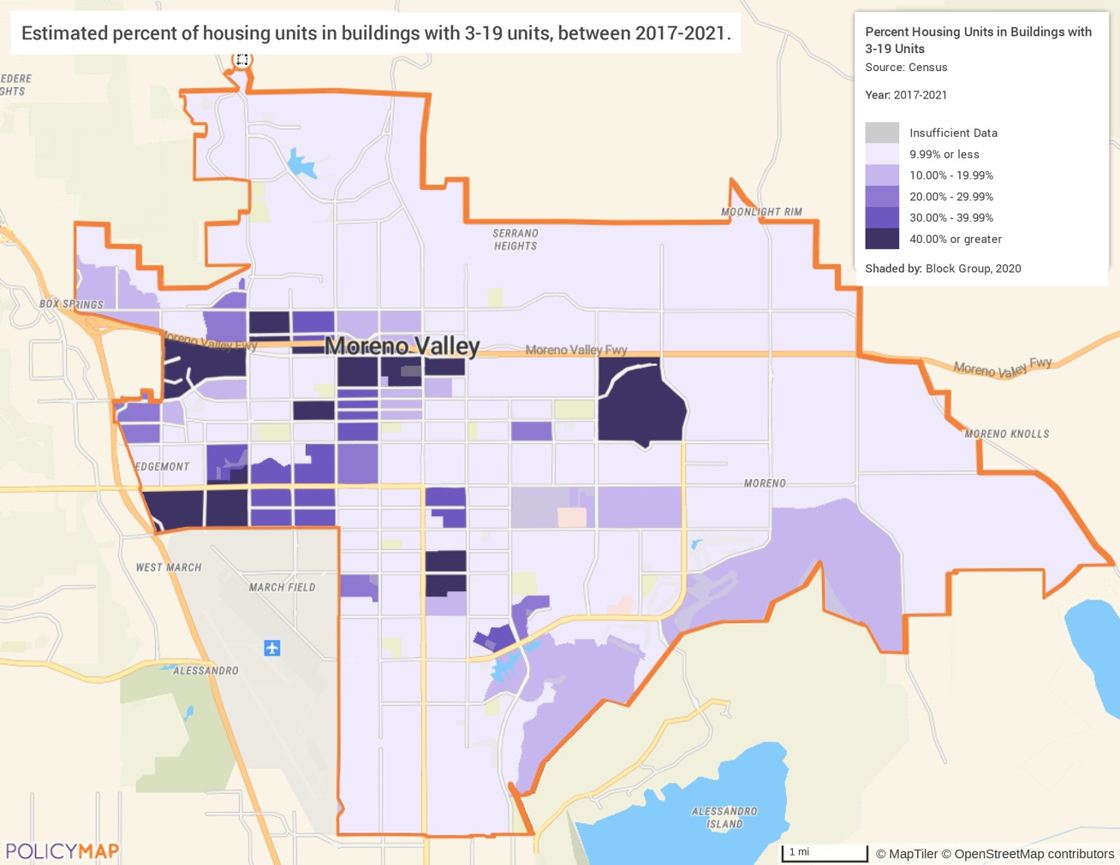
Source: ACS 2017-2021 via PolicyMap

Medium multifamily developments have between 20 and 49 units per development. Like small multifamily developments, medium developments are found primarily on the western side of the city, but they are significantly less common. There are virtually no units in medium structures on the east side of the city.
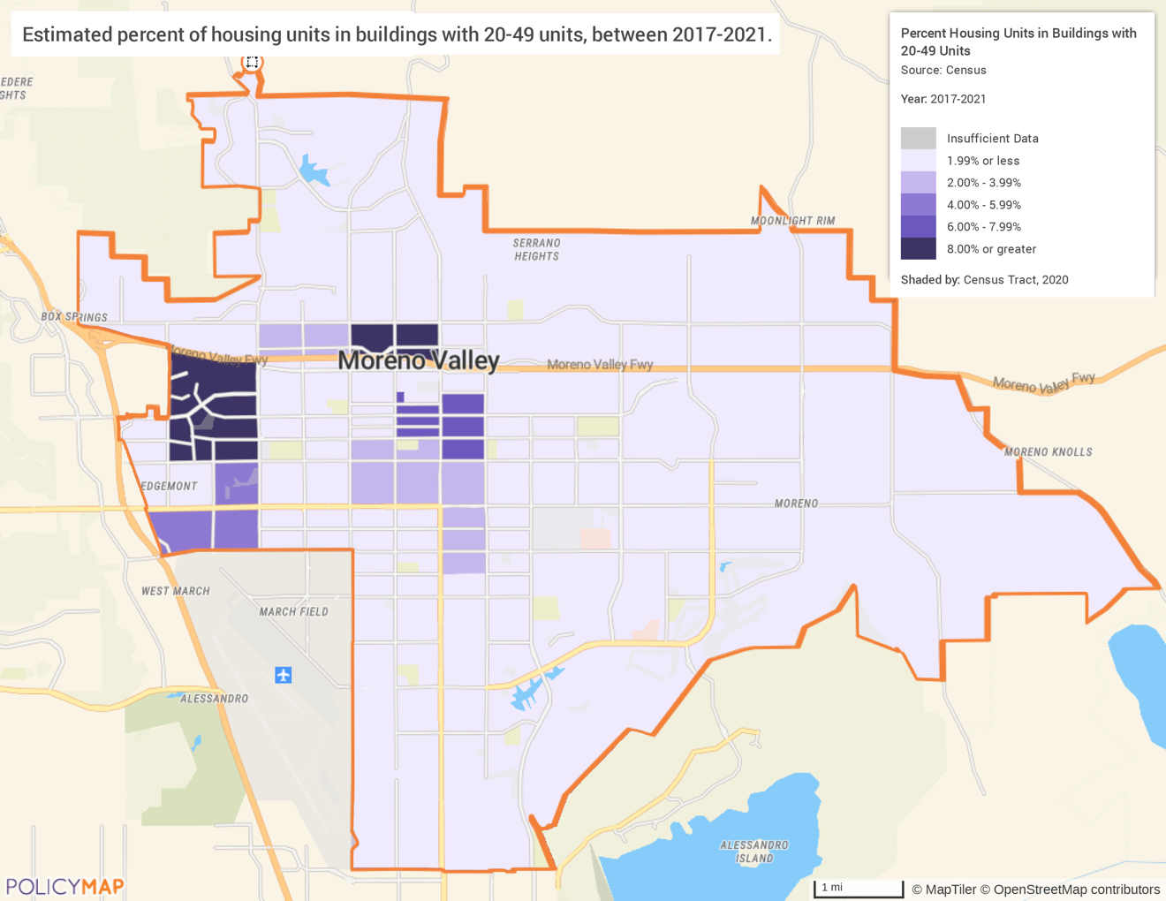
Source: ACS 2017-2021 via PolicyMap

Large multifamily developments are buildings with 50 or more units and have a similar distribution pattern as medium and small developments. However, they appear to be more common than medium multifamily structures, which include units outside of the more urbanized area.
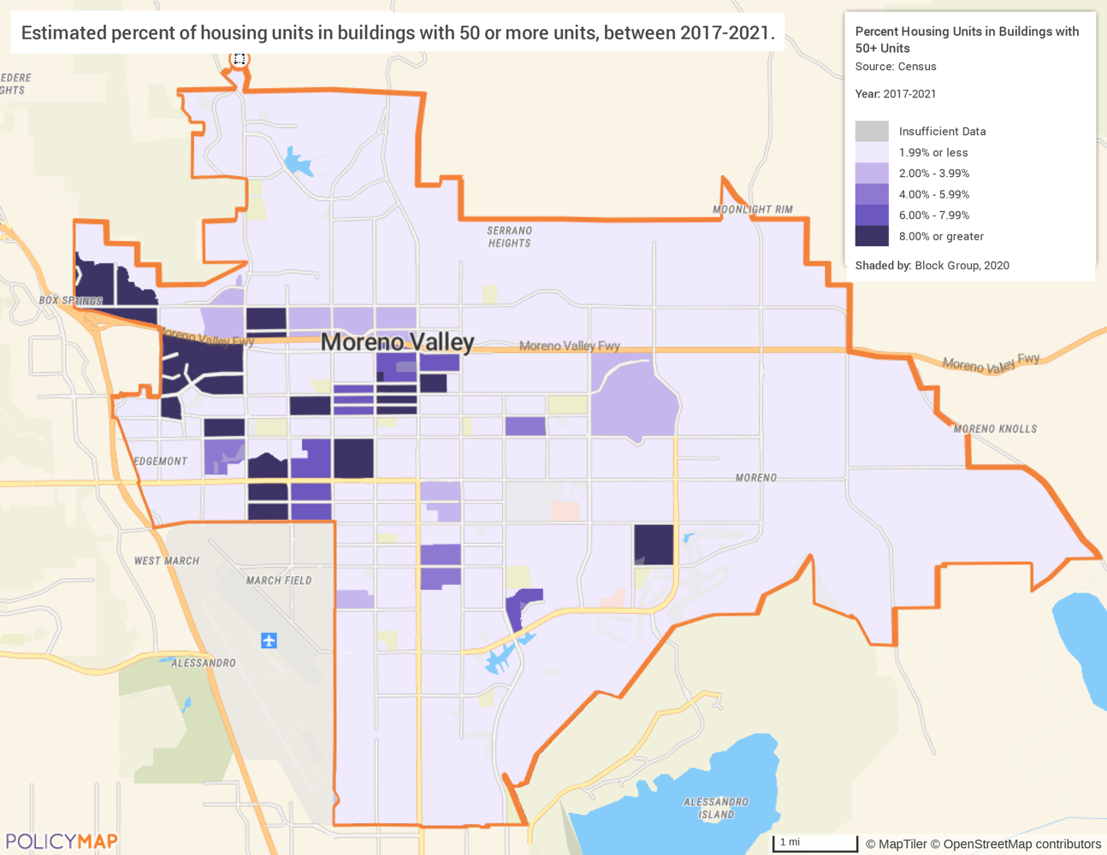
Source: ACS 2017-2021 via PolicyMap

Unit Size by Tenure
 | Owners |  | Renters
 | Number | % | Number | %
No bedroom | 182 | 1% | 339 | 2%
1 bedroom | 82 | 0% | 2,457 | 12%
2 bedrooms | 2,874 | 9% | 6,247 | 31%
3 or more bedrooms | 29,839 | 90% | 11,115 | 55%
Total | 32,977 | 100% | 20,158 | 100%
Table 29 – Unit Size by Tenure
Data Source: | 2017-2021 ACS

The size of housing units is generally linked to whether it is owner-occupied, or renter occupied. Owner-occupied units tend to be larger than rental units. Less than 2% of owner-occupied units have one bedroom or less, while 14% of renter-occupied units are that size. Conversely, about 90 % of owner-occupied units have three bedrooms or more, while only 55% of rental units are this large.

Describe the number and targeting (income level/type of family served) of units assisted with federal, state, and local programs.
The city has identified low-income households as being in need of support. They plan to fund an owner-occupied housing rehabilitation program for low-income residents. The goal of this program is to ensure secure housing for all extremely low-income families.
The city currently has over 1,200 affordable developments that are targeted toward low- and moderate-income households, including Housing Choice Vouchers, multifamily developments, and LIHTC Developments. The city has partnered with multiple developers to invest in construction and rehabilitation of affordable units to ensure that LMI households have adequate housing.
Additionally, the city ran an emergency rental assistance program called MoVal Rental Rescue. This program targeted low- and extremely-low-income households who were at risk of eviction and homelessness by providing rental assistance for arrears and three months of forward rent. The intention was to keep households stably housed.
Provide an assessment of units expected to be lost from the affordable housing inventory for any reason, such as expiration of Section 8 contracts.
According to the HUD Multifamily Assistance and Section 8 Database, there are three developments with contracts in the city. Of these developments, two have expiring contracts in the next five years. These developments account for 92 units of affordable housing.
According to the city’s 2021 - 2029 Housing Element, Moreno Valley does not have units at risk of conversion within the next ten years. However, the affordability covenants of the 25 units in two rehabilitated developments (The Mediterranean at Towngate and Walker Terrace) are set to expire within five to ten years. The city plans to enact a program to purchase affordability covenants on existing multifamily units in partnership with a local agency to maintain the city’s affordable housing inventory.
Does the availability of housing units meet the needs of the population?
While the availability of housing meets a variety of needs in terms of size of units, there continues to be increased need for more affordable units. As mentioned in the Needs Assessment, cost burden is the most common housing problem for residents of the city, affecting both renters and homeowners. Residents cannot find housing units that are the size and price that meet their needs. Renters are particularly likely to be cost burdened. Overall, there is a need for increased supply of affordable rental and owner-occupied housing.
Describe the need for specific types of housing.
The city has a very limited supply of smaller owner-occupied units with fewer than two bedrooms. Smaller units tend to be more affordable and attractive to new homeowners or retired residents who are looking to downsize. If these units are not available, then residents have no choice but to move outside of the city or live in substandard housing. There is also a lack of small and medium sized rental units, particularly on the east side of city. Small families and individuals who live alone have fewer housing options which may lead to living in substandard housing or being severely cost burdened.
Describe the need for specific types of housing for special needs groups.
The gap in the supply of smaller rental units is particularly challenging for elderly and disabled residents. According to the city’s 2020 Analysis of Impediments to Fair Housing Choice (AI), almost one in every four households in Moreno Valley includes a family member with one or more disabilities. Ninety-six percent of disabled residents live in a housing unit that does not meet their accessibility and support needs. While the Housing Authority of the County of Riverside provides Housing Choice Vouchers to disabled residents (including listings of accessible units and supportive services), it can still often be a challenge for disabled residents to find available housing units that meet their needs.

MA-15 Housing Market Analysis: Cost of Housing - 91.210(a)
Introduction
One of the most important factors in evaluating a community’s housing market is the cost of housing and, more importantly, whether the housing is affordable to households who live there or would like to live there. Housing costs correlate to the housing problems in a community. If housing costs are relatively high in comparison to household income, a correspondingly high rate of housing cost burden and overcrowding could result. The following section examines the cost of housing for both homeowners and renters. A review is made of current home values and rents as well as the recent changes in home values and rents. Finally, a closer look is given to the affordability of the existing housing stock for the residents of the jurisdiction.

Cost of Housing
 | Base Year: 2009 | Most Recent Year: 2017 | % Change
Median Home Value | 194,700 | 353,400 | 81.5%
Median Contract Rent | 1,128 | 1,510 | 33.9%
Table 30 – Cost of Housing

Data Source: | 2008-2012 ACS, 2017-2021 ACS

Rent Paid | Number | %
Less than $500 | 406 | 2%
$500-999 | 1,645 | 8%
$1,000-1,499 | 4,273 | 21%
$1,500-1,999 | 8,552 | 43%
$2,000 or more | 5,032 | 25%
Total | 19,908 | 100%
Table 31 - Rent Paid
Data Source: | 2017-2021 ACS

Housing Costs
Since 2010, the median home value has increased by 81.5% and rent has increased by 33.9% in nominal dollars. When housing costs from 2010 are compared to 2021 using inflation adjusted dollars (real dollars), the analysis changes slightly. The median home value increased by 33.5% instead of 81.5% and median contract rent increased by 11% instead of 33.9%. As noted in NA-10, the median income in the city grew by 23% during this period. That means that rental units have generally become more affordable for a household with median income, but home ownership continues to be more difficult.
Table Rent Paid breaks down the number of households and the amount they are paying in rent. Approximately 43% of renters are paying $1,500 to $1,999, making this the largest price cohort. The smallest group is households that pay less than $500 per month (2%). Later in this section rental rates will be looked at more closely.
Home Value
The map below shows the median home value by block group throughout the city. Higher home values are primarily found in the eastern and northern portions of the city. Earlier in the plan it was noted that these areas had low concentration of multiunit developments. Considering standard urban growth patterns, it is not unexpected that the high value areas include newer and larger single-family homes.
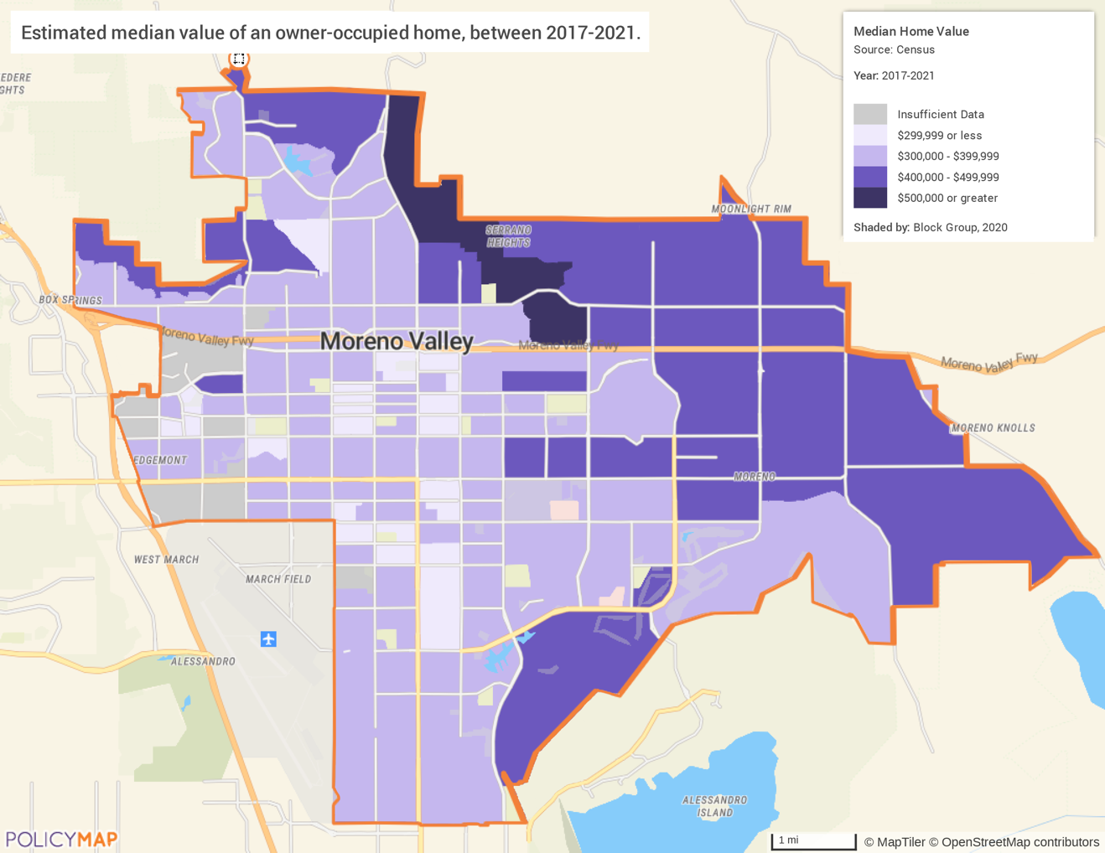
Source: ACS 2017-2021 via PolicyMap

Median Rent
The map below displays the median rent by block group, and a distribution that is similar to those of home values. There is no clear area with a concentration of high rent census tracts, though the city center appears to have generally lower rents.
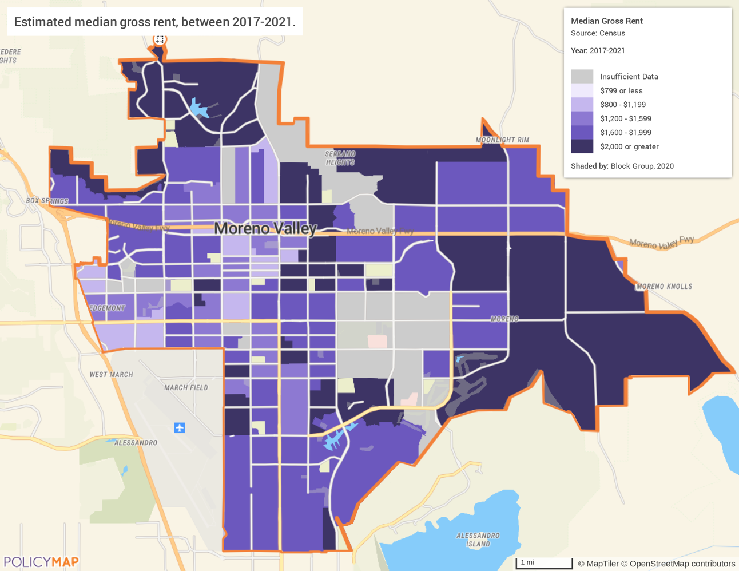
Source: ACS 2017-2021 via PolicyMap

Housing Affordability
% Units affordable to Households earning | Renter | Owner
30% HAMFI | 465 | No Data
50% HAMFI | 1,140 | 520
80% HAMFI | 6,165 | 3,445
100% HAMFI | No Data | 7,079
Total | 7,770 | 11,044
Table 32 – Housing Affordability
Data Source: | 2013-2017 CHAS

Supplemental Data for Housing Affordability below:
 | Owner | Estimate | Renter | Estimate
Less than $20,000 | 1,887 | 6% | 2,067 | 10%
$20,000 to $34,999 | 1,895 | 6% | 2,280 | 11%
$35,000 to $49,999 | 3,185 | 10% | 2,858 | 14%
$50,000 to $74,999 | 5,785 | 17% | 4,905 | 23%
$75,000 or more | 20,217 | 61% | 8,321 | 40%
Total | 33,152 | 100% | 20,952 | 100%
Zero, negative or no cash (for renters), not computed | 183 | -- | 521 | --
Table 33 - Household Income by Tenure
Data Source: | 2015-2019 ACS (B25106)

Monthly Rent
Monthly Rent ($) | Efficiency (no bedroom) | 1 Bedroom | 2 Bedroom | 3 Bedroom | 4 Bedroom
Fair Market Rent | $955 | $1,106 | $1,390 | $1,917 | $2,369
High HOME Rent | $879 | $943 | $1,134 | $1,302 | $1,433
Low HOME Rent | $691 | $740 | $888 | $1,027 | $1,146
Table 34 – Monthly Rent
Data Source: | HUD 2021 FMR and HOME Rents

HOME Rents Limits and Fair Market Rents (FMR)
The tables above compare the 2021 Fair Market Rents (FMR) to the 2021 HOME program rent limits for the Riverside-San Bernardino-Ontario MSA, which includes Moreno Valley. FMRs are set by HUD and used to determine payment standard amounts for HUD Programs. HUD annually estimates FMRs for the Office of Management and Budget (OMB) defined metropolitan areas, some HUD defined subdivisions of OMB metropolitan areas, and each nonmetropolitan county. HOME Rent Limits are based on the FMRs published by HUD. HOME Rent Limits are the maximum amount that may be charged for rent in HOME-assisted rental units and are applicable to new HOME leases.
Is there sufficient housing for households at all income levels?
According to 2017-2021 ACS data, the vacancy rate of Moreno Valley is 4.3%. This vacancy rate is significantly lower than the national average of 11.2%. Additional housing stock is needed for all income levels. Low- and moderate-income households are especially in need of additional affordable housing. As rent and home values increase more quickly than incomes, housing costs exceed what is affordable to many of these households.

How is affordability of housing likely to change considering changes to home values and/or rents?
It is difficult to project exactly how housing affordability will change, but it is likely that the affordability of housing will continue to decrease. As home values increase, the rental market will become more competitive due to less households having the ability to purchase a home. The increased competition will continue to increase rental prices. In addition to this, the low vacancy rates and growing population will contribute to the competition and rising prices; low- and moderate-income households will likely have fewer affordable options.
How do HOME rents / Fair Market Rent compare to Area Median Rent? How might this impact your strategy to produce or preserve affordable housing?
The area median rent is $1,510, which is in between the FMR for a two bedroom and a three bedroom. The median rent exceeds both Low and High HOME Rents for all bedroom sizes. FMR significantly increases for three- and four-bedroom sizes. The city will take these items into consideration when determining the appropriate size and pricing for the development of affordable units. Subsidies will likely be necessary to produce housing affordable to extremely low- and low-income households. HOME funds often need to be combined with other state and federal resources to facilitate the production of affordable rental housing.

MA-20 Housing Market Analysis: Condition of Housing – 91.210(a)
Introduction
The tables and maps in this section provide details on the condition of housing units throughout the region by looking at factors such as age, vacancy, and the prevalence of housing problems.

As defined by HUD, the four housing problems are:
1) a home which lacks complete or adequate kitchen facilities
2) a home which lacks complete or adequate plumbing facilities
3) a home which is overcrowded (having more than one person per room)
4) a household that is cost burdened (paying 30% or more of their income towards housing costs)
It is important to recognize that safe and secure housing is more than just an available physical space. The quality of the space and its ability to meet the needs of the residents is vital to housing security.

Definitions
For the purposes of this plan, units are in “standard condition” when the unit complies with the local building code, and the California Building Code, which is based on the International Building Code.
The definition of substandard housing is a housing unit with one or more serious code violations. For the purposes of this analysis the lack of a complete plumbing or a complete kitchen will also serve as an indicator of substandard housing.
Units are in “substandard condition but suitable for rehabilitation” when the unit is out of compliance with one or more code violations, and it is both financially and structurally feasible to rehabilitate the unit.
Condition of Units
Condition of Units | Owner-Occupied |  | Renter-Occupied
Condition of Units | Number | % | Number | %
With one selected Condition | 11,456 | 35% | 11,233 | 56%
With two selected Conditions | 827 | 3% | 2,080 | 10%
With three selected Conditions | 10 | 0% | 24 | 0%
With four selected Conditions | 0 | 0% | 0 | 0%
No selected Conditions | 20,684 | 63% | 6,821 | 34%
Total | 32,977 | 100% | 20,158 | 100%
Table 35 - Condition of Units
Data Source: | 2013-2017 ACS

Housing Conditions
The table above details the number of owner and renter households that have at least one housing condition. Thirty-five percent of all owner-occupied housing units face at least one housing condition, while 56% of all renters have at least one housing condition. Generally, there are relatively few households with multiple housing problems and when compared to the affordability statistics provided earlier in the plan, the overwhelming majority of housing problems are housing cost burden. However, it should be noted that approximately 10% of renters have two housing problems.

Year Unit Built
Year Unit Built | Owner-Occupied |  | Renter-Occupied
Year Unit Built | Number | % | Number | %
2000 or later | 7,855 | 24% | 5507 | 27%
1980-1999 | 19,396 | 59% | 9,677 | 48%
1950-1979 | 5,305 | 16% | 4,294 | 21%
Before 1950 | 421 | 1% | 680 | 3%
Total | 32,977 | 100% | 20158 | 100%
Table 36 – Year Unit Built
Data Source: | 2017-2021 CHAS

In Moreno Valley, the housing stock is relatively new. Approximately 17% of owner-occupied units and 24% of rental units were built prior to 1980. These homes have a risk of lead-based paint and may require additional support to ensure a safe living environment, particularly for children. This amounts to over 10,000 units total, most of which are owner-occupied.

Age of Housing

The maps below depict the prevalence of older housing units in the jurisdiction. The first map identifies the percentage of all housing units built prior to 1940. As noted above, the housing stock is relatively new in the area. There are two areas that stand out with a relatively older housing stock. The first is west of Elsworth Street near I-215 between Alessandro Blvd and Eucalyptus Avenue. The second area is towards the east between Alessandro Blvd to the south, Cottonwood Avenue to the north, Moreno Beach Drive to the east and Lasselle Street to the west.
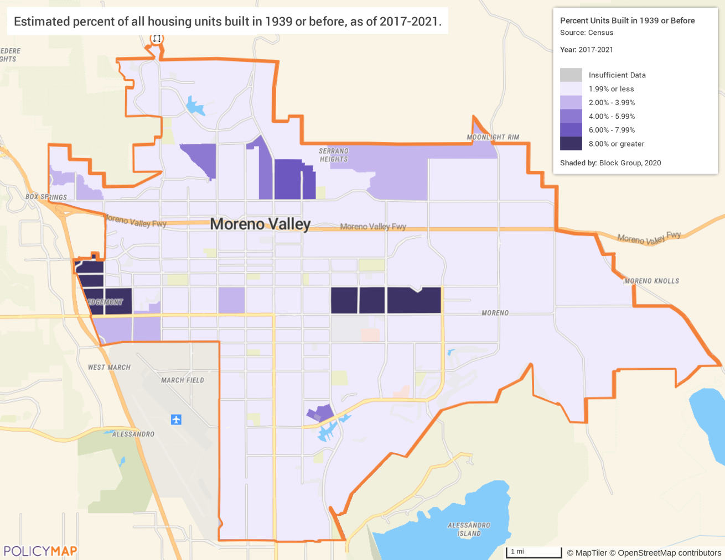
Source: ACS 2017-2021 via PolicyMap

In the following map the distribution of homes built prior to 1980 is shown. Areas in the west and northern portion of the city have tracts with a relatively large number of units built prior to 1980, sometimes over 80%. Due to the age of the units many units in those tracts have a risk of lead-based paint hazard.
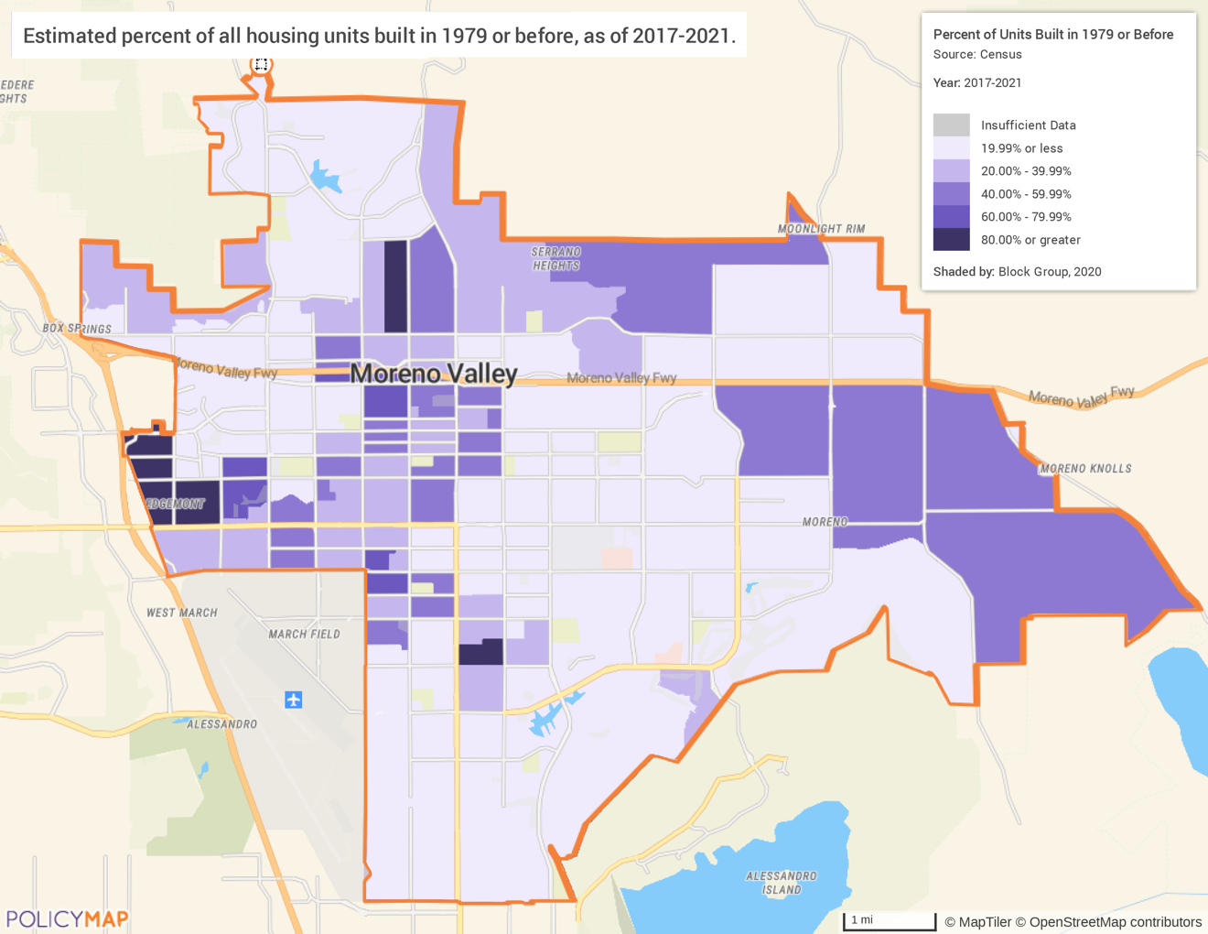
Source: ACS 2017-2021 via PolicyMap

Risk of Lead-Based Paint Hazard
Risk of Lead-Based Paint Hazard | Owner-Occupied |  | Renter-Occupied
Risk of Lead-Based Paint Hazard | Number | % | Number | %
Total Number of Units Built Before 1980 | 5,070 | 16% | 4,595 | 23%

Housing Units build before 1980 with children present | 10,905 | 35% | 5,945 | 30%
Table 37 – Risk of Lead-Based Paint
Data Source: | 2013-2017 ACS (Total Units) 2013-2017 CHAS (Units with Children present)

Lead-Based Paint Hazard
As mentioned previously, any housing unit built prior to 1980 may contain lead-based paint in portions of the home. The most common locations are window and door frames, walls, and ceilings, and in some cases throughout the entire home. Thus, it is generally accepted that these homes at least have a risk of lead-based paint hazards and should be tested in accordance with HUD standards. According to the most recent CHAS data, there are approximately 16,850 units with both a lead-based paint hazard and children present.

Vacant Units
 | Suitable for Rehabilitation | Not Suitable for Rehabilitation | Total
Vacant Units | 2,397 | 0 | 2,397
Abandoned Vacant Units | 0 | 0 | 0
REO Properties | 0 | 0 | 0
Abandoned REO Properties | 0 | 0 | 0
Table 38 - Vacant Units
Alternate Data Source Name: 2017-2021 ACS
Data Source Comments: Moreno Valley does not have data for specific types of vacant units in the city, and ACS data only reports on the total number of vacant units. Data does not distinguish between suitable or nor suitable for rehab or if they were abandoned, Real Estate Owned (REO) properties or abandoned REO properties

Vacancy Rate
There are currently nearly 2,400 vacant units in the area that are suitable for rehabilitation. These units provide an opportunity to create affordable housing units for LMI households. However, it is important to note that HUD considers a unit vacant for several reasons, including units that are used seasonally and not available for occupancy. There are approximately 400 units vacant due to seasonal use and another 663 units that were vacant for other reasons and are not available for rent or sale. The following map shows that vacancy rates are not uniform throughout the city. Rates range from less than 5% to over 20%, depending on the neighborhood.
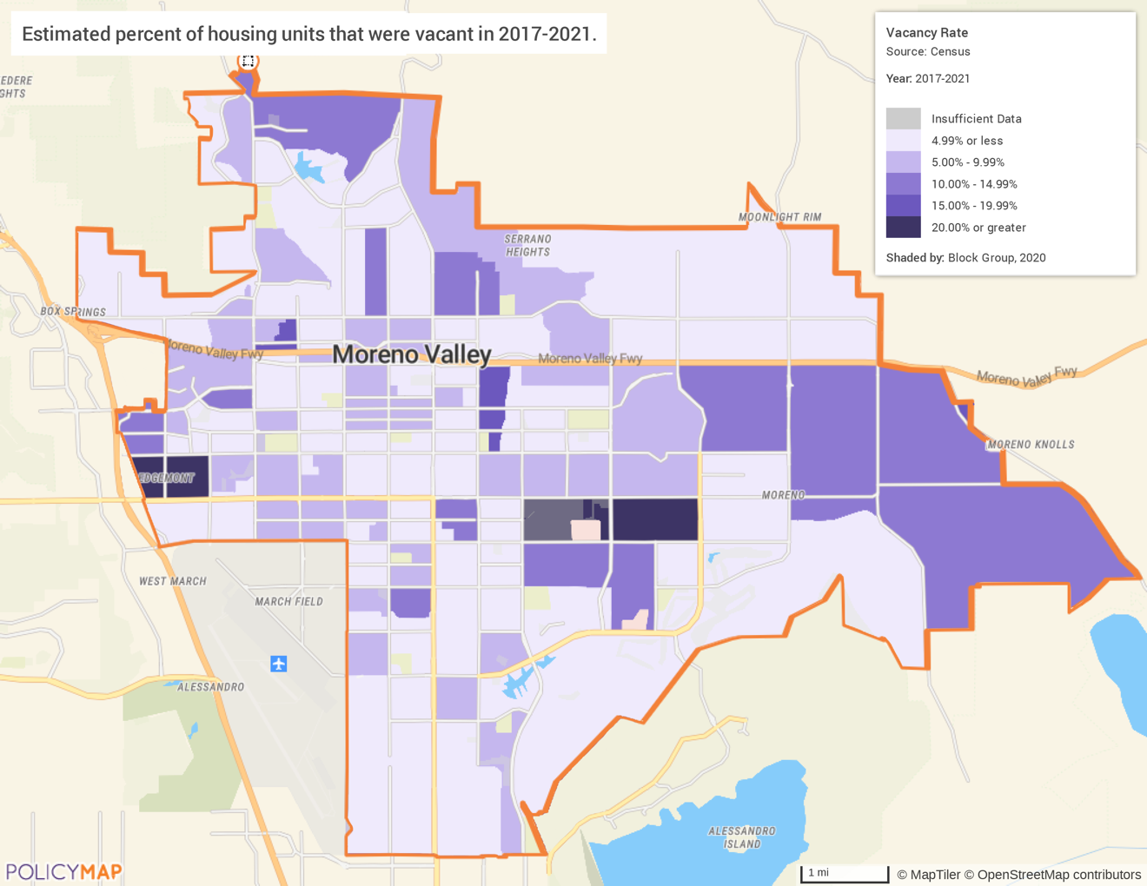
Source: ACS 2017-2021 via PolicyMap

Need for Owner and Rental Rehabilitation
Within the city’s jurisdiction there is a continued need for rehabilitation for both homeowners and renters. There are 10,000 homes built prior to 1980 that have a potential lead-based paint hazard. This is a large concern for low-income households that may lack the resources to properly rehabilitate their homes to address the presence of lead-based paint.
Estimated Number of Housing Units Occupied by Low- or Moderate-Income Families with LBP Hazards.
To estimate the number of housing units in the jurisdiction by low- or moderate-income families that may contain lead-based paint hazards, this report assumes that homes by year built are distributed evenly across income categories, as no local data exists to describe otherwise. There are approximately 10,000 units built prior to 1980 and approximately 5,750 have LMI households in them.

MA-25 Public and Assisted Housing – 91.210(b)
Introduction
The City of Moreno Valley does not have a designated Public Housing Authority. Therefore, the city does not own or manage any housing directly or directly operate any voucher programs. However, the Housing Authority of the County of Riverside (HACR) operates as the public housing authority for all Riverside County. The HACR administers Housing Choice Vouchers and public housing units. Additionally, the city has invested housing funds into the construction and rehabilitation of affordable multi-family rental projects in partnership with developers throughout the city. In return, the project owners provide discounted, below-market rents to income-qualified tenants during the term of their agreements with the city. Units in development priced at a “below market rate” are made affordable to varied incomes ranging from very-low- to moderate- income households (30% -120% AMI). Each project has a specific number of units reserved at below market rates, as well as specific income requirements for the units. The city does not own or manage any housing directly.
Totals Number of Units
Program Type
 | Certificate | Mod-Rehab | Public Housing | Vouchers
 |  |  |  | Total | Project -based | Tenant -based | Special Purpose Voucher
 |  |  |  |  |  |  | Veterans Affairs Supportive Housing | Family Unification Program | Disabled  *
# of units vouchers available | 0 | 77 | 469 | 8,681 | 48 | 8,633 | 819 | 1,759 | 342
# of accessible units |  |  | 2

*includes Non-Elderly Disabled, Mainstream One-Year, Mainstream Five-year, and Nursing Home Transition
Table 39 – Total Number of Units by Program Type
Data Source: | PIC (PIH Information Center)

Describe the supply of public housing developments.
According to the HACR, there are currently 469 public housing units available in the city. The HACR also administers approximately 8,680 Housing Choice Vouchers to Moreno Valley Residents, including 819 veteran’s affairs supportive housing (VASH) vouchers, and 1,759 Family Unification Vouchers. Each resource currently has a waiting list of residents in need.
Describe the number and physical condition of public housing units in the jurisdiction, including those that are participating in an approved Public Housing Agency Plan.
There are currently no public housing developments in the City of Moreno Valley.

Public Housing Condition
Public Housing Development | Average Inspection Score
N/A | N/A
Table 40 - Public Housing Condition

Describe the restoration and revitalization needs of public housing units in the jurisdiction.
Not applicable; there are currently no public housing developments in the City of Moreno Valley.
Describe the public housing agency's strategy for improving the living environment of low- and moderate-income families residing in public housing.
The mission of the HACR is “to transform and promote healthy, thriving communities, re-ignite hope and restore human dignity through the creation and preservation of high quality and innovative housing and community development programs which enhance the quality of life and revitalize neighborhoods to foster self-sufficiency.” The HACR’s strategy for carrying out this mission is through the following goals:
- Expanding the supply of assisted housing though an increase in vouchers and rehab/construction of affordable units.
- Improving the quality of assisted housing through HQS inspections and increased customer service.
- Increasing assisted housing choice through landlord outreach, replacement vouchers, and expansion of the Family Self-Sufficiency Program (FSS).
- Promoting self-sufficiency within existing programs through FSS, employment programs, and supportive services.
- Ensuring equal opportunity and affirmatively furthering fair housing.
Discussion.
No further discussion.

MA-30 Homeless Facilities and Services – 91.210(c)
Introduction
The following section provides a discussion and analysis of homeless facilities and services that are available to those who are in need in the community. The city has approximately 12 year-round emergency shelter beds, 12 transitional housing beds, and 70 Permanent Supportive Housing beds. One of the city’s highest priorities for the use of CDBG and ESG funds is to address the emergency shelter and housing needs of homeless persons. The city will continue to fund applications for homeless shelters that serve the Moreno Valley homeless population. In addition to beds, supportive services are an essential part of the service delivery system.
Facilities and Housing Targeted to Homeless Households
 | Emergency Shelter Beds |  | Transitional Housing Beds | Permanent Supportive Housing Beds
 | Year-Round Beds (Current & New) | Voucher / Seasonal / Overflow Beds | Current & New | Current & New | Under Development
Households with Adult(s) and Child(ren) | 0 | 0 | 12 | 18 | 0
Households with Only Adults | 12 | 0 | 12 | 52 | 0
Chronically Homeless Households | 0 | 0 | 0 | 29 | 0
Veterans |  | 12 | 12 | 0 | 0
Unaccompanied Youth | 0 | 0 | 0 | 0 | 0
Table 41 - Facilities and Housing Targeted to Homeless Households

Alternate Data Source Name: 2022 PIT Count

Describe mainstream services, such as health, mental health, and employment services to the extent those services are used to complement services targeted to homeless persons.
The Riverside County Housing and Workforce Solutions (HWS) Department facilitates the Continuum of Care (CoC) as the Collaborative Applicant and lead agency. It oversees the community's plan to organize and deliver supportive social services and maintains and establishes partnerships to leverage community stakeholders, agencies, businesses, and non-profit partners.
Many local agencies and organizations offer mainstream services to help close the gaps of homelessness through the local, state, and private funding streams. CoC providers and community stakeholders can leverage federal funding sources in partnership with agencies like the Riverside County University Health System-Behavioral Health, Housing Authority of the County of Riverside (HACR), Veterans Administration, and the DPSS Self Sufficiency programs. Mainstream benefits are made accessible to qualifying clients through the CoC program housing providers, local non-profit organizations, agencies, and educational institutions which collaborate and work on creating accessibility to homeless emergency services for homeless families and individuals.
Other mainstream services available in the city include:
- CalWORKs: Funds are available to families on public assistance to provide rent and utility payments, which are funded through Temporary Assistance for Needy Families (TANF).
- Riverside County Workforce Development Center: helps job seekers access employment, education, training, and support services to succeed in the labor market and match employers with the skilled workers they need through the Riverside County Workforce Development Centers.
- Moreno Valley Employment Resource Center: The city partners with Riverside County to operate the Business & Employment Resource Center that provides job training, placement services, and job search assistance.
- Riverside County Department of Public Social Services: Provides assistance to individuals and families needing senior services, physical health, behavioral health, dentistry services, and public health.
List and describe services and facilities that meet the needs of homeless persons, particularly chronically homeless individuals and families, families with children, veterans and their families, and unaccompanied youth.
The Housing First approach adopted by the Continuum of Care (CoC) requires that homeless people are assisted with permanent housing or rapid re-housing as soon as possible. Transitional housing beds have been decreasing in the county and permanent housing is increasing due to reallocations made in the HUD CoC Program Consolidated Application, and the CoC’s success in obtaining additional funding for Permanent Supportive Housing.
Both transitional housing programs and emergency shelters focus on decreasing a homeless person’s or family’s length of time homeless (LOTH) in the shelter by getting them quickly stabilized into permanent housing and providing support through intensive case management as they transition out of homelessness.
The CoC works with the Economic Development Agency (EDA) and other public funding agencies to integrate the CoC Programs, Emergency Solutions Grant, Social Services to Veteran Families (SSVF), and CDBG funding to increase the number of families with children who are assisted through rapid re-housing. Service providers that serve homeless persons in Moreno Valley are listed below:
Path of Life Ministries offers an emergency shelter program to individuals and families in a housing crisis. The Community Shelter provides 90 beds to men and women, and the Family Shelter provides 46 beds to families with children. Shelter guests are provided with wraparound stabilization services including employment support and housing referrals that foster self-sufficiency and family restoration.
LightHouse Social Service Centers operates a Veterans Transitional Living Program that provides comprehensive transitional living services to male veterans ages 18 years and up, in a drug and alcohol free, peer oriented, supportive environment. Transitional living services can be provided to 12 veterans at any given time.
March Veterans Village, a community dedicated to supporting low-income veterans and their families with affordable housing and supportive services, is conveniently located next to March Air Reserve Base in Riverside County. March Veterans Village consists of 7 apartment buildings that are home to more than 400 veterans and their families, including 138 units of permanent supportive housing.
Operation SafeHouse is a 24-hour emergency shelter whose mission is to serve runaway, homeless, and at-risk youth ages 11 – 17 in Riverside County. Services include up to 3 weeks of emergency shelter, nutritious meals, counseling, attempts at family reunification, on-site education program, aftercare, and a 24-hour toll-free crisis line. The organization also has a Main Street Housing Program that offers a unique program consisting of Transitional Living for homeless young adults in Riverside County between 18-21 years of age. Participants are aided in developing the life skills needed to live independent lives.
Saving Grace Homes Sober Living Transitional Home in Moreno Valley is a Faith based sober living home for men in recovery from alcohol and drug addiction. It provides its residents with a safe, supportive environment, a clean and positive living experience based on sobriety and a new way of living without the use of drugs or alcohol.
Immanuel House Transitional Housing Program is a full-service structured 6-month re-entry program for the lifer and long-term parolee population. The program facility has space for 15 participants with 24-hour staffing. Services provided include one-on-one case management, external resource linkage, family reintegration support, peer-led support groups, social security assistance, ID and driver’s license services, appointment help, vocational training services, and job development and referrals.

MA-35 Special Needs Facilities and Services – 91.210(d)
Introduction
The following section discusses the resources available to the populations identified in NA-45. In the city, a significant effort has been made to ensure that these populations have access to the resources they need. A variety of facilities and services targeting persons with special needs are available in Moreno Valley. In particular, the city works with medical facilities, agencies, and non-profit service providers to efficiently allocate resources. Health specific services such as free or reduced-price clinics, and educational programs provide health access to low-income residents and those without healthcare.

Including the elderly, frail elderly, persons with disabilities (mental, physical, developmental), persons with alcohol or other drug addictions, persons with HIV/AIDS and their families, public housing residents and any other categories the jurisdiction may specify and describe their supportive housing needs.
Elderly and Frail Elderly: The supportive housing needs for this population can vary widely depending on the health and fitness of the individuals. Generally, with aging, disabilities and other health issues become more common. Because of this, supportive housing must include access to health professionals and housing modifications to assist the resident. It is important to help residents stay independent and in their own homes for as long as possible if they prefer that. The city has a Senior Citizens' Advisory Board that assists in identifying and finding support for these needs. Seniors that participated in the 2020-2024 Area Plan on Aging Needs Assessment process for Moreno Valley indicated that their top needs for assistance were meal preparation, transportation, and housework. The city helps fund various nonprofits to help address these needs, including Family Services Association and More Than A Meal. The city also offers health classes for seniors, low-cost lunch, and low-cost transportation and other programs for seniors. There are 220 Senior Living options in the Moreno Valley area, with 15 in the City of Moreno Valley.
HIV/AIDS: Medical and social support is important for residents living with HIV/AIDS. While there have been great advances in the medical treatment of HIV/AIDS, it is still important to provide specialized support. Family and friends must be accessible and medical facilities should be nearby. However, data in the Needs Assessment shows that there is still an ongoing need in the region for support, to include live-in medical facilities, and housing sites developed exclusively for people living with HIV/AIDS.
Alcohol and/or Drug Addiction: Individuals dealing with addiction often require housing options that will provide a safe and sober place for recovery. A strong network is necessary to maximize the chance they will stay healthy and sober. It is important that these persons have access to health services, support groups, employment assistance, and access to family and friends. There is also a need for sober emergency shelter facilities and emergency staff that is knowledgeable about the best way to support residents with addiction. Additionally, detoxification facilities are necessary when addiction is first recognized.
Mental and Physical Disabilities: Individuals with disabilities encompass a wide range of skill levels and abilities. Therefore, they have many of the same issues as the general population with the added needs that are unique to their situation. Often, individuals with disabilities have a fixed income and limited housing options. Individuals with more independent skills can utilize subsidized housing but individuals that need more support or specialized housing have fewer options. Many individuals continue to reside with parents and families throughout adulthood, which can put additional financial burdens on the family. Natural disasters can be particularly difficult for residents with disabilities. It is important that emergency procedures and resources are available to ensure support, safe sheltering, and evacuation, if necessary. Regardless of the housing situation, a common thread is the need for continuous supportive services that vary based on level of capabilities.
Describe programs for ensuring that persons returning from mental and physical health institutions receive appropriate supportive housing.
As part of the city’s involvement with the Continuum of Care, a Discharge Planning Policy was established to ensure that all appropriate local and State government entities that discharge persons from publicly funded institutions or systems of care participate in the Discharge Planning Policy. The Policy strengthens discharge planning with major institutions to limit the number of chronically homeless persons discharged into homelessness and connects the homeless and those persons threatened with homelessness with supportive housing and community‐based resources upon discharge. The overall objective of the Discharge Coordination Policy and Practices is to reduce the number of persons being released and discharged into homeless shelters, unsuitable accommodations, or homelessness.
Specify the activities that the jurisdiction plans to undertake during the next year to address the housing and supportive services needs identified in accordance with 91.215(e) with respect to persons who are not homeless but have other special needs.
The city has identified several activities that will be funded in the next year to support persons who are not homeless but have other special needs. Activities to be funded include:
Capital Improvement Activities
- Health, Safety, and Public Welfare Activities
- Homeless/Homeless Prevention Activities
- Housing and Neighborhood Improvement Activities
- Public Service Activities
  - Basic Needs Related to Social Services Programs (such as but not limited to emergency food, shelter (homelessness), and utility assistance)
- Community Public Safety Programs
- Capital Improvement Activities
- Fair Housing Activities
For entitlement/consortia grantees: Specify the activities that the jurisdiction plans to undertake during the next year to address the housing and supportive services needs identified in accordance with 91.215(e) with respect to persons who are not homeless but have other special needs. Link to one-year goals. (91.220(2)).
Not applicable.

MA-40 Barriers to Affordable Housing – 91.210(e)
Describe any negative effects of public policies on affordable housing and residential investment.
In 2023, the city completed an Analysis of Impediments to Fair Housing Choice (AI). During the production of this analysis the city identified several potential barriers to fair housing and affordable housing. The barriers to affordable housing are listed below. Further details are provided in the city’s AI.
- Lack of a Balanced Housing Stock.
- Need for Utilization of Bilingual Housing Materials.
- Rapid Increase in Home Prices and Cost Burdened Households.
- Reduction in Housing Funds.
- High Number of Cost Burdened Renters.
The City does not have growth limits, or policies and ordinances that regulate the number of housing units that can be constructed annually. The City does not have ordinances such as rent control that directly affect the residential investment rate of return. In affordable for‐sale and for‐rent projects, however, the City does enact controls to maintain affordability. For instance, in HOME‐assisted ownership projects the City implements a recapture policy.
Furthermore, tax policy affecting land and other property is governed by California state law. Property taxes are based on a property’s assessed value. State law mandates that all property is subject to taxation unless otherwise exempted. In general, properties that are owned and used by educational, charitable, religious, or government organizations may be exempt from certain property taxes. Housing for low-income households owned and operated by a qualifying nonprofit organization is eligible for exemption from property taxes.

MA-45 Non-Housing Community Development Assets – 91.215 (f)
Introduction
This section provides insight into the economic development landscape of the City of Moreno Valley. The table below details the extent of business sector employment throughout the city. Unemployment, commuting times, and education are also analyzed in this section.
Economic Development Market Analysis
This section provides insight into the non-housing assets within the community, with a focus on economic activity and education levels. These are used to identify areas of concern or sectors to reinforce support.

Business Activity
Business by Sector | Number of Workers | Number of Jobs | Share of Workers  % | Share of Jobs  % | Jobs less workers  %
Agriculture, Mining, Oil & Gas Extraction | 573 | 33 | 0 | 0 | 0
Arts, Entertainment, Accommodations | 8,102 | 4,645 | 9 | 11 | 2
Construction | 7,599 | 664 | 7 | 8 | 1
Education and Health Care Services | 18,924 | 15,278 | 19 | 39 | 20
Finance, Insurance, and Real Estate | 3,891 | 1,077 | 10 | 3 | -7
Information | 1,408 | 229 | 5 | 3 | -2
Manufacturing | 6,499 | 1,421 | 5 | 1 | -4
Other Services | 4,377 | 664 | 5 | 3 | -2
Professional, Scientific, Management Services | 7,327 | 3,190 | 14 | 8 | -6
Public Administration | 4,624 | 776 | 6 | 10 | 4
Retail Trade | 13,180 | 5,514 | 12 | 12 | 0
Transportation and Warehousing | 11,238 | 12,537 | 4 | 0 | -4
Wholesale Trade | 3,231 | 1,051 | 3 | 2 | -1
Total | 90,973 | 47,079 | -- | -- | --
Table 42 - Business Activity
Alternate Data Source Name: 2017-2021 ACS (Workers), 2019 LEHD (Jobs)
Data Source Comments: The Business Activity table above compares the number of workers to the number of jobs in the city. At this time, the most recent data set for the number of jobs was 2019 from the Longitudinal Employer-Household Dynamics (LEHD), US Census Bureau. Data from the 2017-2021 ACS 5-Year estimates was used for comparison.

Share of Workers and Jobs
In the above table the prevalence of both workers and jobs by sector is presented. There are nearly twice as many workers than jobs. There are nearly 44,000 more workers in the city. In addition to the discrepancy in raw numbers, there are significant gaps in specific sectors. Overall, there is a 160,000-job discrepancy. The largest gap is in the Retail Trade sector which has nearly 7,700 more workers than jobs. Transportation and Warehousing is the only sector with more jobs than workers.
Labor Force
Total Population in the Civilian Labor Force | 99,492
Civilian Employed Population 16 Years and Over | 91,490
Unemployment Rate | 3.7%
Unemployment Rate for Ages 16-24 | 18%
Unemployment Rate for Ages 25-65 | 7%
Table 43 - Labor Force
Data Source: 2017-2021 ACS
Data Source Comments: Unemployment Rate data is from the BLS, November 2022. All other labor force data is from the 2017-2021 ACS including unemployment rate by age.

Unemployment
There are two primary sources used to analyze the unemployment rate in the city for this report. They each have pros and cons, but when taken together they can provide a clearer view of unemployment in the city. The first source is the US Census Bureau’s American Community Survey 5-Estimates (ACS). In the ACS, unemployment data is only taken annually, and the most recent data is from 2021. It is also an average of the five years included, which does not necessarily provide an accurate view of recent employment trends. However, the ACS data is available at a block group level and can help identify any areas that have disproportionately high unemployment. The most recent unemployment rate is 3.7%, according to ACS. There is a large difference between the unemployment rate for eligible workers under the age of 25 and those between 25 and 65. The following map shows the difference in unemployment rates by block group. There is no clear pattern, but some tracts have an unemployment rate that is triple the rate in other block groups.
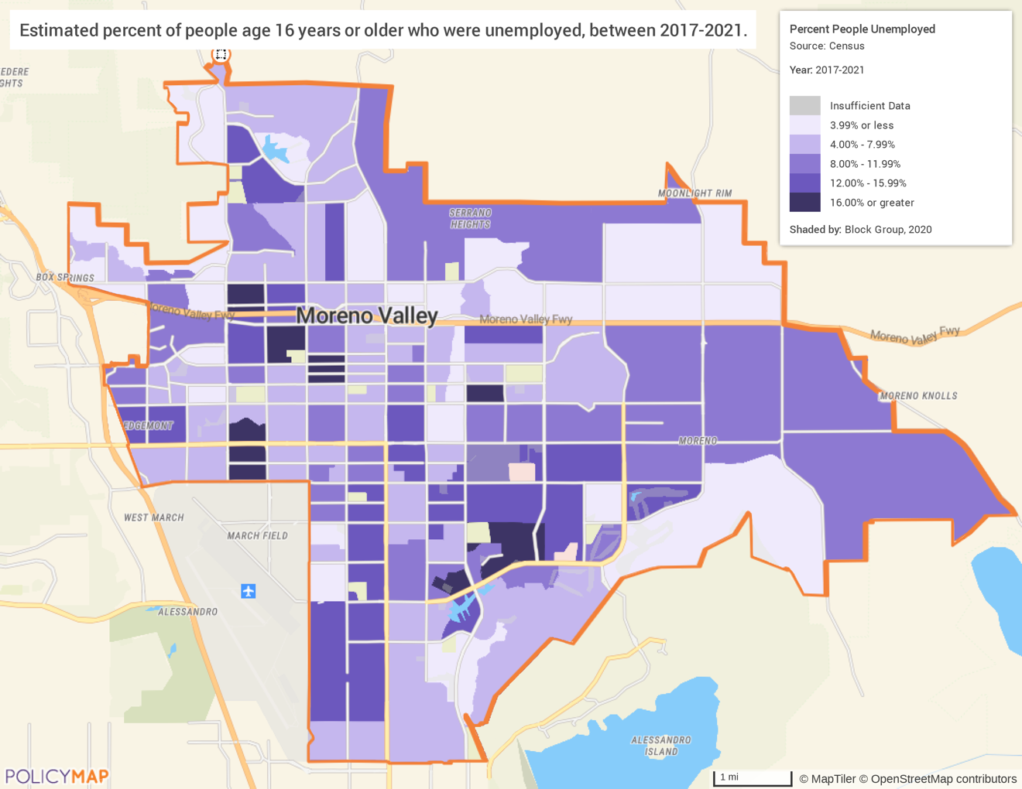
Source: ACS 2017-2021 via PolicyMap
The second source is the Bureau of Labor Statistics. This measurement of unemployment is updated monthly and provides insight into trends at the city level. It is not available at the census tract or block group level and therefore provides a look at employment as it relates to time, while the ACS looks at employment as it relates to space.
The tables below show that the unemployment rate in the city has steadily decreased over the last decade except for 2020 due to the impacts of the COVID-19 pandemic. Additionally, according to the monthly unemployment rates during 2022 (most current data at the time of plan development), the overall downward trend of unemployment levels remained steady, highlighting a strong labor market.
2012 | 2013 | 2014 | 2015 | 2016 | 2017 | 2018 | 2019 | 2020 | 2021 | 2022
12.5 | 10.7 | 8.8 | 7.2 | 6.4 | 5.6 | 4.6 | 4.4 | 10.8 | 8.4 | 4.4
Table 44 - Table: BLS Unemployment by Year
Jan | Feb | Mar | Apr | May | Jun | Jul | Aug | Sep | Oct | Nov | Dec
6.4 | 5.6 | 4.6 | 4.2 | 3.6 | 4.1 | 3.9 | 4.1 | 3.9 | 4.0 | 4.5 | 3.9
Table 45 - Table: BLS Unemployment by Month, January to December 2022

Occupations by Sector | Number of People
Management, Business, and Financial | 22,617
Farming, Fisheries, and Forestry Occupations | 357
Service | 17,091
Sales and Office | 19,824
Construction, Extraction, Maintenance, and Repair | 11,487
Production, Transportation, and Material Moving | 20,114
Table 46 – Occupations by Sector
Data Source: | 2017-2021 ACS

Occupations by Sector
In the table Occupations by Sector, occupations by sector are analyzed. Instead of showing which sectors are most common, as the table at the beginning of this section did, this shows what type of jobs are available in each sector. For example, this table would include a manager of a fast-food restaurant and the manager of a logging company in the same category (Management, Business, and Financial) while in the earlier table they would be in separate categories. In Moreno Valley, the most prominent occupation sector is the Management, Business, and Financial sector. Over 22,500 people are employed in that sector. The second largest sector is Production, Transportation, and Material Moving with 20,114 people and the third largest is Sales and Office with 19,824.

Travel Time
Travel Time | Number | Percentage
< 30 Minutes | 37,815 | 45%
30-59 Minutes | 29,598 | 35%
60 or More Minutes | 16,434 | 20%
Total | 83,846 | 100%
Table 47 - Travel Time
Data Source: | 2017-2021 ACS

All other things being equal, residents would rather live in the same area as their job. Relative to short commutes, long commute times are associated with lower life satisfaction, increased stress, obesity, anxiety, depression, and increased exposure to pollutants. This is particularly true when compared to commuters who use bicycles or walk to work. Less than half of the residents in Moreno Valley commute less than 30 minutes. Most residents commute longer than 30 minutes and 20% commute more than an hour.

Education
Educational Attainment by Employment Status (Population 16 and Older)
Educational Attainment | In Labor Force
Educational Attainment | Civilian Employed | Unemployed | Not in Labor Force
Less than high school graduate | 13,535 | 1,664 | 7,869
High school graduate (includes equivalency) | 22,893 | 2,610 | 8,094
Some college or Associate's degree | 25,129 | 1,854 | 7,655
Bachelor's degree or higher | 13,853 | 1,117 | 3,152
Table 48 - Educational Attainment by Employment Status
Data Source: | 2017-2021 ACS

Educational attainment is one of the best indicators of economic success, both in attaining a job and receiving a higher wage. In Moreno Valley, the unemployment rate for a person without a high school diploma is 11% while the rate for a resident with a bachelor’s degree or higher is only 7.5%. The labor participation rate is also higher for those with higher educational attainment. Approximately 34% of residents without a high school diploma are not in the workforce, which is higher than the 17% for those with bachelor’s degrees.

Educational Attainment by Age
 | Age
 | 18–24 yrs. | 25–34 yrs. | 35–44 yrs. | 45–65 yrs. | 65+ yrs.
Less than 9th grade | 255 | 736 | 1,950 | 7,585 | 3,971
9th to 12th grade, no diploma | 2,276 | 3,210 | 3,724 | 5,278 | 1,574
High school graduate, GED, or alternative | 9,609 | 12,273 | 7,924 | 12,838 | 3,885
Some college, no degree | 8,492 | 8,876 | 6,424 | 10,469 | 4,169
Associate's degree | 974 | 2,690 | 2,381 | 3,489 | 1,949
Bachelor's degree | 1,301 | 4,718 | 3,388 | 4,205 | 2,575
Graduate or professional degree | 87 | 1,504 | 1,964 | 2,235 | 1,184
Table 49 - Educational Attainment by Age
Data Source: | 2017-2021 ACS

There are nearly 15,000 residents that have less than a 9th grade education, the majority of whom are over the age of 45. Over 20% of residents over 65 years old have less than a 9th grade education. Also, there are approximately 16,000 residents with a 9th grade education but without a high school diploma. As noted above, education is closely related to employment, and without a high school diploma or equivalent these residents may struggle to find stable employment and sustainable living wages.

Educational Attainment – Median Earnings in the Past 12 Months
Educational Attainment | Median Earnings in the Past 12 Months
Less than high school graduate | 29,300
High school graduate (includes equivalency) | 35,194
Some college or Associate's degree | 41,325
Bachelor's degree | 53,351
Graduate or professional degree | 76,397
Table 50 – Median Earnings in the Past 12 Months
Data Source: | 2017-2021 ACS

As mentioned earlier in the plan, educational attainment and earnings are linked. The annual wage difference based on education can lead to substantial wealth differences over time. A person who graduates high school and works from the age 18 to 65 will earn approximately $1,377,100 during their working life. A person with a bachelor’s degree who works from age 23 to 65 will earn $2,240,742. That is nearly 40% more with fewer years of work. Additionally, this added financial benefit does not consider that most jobs that require a bachelor’s degree tend to have benefits like health insurance, and the higher income can lead to investments, purchasing a home instead of renting, and other activities that can increase wealth substantially.
Based on the Business Activity table above, what are the major employment sectors within your jurisdiction?
According to the Business Activity table, the Education and Healthcare sector provides the highest percentage of all workers and jobs in the area. Approximately 19% of workers and 39% of jobs are in that field. Most jobs are in a different sector. The sector with the second largest number of workers is Professional, Scientific, Management Services; and the sector with the second largest number of jobs is Retail Trade.
Describe the workforce and infrastructure needs of the business community.
Among the workforce characteristics local Inland Empire companies are seeking as they add workers are:
- Higher education providing the skills needed by employees (new employees need to recognize that skills and technical abilities are changing rapidly, and workers must continue with training and certifications to stay current).
- Acquire the appropriate technical education and training to fill employer needs.
Among the city’s priority objectives for funding are economic development and capital improvement activities. The city staff assess the needs of the communities yearly and include specific activities when developing its Annual Action Plan.

Describe any major changes that may have an economic impact, such as planned local or regional public or private sector investments or initiatives that have affected or may affect job and business growth opportunities during the planning period. Describe any needs for workforce development, business support or infrastructure these changes may create.
Moreno Valley recently allocated $50 million toward repaving nearly 190 miles of road throughout the city and set aside $5.5 million to strengthen the city’s public safety initiatives. The city has welcomed several electric vehicle manufacturers in recent years, bringing job opportunities to its residents. The city’s economic incentive efforts have helped create nearly 26,000 local jobs since 2011. The city has plans in the works for the revitalization of the Moreno Valley Mall, the Moreno Valley Town Center, and Aquatic Center, as well as park renovation projects.
How do the skills and education of the current workforce correspond to employment opportunities in the jurisdiction?
As noted earlier in the plan, there is currently a significant disconnect between workers and jobs in the city. There are nearly 44,000 more workers than jobs in the community. Except for the Agriculture sector, every sector requires between 1,000 and 7,700 jobs for workers to stay in the city.
Describe any current workforce training initiatives, including those supported by Workforce Investment Boards, community colleges and other organizations. Describe how these efforts will support the jurisdiction's Consolidated Plan.
The City of Moreno Valley partners with Riverside County to provide a small business resource center for both owners and job seekers. This program is called the Business and Employment Resource Center (BERC). BERC provides several services, including:
- Access to computers and the internet
- Workshops, training, and recruitment events
- Resume assistance
- Resource library
- Hot jobs announcements
- Career assessment software
- Veteran’s employment services and resources
Does your jurisdiction participate in a Comprehensive Economic Development Strategy (CEDS)?
Yes
If so, what economic development initiatives are you undertaking that may be coordinated with the Consolidated Plan? If not, describe other local/regional plans or initiatives that impact economic growth.
The City of Moreno Valley is part of the County of Riverside CEDS. The most recent strategy is the 2019-2024 Five Year Plan. Five goals were identified at the county level, all of which also apply to the City of Moreno Valley.
- Goal 1: Increase access to high-paying jobs.
- Goal 2: Provide a world-class education.
- Goal 3: Provide quality housing.
- Goal 4: Promote and provide culturally rich activities.
- Goal 5: Enhance safe and healthy communities.

MA-50 Needs and Market Analysis Discussion
Are there areas where households with multiple housing problems are concentrated?
HUD identifies four specific data points that constitute "housing problems". Housing problems include:
- Housing units that lack complete kitchen facilities.
- Housing units that lack complete plumbing facilities.
- Households with more than one person per room (i.e., overcrowding).
- Cost Burden - monthly housing costs (including utilities) exceeding 30% of monthly income.
Areas of concentration are census tracts that have two or more housing problems that are substantially higher than the city average. For this analysis, “substantially higher” is based on the HUD provided standards set in the Needs Assessment section of the plan. A tract with a housing problem rate of 10% higher than the city average is considered substantially higher. To provide a more nuanced analysis, “cost burden” has been split into renter cost burden and homeowner cost burden.
Citywide Rate
- Overcrowding: 10.5%
- Lack of Complete Plumbing Facilities: 0.2%
- Lack of Complete Kitchen Facilities: 0.4%
- Renter Cost Burden: 62.8%
- Homeowners Cost Burden: 37.9%
Substantial Rate
- Overcrowding: 20.5%
  - No areas of concentration
- Lack of Complete Plumbing Facilities: 10.2%
  - No areas of concentration
- Lack of Complete Kitchen Facilities: 10.4%
  - No areas of concentration
- Renter Cost Burden: 72.8%
  - Census Tract 424.03 – 77.3%
  - Census Tract 424.09 – 75.4%
  - Census Tract 424.10 – 89.2%
  - Census Tract 425.13 – 76.3%
  - Census Tract 425.14 – 80.5%
  - Census Tract 425.19 – 82.2%
  - Census Tract 425.21 – 84.1%
  - Census Tract 425.22 – 80.4%
  - Census Tract 489.01 – 85.2%
- Homeowner Cost Burden: 47.9%
  - Census Tract 425.10 – 66.0%
  - Census Tract 425.11 – 51.6%
  - Census Tract 425.14 – 49.1%
  - Census Tract 426.22 – 50.4%
  - Census Tract 490.01 – 48.1%
Cost burdens create the bulk of housing problems. There are 14 tracts with a concentration of housing cost burden, but no tracts have a concentration of multiple housing problems. Substandard housing does not contribute greatly to housing problems.
Are there any areas in the jurisdiction where racial or ethnic minorities or low-income families are concentrated?
Race/Ethnicity
For the purposes of this analysis, a concentration is any census tract where the racial or ethnic minority group makes up 10% more than the city average.
Citywide Rate
- Asian, non-Hispanic: 5.2%
- Black or African American, non-Hispanic: 17.6%
- Multiracial, non-Hispanic: 2.5%
- Multiracial, Hispanic: 7.0%
- Hispanic, all races: 60.4%
Concentration Rate
- Asian, non-Hispanic: 15.2%
- Black, non-Hispanic: 27.6%
- Multiracial, non-Hispanic: 12.5%
- Multiracial, Hispanic: 17.0%
- Hispanic, all races: 70.4%
Due to the small size of other racial groups a comparison could not be conducted. Each group had a total population of less than 1%.

Asian, non-Hispanic:
There are no tracts that have a concentration of Asian, non-Hispanic residents.
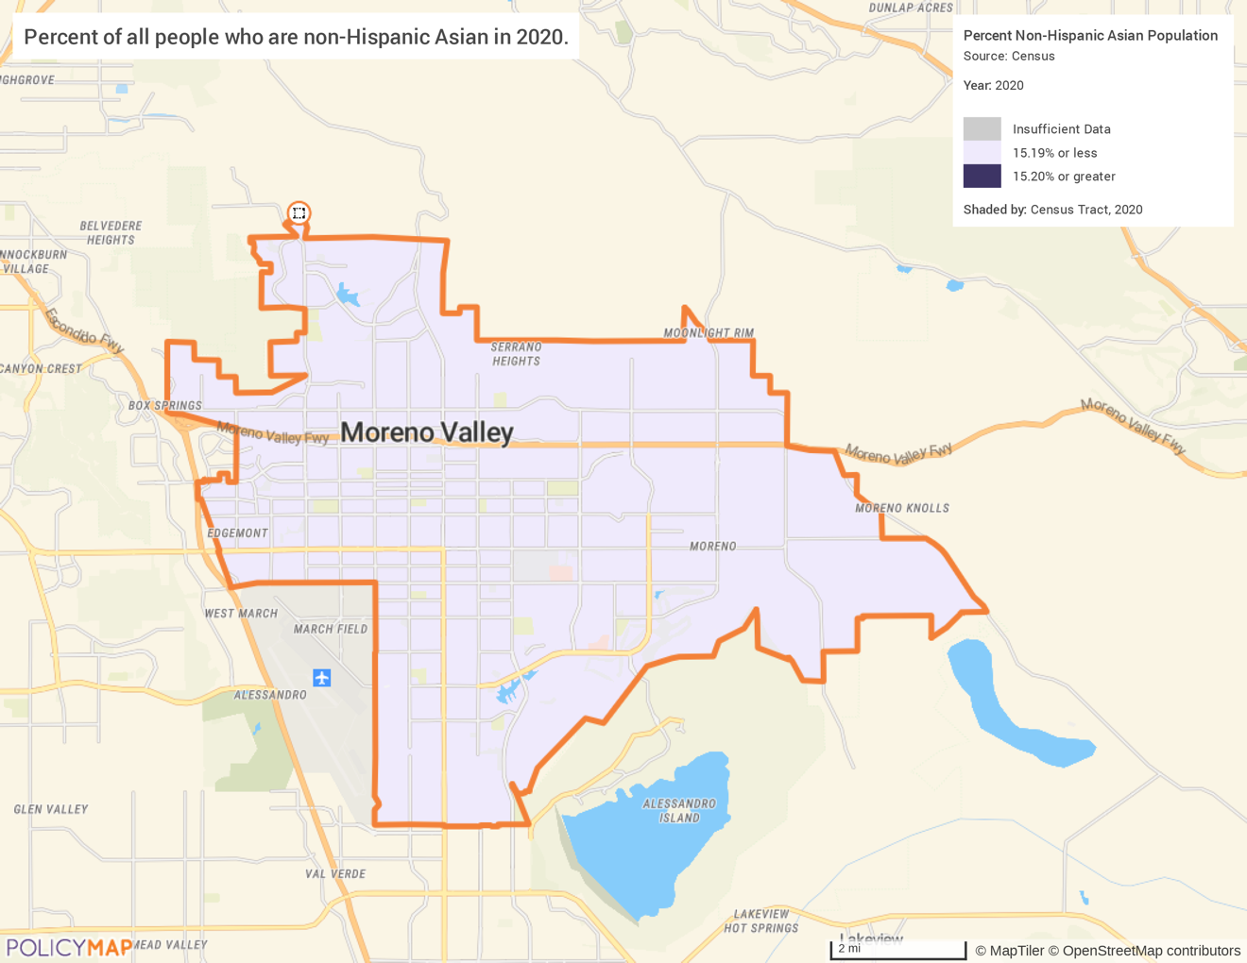
Source: ACS 2017-2021 via PolicyMap

Black, non-Hispanic
There are multiple tracts that have a concentration of Black, non-Hispanic residents. As the map below shows, there are two general areas with a concentration of this population. One area encompasses multiple tracts on the northwest side of the city and one area is in the southern tip.
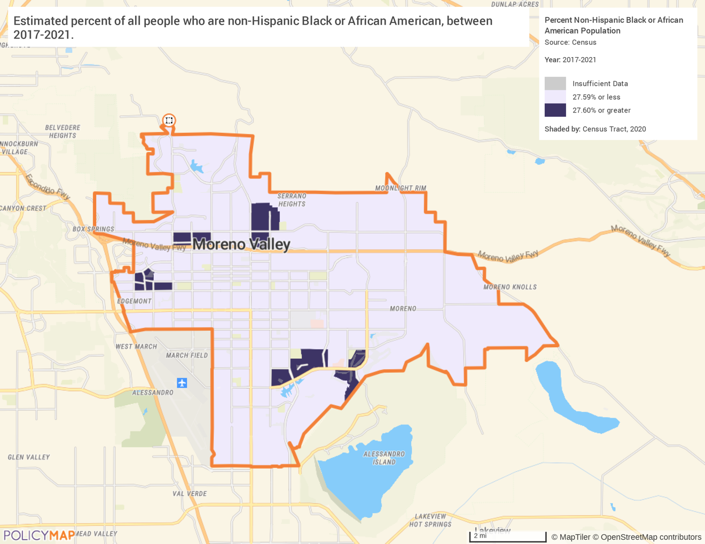
Source: ACS 2017-2021 via PolicyMap

Multiracial, non-Hispanic
There are no tracts that have a concentration of multiracial, non-Hispanic residents.
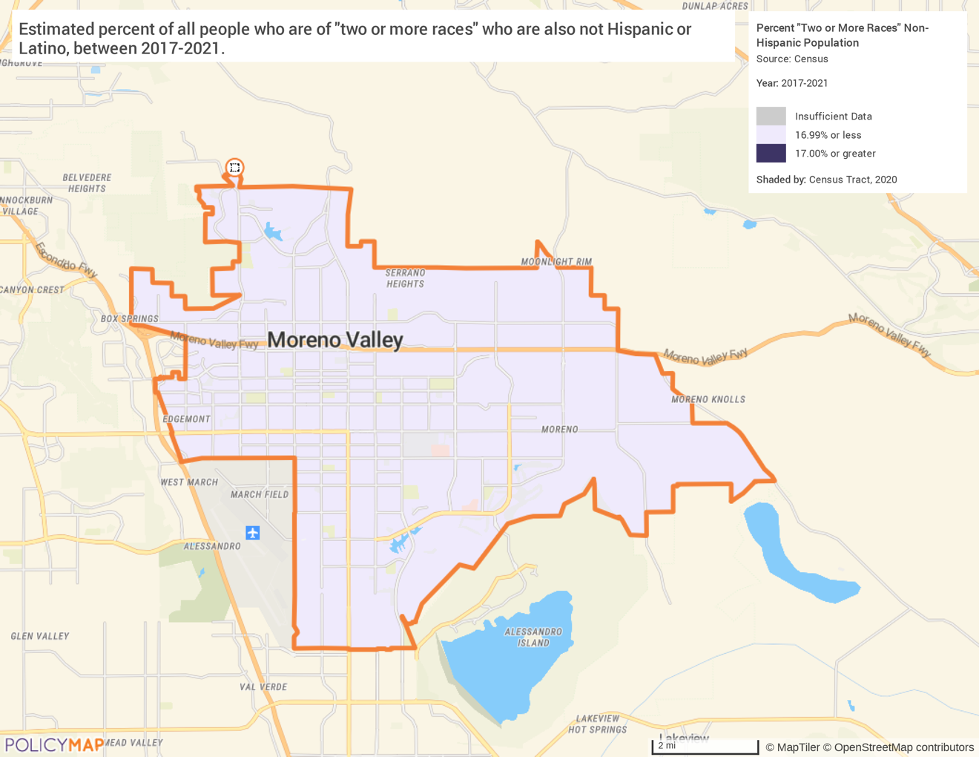
Source: ACS 2017-2021 via PolicyMap

Multiracial, Hispanic
There are a few tracts that have a concentration of multiracial, Hispanic residents. As the map below shows, there are two general areas with a concentration of this population. One area encompasses tracts on the northcentral part of the city and one area is in the south.
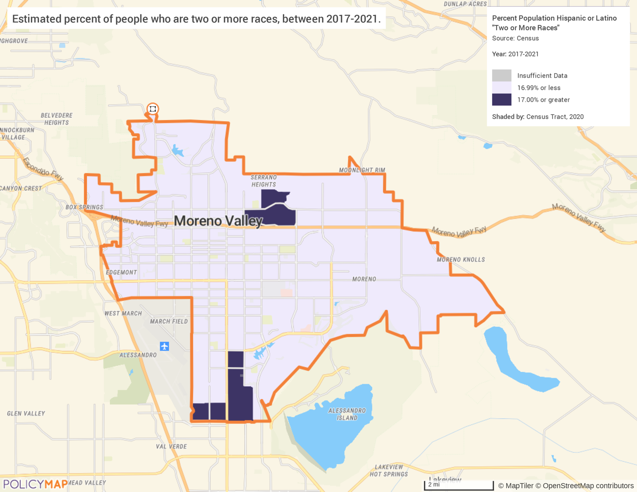
Source: ACS 2017-2021 via PolicyMap

Hispanic, all Races
Moreno Valley has multiple census tracts that have a concentration of Hispanic residents. As the map below shows, the southwest quadrant of the city has a large Hispanic population.
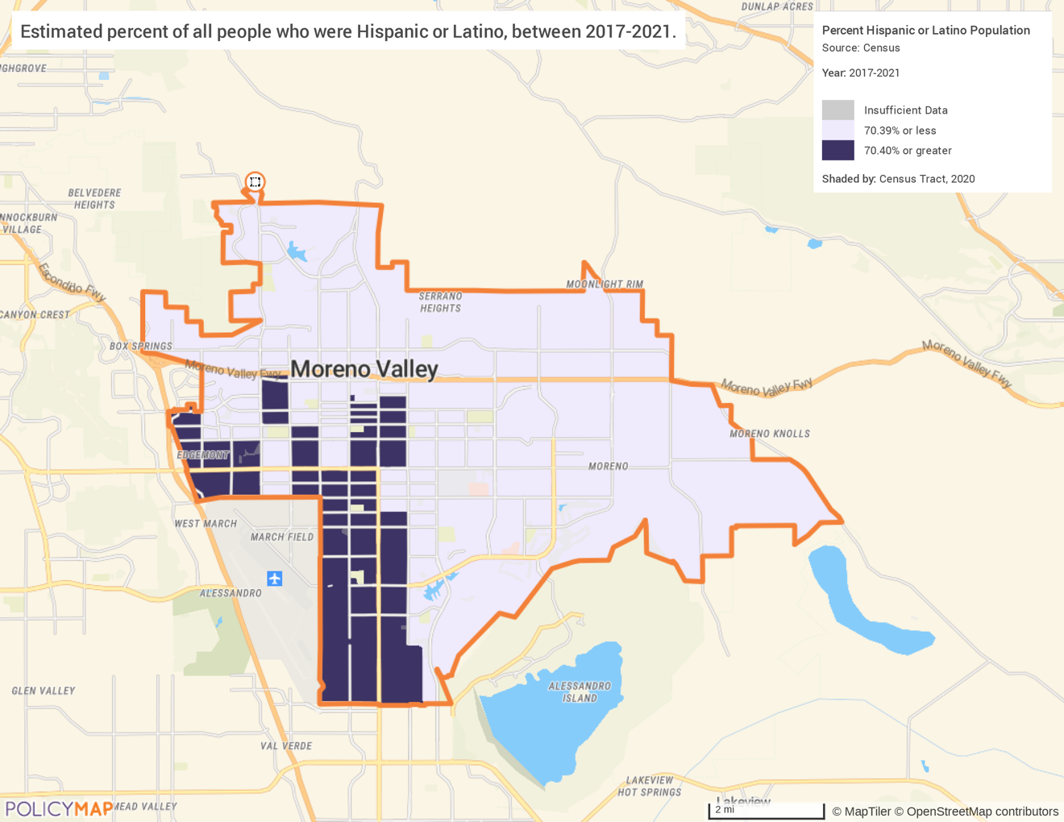
Source: ACS 2017-2021 via PolicyMap

Low-Income Families
A family is considered low-income if it earns less than 80% of the area median income. A tract has a concentration of low-income families if the tract’s median household income is less than 80% of the area median household income. The city median family income is $73,635 and relatively low-income is $58,908. Using this definition, the tracts on the west side of the city have a concentration of low-income families. These tracts match the areas with a concentration of Hispanic households and a concentration of Black, non-Hispanic households.
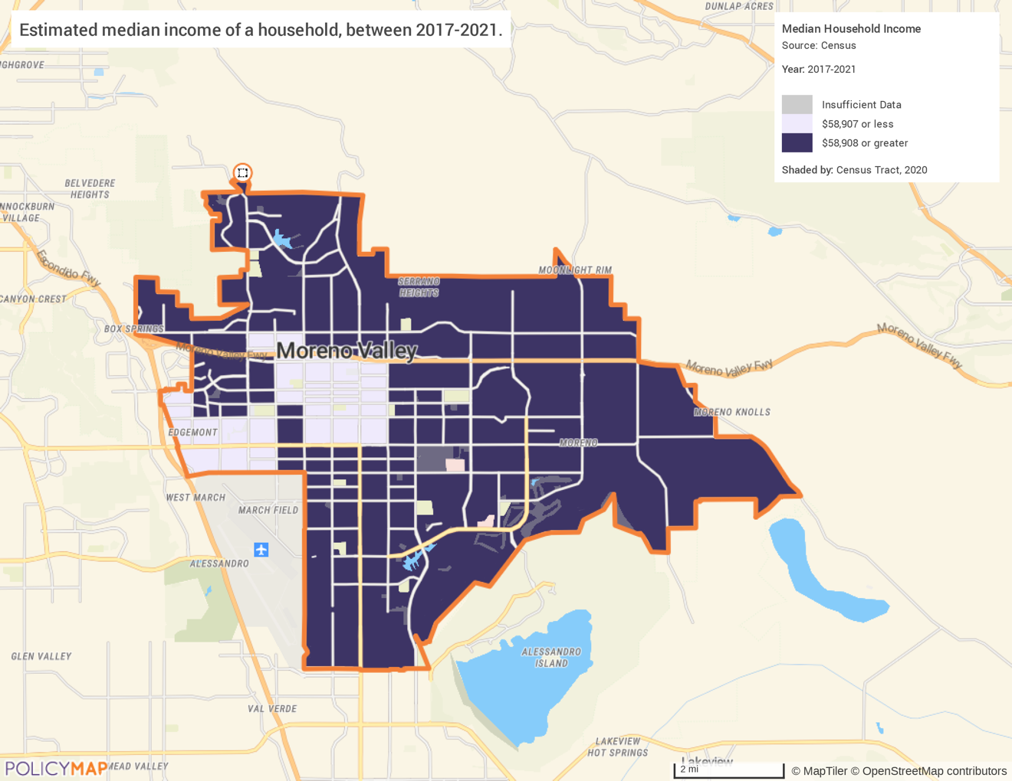
Source: ACS 2017-2021 via PolicyMap

What are the characteristics of the market in these areas/neighborhoods?
In the areas of the city that have disproportionately large number of low-income households, the housing market shows some unique characteristics. The units that tend to be older and have an increased risk of lead-based paint hazard overlap many of the same areas in the city. The units also tend to be in larger multi-family developments and have an increased rate of housing problems, which is common in older homes. Additionally, housing units in these areas have lower rents and home values. Due to the lower housing price in this area, it is possible that these areas are a prime place for reinvestment and improvement.
Are there any community assets in these areas/neighborhoods?
There are several community assets in this relative area. The following community centers are in the area and accessible to residents: Edgemont Community Center, Towngate Community Center, and Moreno Valley Community Education Center. The Moreno Public Library also has 2 locations in this area. The city has 24 affordable housing developments located in this concentrated area that are priced at below market rate and leased to very-low- to moderate-income households. On the perimeter of the area lies Highway 265 and 60 providing transportation opportunities for residents and businesses.
Are there other strategic opportunities in any of these areas?
The Village Specific Plan includes a portion of this geographic area. A purpose of the Village Plan is to revitalize the neighborhoods by providing a vision for the area and to create a balanced distribution of land uses. CDBG funds have been expended in the Village area including the installation of curbs, gutters, and sidewalks; park improvements; and street improvements. In addition to this Specific Plan and other redevelopment projects, there are several economic opportunities in the identified area that aim to create a robust walkable community where jobs, recreation, and housing can thrive in one place.

MA-60 Broadband Needs of Housing occupied by Low- and Moderate-Income Households - 91.210(a)(4), 91.310(a)(2)
Describe the need for broadband wiring and connections for households, including low- and moderate-income households and neighborhoods.
Internet is an essential communications and information platform that allows users to take advantage of the increased interconnectedness of business, education, commerce, and day-to-day utility. The FCC definition of broadband includes download speeds faster than 25 Mbps. Broadband is accessible to 99.6% of Moreno Valley.
Reliable access to the internet is a necessity to thrive in the modern economic environment. Communities that lack broadband access struggle to keep pace with the country. Locations without broadband access impedes its population’s ability to take advantage of the educational and entrepreneurial opportunities available online. This is particularly problematic for LMI areas where economic opportunities are already often lacking. Moreno Valley does not have significant gaps in broadband coverage in the residential areas. Nearly all the city has multiple options of internet providers, to include LMI areas.
According to Stanford University, the "digital divide" refers to the growing gap between the underprivileged members of society, especially the poor, rural, elderly, and handicapped portion of the population who do not have access to computers or the internet; and the wealthy, middle class, and young Americans living in urban and suburban areas who have access. RIVCOconnect is a Riverside County initiative, supported by the Riverside County Board of Supervisors and Executive Office, and led by Riverside County Information Technology (RCIT), that seeks to remove the roadblocks that obstruct service providers from building out current infrastructure. RIVCOconnect invites the private sector to deliver broadband services Countywide at speeds of 1 Gbps and above. RIVCOconnect also has a Digital Equity Program that provides refurbished computers to low-income families and non-profit organizations within Riverside County at no cost.
The following map shows broadband access throughout the city. The FCC definition of broadband includes download speeds faster than 25 Mbps. FCC data shows three major infrastructure options within Moreno Valley: cable, DSL, and fiber.
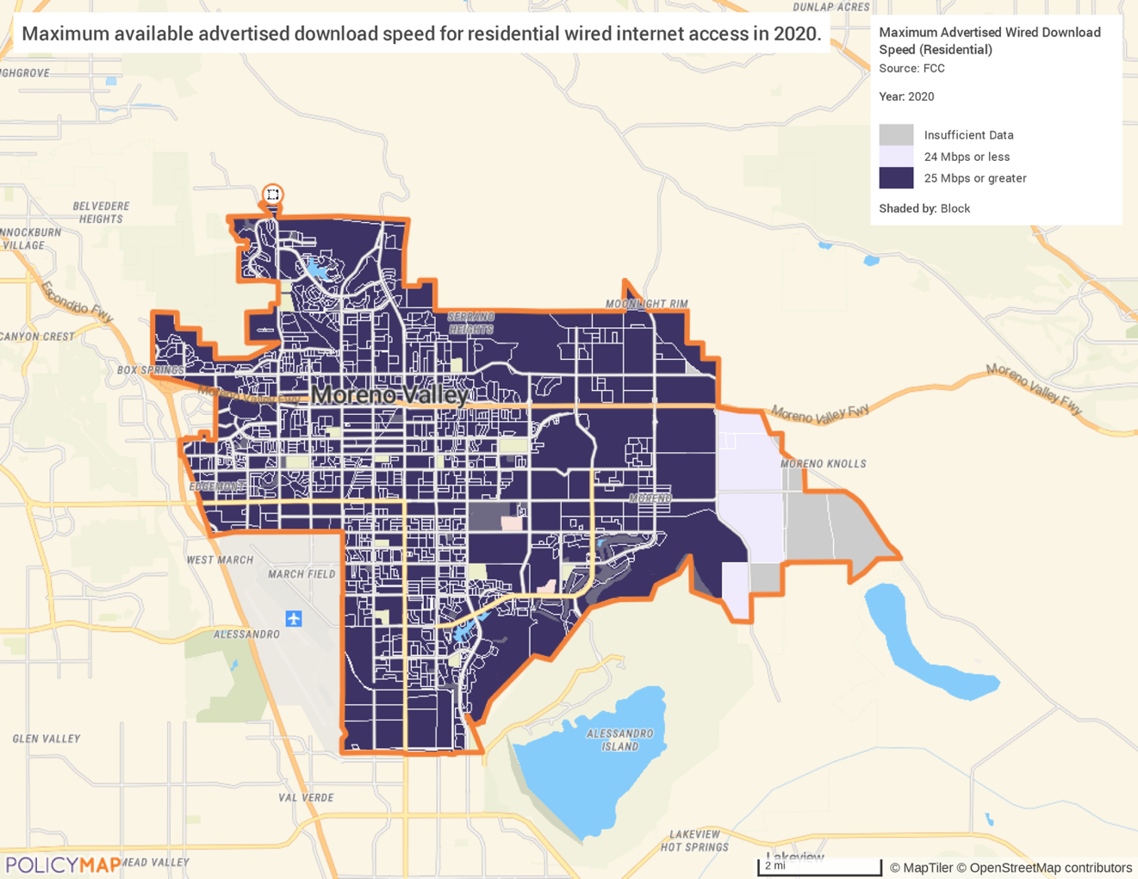
Source: ACS 2017-2021 via PolicyMap
Describe the need for increased competition by having more than one broadband Internet service provider serve the jurisdiction.
Once broadband access has been obtained, it is important to ensure there is competition among service providers. Any resource that has a de facto monopoly on an area may not be incentivized to provide standard and consistent services. The city has three types of internet service providers: cable, DSL and fiber. There are 22 internet service providers in Moreno Valley. The following providers who cover over 95% of the city with broadband:
- Spectrum (Cable)
- Frontier (Fiber)
- Viasat Internet (Satellite)
- HughesNet (Satellite)
The following map shows the number of broadband service providers by block. Most of the residential areas in the city have two (2) options of high-speed internet with competitive providers, though there are some tracts with lower populations that only have access to one provider.

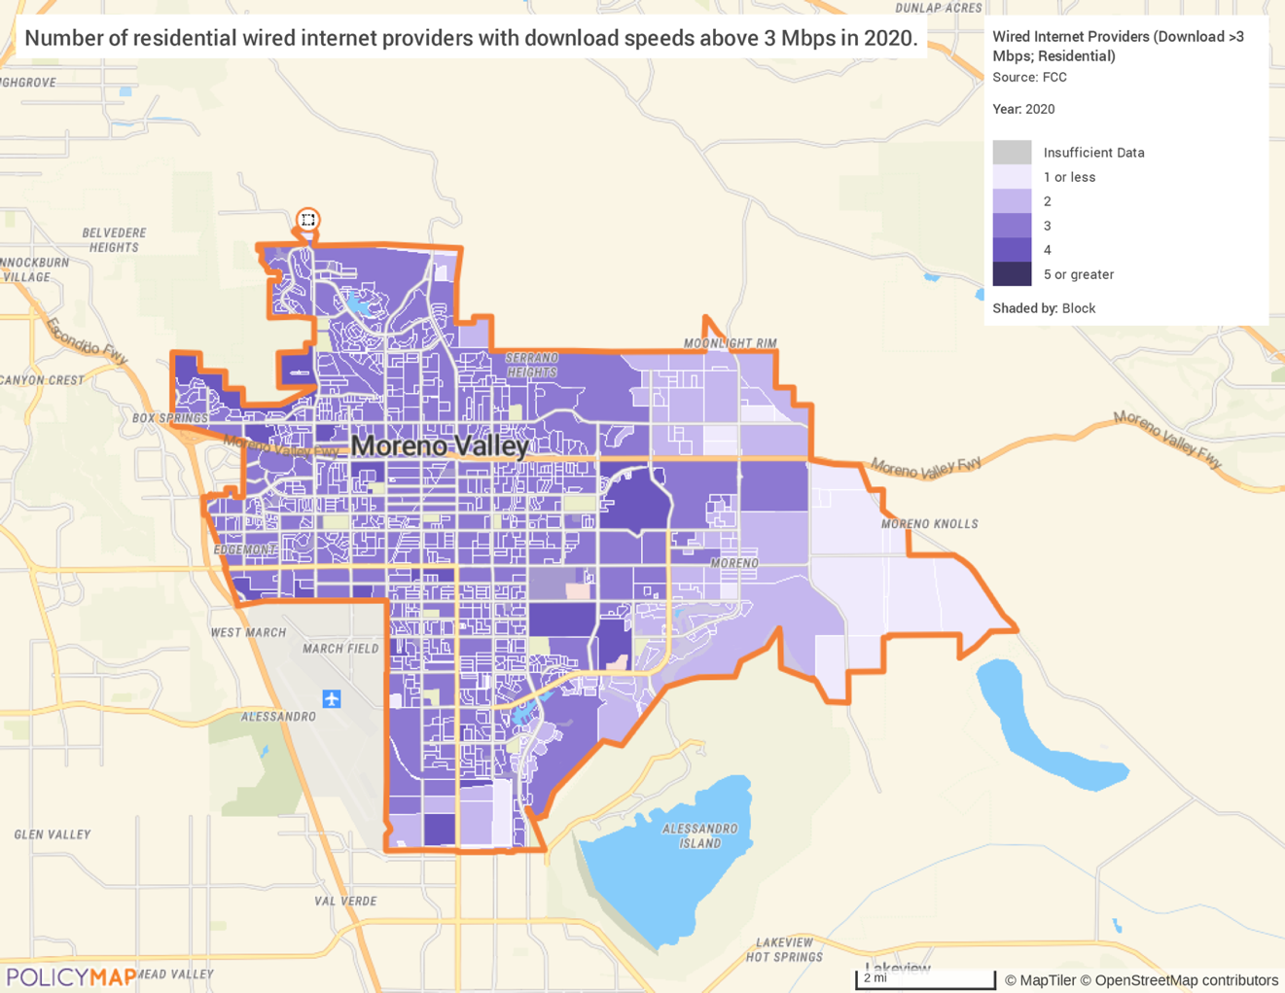

MA-65 Hazard Mitigation - 91.210(a)(5), 91.310(a)(3)
Describe the jurisdiction’s increased natural hazard risks associated with climate change.
The City of Moreno Valley is in the northwestern portion of Riverside County, surrounded by the Box Springs Mountains, the hills of the Badlands and the mountains of Lake Perris State Recreation Area. According to the city’s 2011 Local Hazard Mitigation Plan (LHMP), because of the topography and the climate, the air basin of the city allows for high air pollution potential.
Additionally, the LHMP identifies multiple natural hazard risks and their probability and severity. The most probable risk identified is power outage, followed by earthquakes, wildland and urban fires, flooding, drought, extreme weather, and severe wind. The most severe of these potential risks would be earthquakes. Three major faults directly affect Moreno Valley: the San Andreas Fault, the San Jacinto Fault, and the Elsinore Fault. The San Jacinto Fault is considered the most active fault in Southern California and is the closest to the city, running through its eastern side.
Riverside County’s 2019 Local Hazard Mitigation Plan Identifies similar increased natural hazard risks, citing earthquakes, fire, and flooding as the most prominent risks for the County area.
Describe the vulnerability to these risks of housing occupied by low- and moderate-income households based on an analysis of data, findings, and methods.
Low- and moderate-income residents in the area are incredibly vulnerable to the risks of these climate-based natural hazards. While the risks of earthquakes widely depend on the severity, sudden ground shaking has the potential to severely damage housing stock. According to Riverside County’s LHMP, a moderate earthquake can cause serious damage to property, including collapsing walls, breaking glass, and more.
LMI residents also face the greatest risk of social and financial impact from exposure to wildfires in wildland-urban interface (WUI) areas. These are areas where structures and other human development meet or intermingle with undeveloped wildland or vegetative fuels, making them much more susceptible to fire. Wildfires can often become uncontrollable and cause severe damage and destruction to the local housing stock.
Additionally, LMI households typically have fewer economic resources, are less able to respond to a disaster without assistance and are less likely to be able to access available local, state, and federal assistance needed for recovery. Dramatic increases in electricity or housing costs can put LMI households at risk of homelessness. Special populations such as people with disabilities, non-English speakers, and homeless individuals are disproportionately more likely to need additional support, such as medical equipment, access to evacuation information, or basic shelter.

Strategic Plan

SP-05 Overview
Strategic Plan Overview
The Strategic Plan is the centerpiece of the Consolidated Plan. The Plan describes:
- General Priority Needs
- Influence of Market Conditions
- Anticipated Resources
- Institutional Delivery System
- Goals Summary
- Public Housing Accessibility and Involvement
- Barriers to Affordable Housing
- Homeless Strategy
- Lead Based Paint Hazards
- Anti‐Poverty Strategy
- Monitoring
Key components of the Strategic Plan include three strategies: homeless strategy, actions to reduce lead‐based paint hazards, and anti‐poverty strategy. The nature and scope of each strategy is described below.
Homeless Strategy
- Outreach to homeless persons (especially unsheltered persons) and assess their individual needs.
- Fill gaps created by lack of emergency shelter and transitional housing needs for those experiencing homelessness.
- Help homeless persons (especially chronically homeless individuals and families, families with children, veterans and their families, and unaccompanied youth) make the transition to permanent housing and independent living.
- Help low‐income individuals and families avoid becoming homeless, especially extremely low‐income individuals and families who are:
  - Likely to become homeless after being discharged from publicly funded institutions and systems of care.
  - Receiving assistance from public and private agencies that address housing, health, social services, employment, education, or youth needs.

Reduction of Lead-Based Paint Hazards Strategy
- Actions to evaluate and reduce lead-based paint hazards.
- Actions to increase access to housing without health hazards.
- How actions will be integrated into housing policies and programs.
- How the actions are related to the extent of lead poisoning and hazards.
Anti-Poverty Strategy
- Establish goals, programs, and policies for reducing the number of poverty‐level families such as:
  - Activities designed to reduce the number of persons in poverty.
  - Coordination of housing programs funded through the Consolidated Plan with other City funding.
  - Job training, job placement, life skills training, and welfare to work programs.
  - Policies for providing employment and training opportunities to Section 3 residents pursuant to 24 CFR 135.

SP-10 Geographic Priorities – 91.215 (a)(1)
Geographic Area
1 | Area Name | Eligible CDBG Target Areas
1 | Area Type | Local Target Area
1 | HUD Approval Date | N/A
1 | % of Low/Mod | N/A
1 | Revital Type | Comprehensive
1 | Other Revival Type Description | N/A
2 | Area Name | Citywide
2 | Area Type | Local Target Area
2 | HUD Approval Date | N/A
2 | % of Low/Mod | N/A
2 | Revital Type | Comprehensive
2 | Other Revival Type Description | N/A
Table 51 - Geographic Priority Areas

General Allocation Priorities
The CDBG program requires that each CDBG‐funded activities principally benefit low- and moderate-income persons, aid in the prevention or elimination of slums or blight, or meet a community development need having a particular urgency because existing conditions pose a serious and immediate threat to the health or welfare of the community and other financial resources are not available to meet that need. With respect to activities that principally benefit low‐ and moderate‐income persons, at least 51% of the activity's beneficiaries must be low and moderate income.
Some CDBG assisted activities, such as parks, neighborhoods, public facilities, community centers and streets, serve an identified geographic area. These activities generally meet the low‐ and moderate-income principal benefit requirement if 51% of the residents in the activity's service area are low- and moderate- income.
When determining the geographic locations where Moreno Valley will allocate its investments, staff will consider if the activity will be physically located within a designated CDBG Target Area, and if the activity is meant to directly benefit the low‐to‐moderate income population in that area.
The City may also consider current poverty levels of an area when determining geographic location priorities. Poverty levels can act as a measure of need, providing staff with insight to fund services appropriately. Staff will also take public demand into account, recommendations from other City departments (such as Code Enforcement, Capital Projects, or the Police Department), reports from CDBG subgrantees which track referrals and measure trends in service levels, recommendations of other local entities such as the Continuum of Care, Department of Public Social Services, Housing Authority, Economic Development Agency, and local non‐profits.

SP-25 Priority Needs - 91.215(a)(2)
Priority Needs
1 | Priority Need Name | Substandard Housing
1 | Priority Level | High
1 | Population | Extremely Low  Low  Moderate  Elderly  Frail Elderly  Persons with Physical Disabilities
1 | Geographic Areas Affected | CDBG TARGET AREA(S)
1 | Associated Goals | Housing and Neighborhood Improvement Activities
1 | Description | Rehabilitated mobile homes and single-family homes in need of repairs.
1 | Basis for Relative Priority | The 2014‐2021 Housing Element indicates that mobile homes and single‐family homes exhibit substandard housing conditions. Moreno Valley’s existing housing stock includes 1,364 mobile homes of which 872 are in seven mobile home parks. The existing housing stock contains 45,220 single family dwellings. T
2 | Priority Need Name | Homelessness
2 | Priority Level | High
2 | Population | Extremely Low  Chronic Homelessness  Persons with Mental Disabilities  Victims of Domestic Violence
2 | Geographic Areas Affected | CDBG TARGET AREA(S)
2 | Associated Goals | Homeless/Homelessness Prevention Activities
2 | Description | Address and prevent homelessness.
2 | Basis for Relative Priority | In Moreno Valley at least 42.5% of the population experience cost burdens, which is a factor of being at risk of homelessness.
3 | Priority Need Name | Public Facilities and Infrastructure
3 | Priority Level | High
3 | Population | Extremely Low  Low  Moderate
3 | Geographic Areas Affected | CDBG TARGET AREA(S)
3 | Associated Goals | Capital Improvement Activities
3 | Description | Some of the public facilities such as parks and public buildings which are in low and moderate neighborhoods need improvement and some neighborhoods lack adequate drainage systems, water lines, traffic signals, street lighting and street improvements.
3 | Basis for Relative Priority | Moreno Valley has a wide range of community development issues, particularly in older neighborhoods where the housing stock, public improvements and community facilities are deteriorating, and businesses are declining.
4 | Priority Need Name | Public Service Programs
4 | Priority Level | High
4 | Population | Extremely Low  Low  Moderate  Elderly  Frail Elderly  Persons with Physical Disabilities  Other
4 | Geographic Areas Affected | CDBG TARGET AREA(S)
4 | Associated Goals | Public Service Activities
4 | Description | Improving the quantity and quality of public services, principally for low-and- moderate income persons, including the homeless, elderly, and disabled
4 | Basis for Relative Priority | The responses to notices of CDBG, CDBG and HOME funding availability have demonstrated the need to continue to financially support the activities of organizations addressing the needs of low- and moderate-income persons
5 | Priority Need Name | Housing Discrimination
5 | Priority Level | High
5 | Population | Extremely Low  Low  Moderate  Large Families  Families with Children  Elderly  Frail Elderly  Persons with Mental Disabilities  Persons with Physical Disabilities  Persons with Developmental Disabilities  Victims of Domestic Violence
5 | Geographic Areas Affected | Citywide
5 | Associated Goals | Fair Housing Activities
5 | Description | Need for fair housing and tenant/landlord counseling services
5 | Basis for Relative Priority | HUD requirement to engage in efforts to further fair housing choice.
6 | Priority Need Name | Economic Development
6 | Priority Level | High
6 | Population | Extremely Low  Low  Moderate
6 | Geographic Areas Affected | Citywide
6 | Associated Goals | Economic Development Activities
6 | Description | Strong economic development is needed to retain and attract businesses and to reduce the unemployment and poverty rates
6 | Basis for Relative Priority | Economic development was identified as a priority need by the City’s Economic Development Strategy Plan and research and analysis completed for several planning studies
7 | Priority Need Name | Planning and Administration
7 | Priority Level | High
7 | Population | Extremely Low  Low  Moderate  Large Families  Families with Children  Elderly  Frail Elderly  Persons with Mental Disabilities  Persons with Physical Disabilities  Persons with Developmental Disabilities  Persons with Alcohol or Other Addictions  Non‐housing Community Development
7 | Geographic Areas Affected | Citywide
7 | Associated Goals | Planning and Administration
7 | Description | Overall program management, coordination, monitoring, and evaluation of projects funded by CDBG, HOME and ESG funds and the preparation of the Annual Action Plans and CAPERs.
7 | Basis for Relative Priority | Administration of HUD programs is needed to carryout successful activities that have positive community impacts.
Table 52 – Priority Needs Summary

SP-30 Influence of Market Conditions – 91.215 (b)
Influence of Market Conditions
Affordable Housing Type | Market Characteristics that will influence  the use of funds available for housing type
Tenant Based Rental Assistance (TBRA) | In determining whether to undertake TBRA programs, the City will take into consideration: documented local need, documented local demand, existing services offering that type of assistance currently provided by the City and/or its subgrantees, existing services offering that type of assistance currently provided by other regional organizations (i.e., County and State programs), the possibility of expansion of financial education programs, evaluation of the area rents, costs of utilities, degree of need based on other pertinent community needs, available funding and how many persons the funding is able to assist.
TBRA for Non-Homeless Special Needs | In determining whether to undertake TBRA for non‐homeless/ special needs programs, the City will take into consideration: documented local need, documented local demand, degree of need based on other pertinent community needs, existing services offering that type of assistance currently provided by the City and/or it’s subgrantees, existing services offering that type of assistance currently provided by other regional organizations (i.e., County and State programs), area statistics for special needs populations, evaluation of changing trends
New Unit Production | The City will evaluate individual projects/proposals with an emphasis on the availability of adequate amount of funding to subsidize the new project and/or the availability of other (funding) resources in which to leverage projects. The City will consider the land values, analysis of the overall construction costs and ‘cost per door’ as per industry standards. It will compare costs to past City projects, and research to ensure reasonable development fees are imposed.
Rehabilitation | At the City level, enough City entitlement is available to offer rehab a program and there is sufficient staff capacity to adequately carry‐out/manage rehab programs. At the market level, characteristics that would influence the use of housing funds toward a rehab activity include home values, homeowner’s ability and willingness to borrow money, construction costs, public need and demand, evaluation of housing types in need of rehab and specific circumstances and types of repairs needed for those housing units, availability of other funding sources in which to leverage projects.
Acquisition, including preservation | Prior to any acquisition, the City would consider the following market characteristics: a full evaluation of parcel size, zoning, and allowable land uses, proximity to Target Areas, current land values, costs of maintenance (current and long term), projection of how quickly a project would be completed, availability of monies in which to purchase land
Table 53 – Influence of Market Conditions

SP-35 Anticipated Resources - 91.215(a)(4), 91.220(c) (1,2)
Introduction
The city is using its FY 2023-2024 yearly allocation as a basis to estimate the funding it may receive over the course of the 5‐year period of the Consolidated Plan. Based on its estimates the City anticipates resources to be received from the CDBG, HOME and ESG programs in the following amounts:
- CDBG $9.5 million
- HOME $3.77 million
- ESG $845,000
Anticipated Resources
Program | Source of Funds | Uses of Funds | Expected Amount Available Year 1 |  |  |  | Expected Amount Available Remainder of ConPlan  $ | Narrative Description
Program | Source of Funds | Uses of Funds | Annual Allocation: $ | Program Income: $ | Prior Year Resources: $ | Total:  $ | Expected Amount Available Remainder of ConPlan  $ | Narrative Description
CDBG | Public - Federal | Acquisition; Admin and Planning; Economic Development; Housing; Public Improvements; Public Services | $1,979,019 | $0 | $421,191 | $2,400,210 | $7,520,981 | A formula‐based program that annually allocates funds to metropolitan cities, urban counties, and states for a wide range of eligible housing and community development activities
HOME | Public - Federal | Acquisition; Homebuyer Assistance; Homeowner Rehab; Multifamily Rental New Construction; Multifamily Rental Rehab; New Construction for Ownership; TBRA | $755,989 | $0 | $1,953,951 | $2,709,940 | $3,019,011 | A formula‐based program that provides allocations to states and units of general local governments, known as participating jurisdictions. Its purpose is to retain and expand the supply of affordable housing principally for low‐ and extremely low‐income families through housing rehabilitation, new construction, first‐time home buyer financing, and rental assistance
ESG | Public - Federal | Conversion and Rehab for Transitional Housing; Financial Assistance; Overnight Shelter; Rapid Re‐Housing (rental assistance); Rental Assistance Services; Transitional Housing | $169,365 | $0 | $0 | $169,365 | $675,635 | A formula ‐based program that allocates funds to states, metropolitan cities, and urban counties to support emergency shelters and other assistance for homeless individuals and families.
Table 54 - Anticipated Resources

Explain how federal funds will leverage those additional resources (private, state, and local funds), including a description of how matching requirements will be satisfied.
Leveraging
The City and HUD share an interest in leveraging HUD resources to the maximum extent feasible to address priority needs and associated goals.
During the 5‐year period of the ConPlan the City will seek funds to leverage the Federal CDBG, HOME and ESG funds.
Volunteer services and private donations provide additional resources to leverage CDBG funds for public service projects.
In the past, Moreno Valley has actively leveraged its affordable housing projects, mostly with Redevelopment Set‐aside funds. As the Redevelopment Agency was dissolved, the city will continue its efforts to leverage projects with other available resources. Some potential leveraging resources are listed below:
- Low‐income Housing Tax Credit (LIHTC): The California Tax Credit Allocation Committee (TCAC) allocates federal and state tax credits to affordable housing projects. Corporations provide equity to build the projects in return for the tax credits.
- Affordable Housing Sustainable Communities Housing Program: AHSC directs investments to historically under‐invested communities, giving more Californians access to opportunity. At least 50% of AHSC funding is required by state law to be allocated to affordable housing and projects in, or that provide a benefit to, disadvantaged communities.

- Housing Choice Vouchers: The Section 8 rental voucher program provides rental assistance to help very low-income families afford decent, safe, and sanitary rental housing. The County of Riverside Housing Authority pays the owner a portion of the rent (a housing assistance payment (HAP)) on behalf of the family.

- Mortgage Credit Certificate Program: Income tax credits are available to first‐time homebuyers to buy new or existing single-family housing. Riverside County administers the program on behalf of jurisdictions in the County. A Mortgage Credit Certificate (MCC) entitles qualified home buyers to reduce the amount of their federal income tax liability by an amount equal to a portion of the interest paid during the year on a home mortgage.
Matching Requirement
Entitlement cities receiving HOME funds are required to contribute a 25% match of non‐HOME funds for every dollar of HOME funds spent. The HOME statute also provides a reduction of the matching contribution under three conditions: 1. Fiscal distress, 2. severe fiscal distress, and 3. presidential disaster declarations. Moreno Valley has been identified by HUD as a fiscally distressed jurisdiction for several consecutive years and has been granted a 100‐percent match reduction. The City anticipates that the ‘fiscally distressed’ classification to continue through the entire Consolidated Plan period.
If appropriate, describe publicly owned land or property located within the jurisdiction that may be used to address the needs identified in the plan.
Current land holdings that may be available for affordable housing developments include:
- Day/Alessandro - 8.15 acres
- Fir/Heacock - 0.90 acres
- JFK/Elm - 0.17 acres
- Sheila/Perris - 0.18 acres

SP-40 Institutional Delivery Structure – 91.215(k)
Explain the institutional structure through which the jurisdiction will carry out its consolidated plan including private industry, non-profit organizations, and public institutions.
Responsible Entity | Responsible Entity Type | Role | Geographic Area Served
City of Moreno Valley | Government | Administer HUD programs; Carryout activities as noted in the Consolidated Plan and Annual Action Plans; Reporting | Citywide
Table 55 - Institutional Delivery Structure

Assess of Strengths and Gaps in the Institutional Delivery System
The institutional delivery system requires the participation of many organizations to accomplish the goals identified in the Consolidated Plan. Coordination with other public and private agencies is necessary. The establishment of solid working relationships is key to assist and enable service providers to better assist those in need. The City has worked to build cooperative relationships with surrounding jurisdictions and agencies, as well as nonprofit organizations. This has proven to be strength for Moreno Valley.
Availability of services targeted to homeless persons and persons with HIV and mainstream services.
Homelessness Prevention Services | Available in the Community | Targeted to Homeless | Targeted to People with HIV
Homelessness Prevention Services
Counseling/Advocacy | X | X
Legal Assistance | X | X
Mortgage Assistance | X
Rental Assistance | X
Utilities Assistance | X

Street Outreach Services
Law Enforcement | X
Mobile Clinics
Other Street Outreach Services |  | X

Supportive Services
Alcohol & Drug Abuse |  | X
Child Care | X | X
Education | X | X | X
Employment and Employment Training | X | X
Healthcare |  | X | X
HIV/AIDS |  | X | X
Life Skills | X | X
Mental Health Counseling |  | X | X
Transportation |  | X

Other
Other
Table 56 - Homeless Prevention Services Summary

Describe how the service delivery system including, but not limited to, the services listed above meet the needs of homeless persons (particularly chronically homeless individuals and families, families with children, veterans and their families, and unaccompanied youth).
In addition to the services delivered by or with the City’s assistance, the CoC implements a countywide Coordinated Entry System (CES) to assess homeless individuals/families using the VI-SPDAT data system that tracks the length of time a client has been on the streets or in emergency shelter. DPSS use HUD CoC Program planning grant funding to measure system wide performance in HMIS, such as length of time homeless. This is used to help the CoC prioritize and house those who have experiences the longest length of time being homeless. The planning process also includes working with the CoC Standards and Evaluation Committee to continue developing strategies to prioritize chronically homeless individuals/families with the longest time homeless and most severe needs, including:
- Increasing the supply of permanent supportive housing and rapid rehousing.
- Housing individuals/families identified in CES with the longest time homeless first.
- Using HMIS data to record episodes of homelessness and destination at program exit to track agency and system performance.
The CoC has also adopted a “Housing First” approach that is based evidence-based and promising practices and endorsed by HUD to place a homeless individual or family in permanent housing and provide services to keep them stably housed.
Homeless CoC youth providers have implemented outreach and service-based events in the communities to draw homeless youth, unaccompanied and transitional age, into contact with services available to them. Housing Authority of the County of Riverside in collaboration with Operation SafeHouse opened a permanent supportive housing program called Harrison House for transitional age youth, in the eastern region of Riverside County.
Describe the strengths and gaps of the service delivery system for special needs population and persons experiencing homelessness, including, but not limited to, the services listed above.
The city has cooperative relationships with surrounding jurisdictions, diverse types of agencies, and nonprofits who can help the city meet its Consolidated Plan goals. This coordination leads to solid working relationships that enable all service providers to better assist those in need.
Non‐Profit Organizations: The City utilizes a variety of nonprofit organizations to address community needs, such as homelessness, special needs, fair housing, and food distribution services.
Public Housing Authority: The Housing Authority of the County of Riverside administers public housing and the Housing Choice Voucher Program (Section 8) for Moreno Valley residents.
JPA: The City is a member of the March Joint Powers Authority (JPA). The JPA is a public entity created for the purpose of addressing the use, reuse, and joint use of realigned March ARB. The JPA approved a Homeless Assistance Program and is the location of two local transitional homeless facilities.
Coordination with those described above has led to solid working relationships that enable all service providers to better assist those in need and create a strong network of individual agencies working toward a common goal.
Provide a summary of the strategy for overcoming gaps in the institutional structure and service delivery system for carrying out a strategy to address priority needs.
With resources becoming more and more limited, the City proposes to overcome gaps in institutional structure by:
- Maintaining open communication with subgrantees and other consolidated planning partners.
- Utilizing technology to share, distribute information, foster, and maintain constant contact with community planning partners.
- Recommending and assisting to coordinate the use of volunteers (volunteer-based organizations) in which to fill gaps where it logically makes sense.

SP-45 Goals Summary – 91.215(a)(4)
Goals Summary Information
Goals and funding noted in the table below are estimates based on predicted funding allocations over the course of the 5-year Consolidated Plan.
Sort Order | Goal Name | Start Year | End Year | Category | Geographic Area | Needs Addressed | Funding | Goal Outcome Indicator
1 | Capital Improvement Activities | 2023 | 2028 | Non-Housing Community Development | Target Areas | Capital Improvement Activities | CDBG: $5,825,000 | Public Facility or Infrastructure Activities other than Low/Moderate Income Housing Benefit: 11,000 Persons Assisted
2 | Fair Housing Activities | 2023 | 2028 | Public Service | Citywide | Housing Discrimination | CDBG: $350,000 | Persons Assisted:  300,000 Persons Assisted
3 | Public Services Activities | 2023 | 2028 | Public Service | Citywide; Target Areas | Public Service | CDBG: $1,425,000 | Persons Assisted:  300,000 Persons Assisted
4 | Homeless/Homelessness Prevention Activities | 2023 | 2028 | Homeless | Citywide | Homelessness | ESG: $781,625 | Homelessness Prevention: 800 Persons Assisted
5 | Housing and Neighborhood Improvement Activities | 2023 | 2028 | Housing | Target Areas | Substandard Housing | HOME: $3,397,500 | 16 Household Housing  Unit  Homeowner Housing Rehabilitated: 90 Household Housing Unit
6 | Planning and Administration | 2023 | 2028 | Program Administration | Citywide | Planning and Administration | CDBG: $1,900,000  ESG: $63,375  HOME: $377,500 | Other: 0
7 | Health, Safety, and Public Welfare | 2023 | 2028 | Non-Housing Community Development | Citywide; Target Areas | Public Health and Safety | TBD, at later date | TBD, at later date
8 | Economic Development Activities | 2023 | 2028 | Economic Development | Citywide | Economic Development | TBD, at later date | Businesses Assisted; Jobs Retained or Created
9 | Slum or Blight Activities | 2023 | 2028 | Slum and Blight | Target Areas | Slum and Blight | TBD, at later date | Other
10 | Historic Preservation | 2023 | 2028 | Historic Preservation | Target Areas | Historic Preservation | TBD, at later date | Other
Table 57 – Goals Summary

Goal Descriptions
1 | Goal Name | Capital Improvement Activities
1 | Goal Description | Acquisition, design, construction, and installation of needed public facilities and improvements located in CDBG income eligible Target Areas where infrastructure is missing or substandard. Public facilities and improvements may include ADA-compliant ramps and sidewalk improvements, storm drains, and water and sewer lines. Improvements shall facilitate pedestrian activity, eliminate flooding, and provide for safer streets within the Target Areas.
2 | Goal Name | Fair Housing Activities
2 | Goal Description | The promotion of housing choice and support of state and federal fair housing laws to ensure that all residents have access to a decent home in a suitable living environment in the City. Fair Housing activities are met by promoting and affirmatively furthering equitable housing opportunities through education, counseling, enforcement, and training.
3 | Goal Name | Public Services Activities
3 | Goal Description | Improving the quantity and quality of public services, principally for low-and- moderate income persons, including the homeless, elderly, and disabled. The following services are identified by order of priority:  - ‘Basic Needs’ Related Social Services Programs (such as but not limited to emergency food, shelter (homelessness), and utility assistance)  - Community Public Safety Programs  - Programs offering Low-Cost Transportation  - Employment Services/Programs and Job (Skills) Training  - Free/Low-Cost programs for School-Aged Youth
4 | Goal Name | Homeless/Homelessness Prevention Activities
4 | Goal Description | Improve the quality of life for the city’s homeless and those threatened with homelessness by extending emergency services aimed at assisting, protecting,  and improving the living conditions and ultimately stabilizing the housing situation of those individual(s).
5 | Goal Name | Housing and Neighborhood Improvement Activities
5 | Goal Description | Conserving and improving housing stock through rehabilitation of units occupied by low-and-moderate income households. Activities are designed to: (1) improve existing substandard or deteriorated housing stock that does not meet building, safety, or fire code and (2) achieve the goals identified in the City’s Consolidated Plan.
6 | Goal Name | Planning and Administration
6 | Goal Description | Overall program management, coordination, monitoring, and evaluation of projects funded by CDBG, HOME and ESG funds and the preparation of the Annual Action Plans and CAPERs.
7 | Goal Name | Health, Safety, and Public Welfare
7 | Goal Description | Eliminating conditions which are detrimental to health, safety, and public welfare through interim rehabilitation, community policing, code enforcement, etc.
8 | Goal Name | Economic Development Activities
8 | Goal Description | Expanded economic opportunities through micro-enterprise loan programs and counseling as well as employment and job skills programs to create and retain jobs for low-and-moderate persons.
9 | Goal Name | Slum or Blight Activities
9 | Goal Description | Elimination of slums and blight to prevent the deterioration of City neighborhoods, principally in the CDBG Target Areas.
10 | Goal Name | Historic Preservation
10 | Goal Description | Restoring and preserving properties formally designated as historic structures.

Estimate the number of extremely low-income, low-income, and moderate-income families to whom the jurisdiction will provide affordable housing as defined by HOME 91.315(b)(2).
HOME 91.315(b)(2) definitions refer to the income eligibility and affordability requirements for housing financially assisted by the HOME program. These requirements are spelled out in detail in CFR 92.252 and CFR 92.254. The city estimates that HOME funds will assist 90 homeowners and 16 renter‐occupied housing units.

SP-50 Public Housing Accessibility and Involvement – 91.215(c)
Need to Increase the Number of Accessible Units (if Required by a Section 504 Voluntary Compliance Agreement).
This section is not applicable to the City.
Activities to Increase Resident Involvements.
This section is not applicable to the City.
Is the public housing agency designated as troubled under 24 CFR part 902?
This section is not applicable to the City.
Plan to remove the ‘troubled’ designation.
This section is not applicable to the City.

SP-55 Barriers to affordable housing – 91.215(h)
Barriers to Affordable Housing
As noted in section MA-40 of this plan, the city’s barriers to affordable housing include:
- Lack of a Balanced Housing Stock.
- Need for Utilization of Bilingual Housing Materials.
- Rapid Increase in Home Prices and Cost Burdened Households.
- Reduction in Housing Funds.
- High Number of Cost Burdened Renters.
The City does not have growth limits, or policies and ordinances that regulate the number of housing units that can be constructed annually. The City does not have ordinances such as rent control that directly affect the residential investment rate of return. In affordable for‐sale and for‐rent projects, however, the City does enact controls to maintain affordability. For instance, in HOME‐assisted ownership projects the City implements a recapture policy.
Furthermore, tax policy affecting land and other property is governed by California state law. Property taxes are based on a property’s assessed value. State law mandates that all property is subject to taxation unless otherwise exempted. In general, properties that are owned and used by educational, charitable, religious, or government organizations may be exempt from certain property taxes. Housing for low-income households owned and operated by a qualifying nonprofit organization is eligible for exemption from property taxes.
Strategy to Remove or Ameliorate the Barriers to Affordable Housing
Key components that the city will engage in to ameliorate and/or remove barriers to affordable housing as follows:
- When feasible, consider reducing, waiving, or deferring development fees to facilitate the provision of affordable housing.
- Periodically review and revise City development standards to facilitate quality housing that is affordable to lower and moderate-income households.
- Monitor all regulations, ordinances, departmental processing procedures and fees related to the rehabilitation and/or construction of dwelling units to assess their impact on housing costs.
- Ensure that water and sewer providers are aware of the City’s intentions for residential development throughout the City.

SP-60 Homelessness Strategy – 91.215(d)
Reaching out to homeless persons (especially unsheltered persons) and assessing their individual needs.
The City has developed a comprehensive Homeless Strategy that involves reaching out to homeless persons, assessing, and addressing their individual emergency/ housing needs. To reach these individuals, the City extends CDBG funding to a variety of public service subgrantees that in turn provide direct services which may including street outreach, case management, housing search assistance, emergency housing/motel vouchers, food, and counseling. These social service programs are often the primary source for referrals and assistance to homeless persons. Typically, homeless populations become aware of available programs through word of mouth and seek out services by calling the service provider or traveling to their local office.
The County of Riverside CoC has established chronically homeless persons as the highest need priority based on HUD established goals. The CoC implements a Coordinated Entry System (CES) to ensure appropriate intervention is utilized to serve those who are homeless and providing a prioritization of community resources and housing based on the vulnerability of the participant.
Within the CoC, there are several outreach teams from County, cities, and nonprofit homeless providers that cover specific populations or geographic regions in the County. There are also specific outreach teams serving those with mental health issues, veterans, youth, and persons experiencing chronic homelessness. The teams collaborate to conduct outreach and provide client services focused on the chronically homeless populations living on the streets to connect them with supportive services and achieve housing stability.
Addressing the emergency and transitional housing needs of homeless persons.
Addressing the housing needs of the homeless is the primary objective of ESG funding and one of the city's highest priorities for the use of CDBG public service dollars. ESG funding will be allocated to address the emergency shelter and housing needs of homeless persons located in Moreno Valley. The city’s ESG program allocation will be used to leverage homeless prevention efforts originally initiated by CDBG. However, ESG will provide for a much-needed injection of additional funding. The ESG program will be used to assist, protect, and improve living conditions for the homeless and provides for the following eligible activities:
- Outreach to homeless individuals and families living on the street.
- Improve the number and quality of emergency shelters for homeless individuals and families.
- Help operate shelters.
- Provide essential services to shelter residents.
- Rapidly re‐house homeless individuals and families.
- Prevent families/individuals from becoming homeless.
Helping homeless persons (especially chronically homeless individuals and families, families with children, veterans and their families, and unaccompanied youth) make the transition to permanent housing and independent living, including shortening the period of time that individuals and families experience homelessness, facilitating access for homeless individuals and families to affordable housing units, and preventing individuals and families who were recently homeless from becoming homeless again.
The City of Moreno Valley will continue to engage with systems that assists efforts for persons and families to transition to permanent housing and independent living through a variety of resources involving the continued partnerships and financial support to local nonprofit service providers and participation and support to the Riverside County Continuum of Care. Additionally, the Riverside County’s Department of Public Social Services (DPSS) is considered the “umbrella” anti‐poverty agency for the region. The goal of self‐sufficiency for persons can be accomplished by moving poor families out of poverty. DPSS interacts with needy residents on many levels, and assists them through childcare, education, employment, training, health and human services, homelessness and housing with available mainstream programs.
Help low-income individuals and families avoid becoming homeless, especially extremely low-income individuals and families who are likely to become homeless after being discharged from a publicly funded institution or system of care, or who are receiving assistance from public and private agencies that address housing, health, social services, employment, education, or youth needs.
The Riverside County CoC has a standing six‐year cooperative agreement between various key organizations and agencies that establish county‐wide protocols and procedures intended to prevent people from being discharged from public and private institutions (programs) into homelessness. The agreement includes County Mental Health, Veterans, Sheriff’s, and Children’s Services Independent Living Program, as well as the Southern California Hospital Association, and administrators of the 2‐1‐1 telephone referral program, Community Connect of Riverside County. With the services made available via ESG funding, Community Connect and other partners can formally register its programs to ensure that the public is referred to appropriate ESG services, among others. City public service providers assists those threatened with homelessness by providing referrals and coordinating with other agencies to locate assistance for the family or individuals. Additionally, Moreno Valley dedicates ESG entitlement funding toward homeless prevention and rapid‐re‐housing efforts.

SP-65 Lead based paint Hazards – 91.215(i)
Actions to address LBP hazards and increase access to housing without LBP hazards.
To help evaluate and reduce the number of housing units containing lead-based paint(LBP) hazards the City has two main courses of action: (1) the City has integrated LBP hazards evaluation and reduction activities into its housing programs, and (2) the City also provides public information and education concerning lead‐based paint.
How are the actions listed above related to the extent of lead poisoning and hazards?
Approximately 9,700 housing units were built before 1980. Based on the age of housing and the HUD‐ approved prevalence rates, it is likely that one‐half (4.850) of the housing units built prior to 1980 may contain LBP.
How are the actions listed above integrated into housing policies and procedures?
Lead based paint issues are addressed via Moreno Valley’s housing loan/grant programs. Housing program participants are provided the ‘Renovate Right Informational Booklet’ from the United States Environmental Protection Agency. Each participant signs a certification that they received and reviewed the booklet.
If a dwelling was constructed prior to 1978, the City contracts with Home Safe for a lead‐ based paint inspection of the property. If the property is found to contain lead‐based paint, mitigation measures are incorporated as a part of the revitalization work.
A City housing specialist answers any questions a participant may have regarding the lead-based paint. City Building Inspectors also discuss with housing program participants any issues found in a dwelling and initiate further evaluation as necessary.

SP-70 Anti-Poverty Strategy – 91.215(j)
Jurisdiction Goals, Programs,and Policies for reducing the number of Poverty-Level Families.
The City strives to reduce the poverty rates of the city’s population and neighborhoods.
During the 5-year Consolidated Plan cycle, the city believes that the most direct path to reducing the poverty rates in its neighborhoods is to concentrate efforts on the working poor and jobless adults in the labor force. To prevent generational poverty, the city can provide job skills or employment programs to help move people, in particular parents of young children, out of poverty.
Specific actions to reduce poverty are described below:
Provide Job Skills Training to Persons Living in the R/ECAP: The City can fund activities that provide jobs skills training to unemployed persons living in the R/ECAP. A key poverty reducing strategy is to provide appropriate technical education and training to low wage workers and unemployed workers in the labor force.
Increase Participation in Poverty Reducing Programs by Persons Living in the R/ECAP: The City will work to inform families living in the R/ECAP of poverty reducing programs such as the Earned Income Tax Credit (EITC). Research has demonstrated that increasing participation in safety net programs helps to reduce poverty rates.
Provide Job search and Placement Services to Low Wage and Unemployed Workers Living in the R/ECAP and High Poverty Neighborhoods: Annually, the city’s Business Employment Resource Center (BERC) can provide job seekers with access to resources that are necessary to search and acquire employment within the city and surrounding areas. Assistance will be provided with preparing resumes, job applications and job searches as well as one‐on‐one mock interviews.
Policies to reduce the number of poverty-level families include:
- Anti‐Poverty Policy #1: To continue to support and coordinate with public and private efforts aimed at preventing and reducing poverty level incomes.
- Anti‐Poverty Policy #2: To conduct outreach with public and private agencies whose mission is to reduce poverty level incomes.
- Anti‐Poverty Policy #3: Allocate CDBG public service funds to projects and activities that will help persons and families who have incomes below the poverty level.
How are the Jurisdiction poverty reducing goals, programs, and policies coordinated with this affordable housing plan.
The Anti‐Poverty Strategy is directly coordinated with the City’s Affordable Housing Plan/Strategy. A fundamental purpose of the housing programs is to reduce the cost burdens experienced by low- and moderate-income families. Many of these families have extremely low incomes and, therefore, likely to have poverty level incomes.

SP-80 Monitoring – 91.230
Describe the standards and procedures that the jurisdiction will use to monitor activities carried out in furtherance of the plan and will use to ensure long-term compliance with requirements of the programs involved, including minority business outreach and the comprehensive planning requirements.
Monitoring serves as an effective tool to ensure that expenditures of funds are consistent with Federal requirements, CDBG National Objectives, and achieve program/project goals. The following outlines Moreno Valley’s monitoring standards and procedures.
Subrecipients: When an organization becomes a city subrecipient, it must sign a contract with the city in which the scopes of work, timelines, and documentation requirements are outlined. On a monthly basis, each subrecipient must submit detailed information regarding the number, ethnicity, and income level of individuals benefiting from CDBG funds. Quarterly summary reports are required of some agencies in which further information is provided on activities accomplished during that quarter. The City conducts an on‐site inspection of each agency at least once per year, usually toward the end of the funding cycle.
Construction Projects: All construction projects comply with Federal Labor and Procurement Procedures as well as the various affirmative action, equal opportunity, and Section 3 requirements mandated by various federal and state laws. Staff review contract preparation at each step from bid preparation, contract document preparation, pre‐ construction meetings, and ongoing project inspections.
Multi‐Family Affordable Housing Programs: The City requires property owners who have received HOME funds to recertify their tenant’s eligibility annually. They report information and provide documentation related to the property, unit occupancy, tenant information and financial reporting. Forms and applicable documentation such as Federal income tax returns are completed by tenants of reserved (affordable) units and submitted with the report. If the unit was occupied by multiple tenants, then a copy of the application, rental agreement, and the dates of residency must be provided. In addition, a copy of ‘Determining Affordable Rent’ is provided to the owner for the reserved units. A city building inspector conducts a property inspection to determine if the property complies with code requirements and in good condition. The City works with a recertification consulting service to ensure that the information is accurate and complete.

Annual Action Plan

AP-15 Expected Resources – 91.220(c) (1,2)
Introduction
For FY 2023-2024 the city of Moreno Valley anticipates the resources noted in Table 58 -Expected Resources
Anticipated Resources
Program | Source of Funds | Uses of Funds | Expected Amount Available Year 1 |  |  |  | Expected Amount Available Remainder of ConPlan  $ | Narrative Description
Program | Source of Funds | Uses of Funds | Annual Allocation: $ | Program Income: $ | Prior Year Resources: $ | Total:  $ | Expected Amount Available Remainder of ConPlan  $ | Narrative Description
CDBG | Public - Federal | Acquisition; Admin and Planning; Economic Development; Housing; Public Improvements; Public Services | $1,979,019 | $0 | $421,191 | $2,400,210 | $7,520,981 | A formula‐based program that annually allocates funds to metropolitan cities, urban counties, and states for a wide range of eligible housing and community development activities
HOME | Public - Federal | Acquisition; Homebuyer Assistance; Homeowner Rehab; Multifamily Rental New Construction; Multifamily Rental Rehab; New Construction for Ownership; TBRA | $755,989 | $0 | $1,953,951 | $2,709,940 | $3,019,011 | A formula‐based program that provides allocations to states and units of general local governments, known as participating jurisdictions. Its purpose is to retain and expand the supply of affordable housing principally for low‐ and extremely low‐income families through housing rehabilitation, new construction, first‐time home buyer financing, and rental assistance
ESG | Public - Federal | Conversion and Rehab for Transitional Housing; Financial Assistance; Overnight Shelter; Rapid Re‐Housing (rental assistance); Rental Assistance Services; Transitional Housing | $169,365 | $0 | $0 | $169,365 | $675,635 | A formula ‐based program that allocates funds to states, metropolitan cities, and urban counties to support emergency shelters and other assistance for homeless individuals and families.
Table 58 - Expected Resources – Priority Table

Explain how federal funds will leverage those additional resources (private, state, and local funds), including a description of how matching requirements will be satisfied.
The City and HUD share an interest in leveraging HUD resources to the maximum extent feasible to address priority needs and associated goals. Volunteer services and private donations provide additional resources to leverage CDBG funds for public service activities.
In the past, Moreno Valley has actively leveraged its affordable housing activities, mostly with Redevelopment Set‐aside funds. As the Redevelopment Agency was dissolved, the City will continue its efforts to leverage activities with other available resources. Some potential leveraging resources are listed below:
- Low‐income Housing Tax Credit (LIHTC): The California Tax Credit Allocation Committee (TCAC) allocates federal and state tax credits to affordable housing projects. Corporations provide equity to build the projects in return for the tax credits.

- Affordable Housing Sustainable Communities Housing Program: AHSC directs investments to historically under invested communities, giving more Californians access to opportunity. At least 50% of AHSC funding is required by state law to be allocated to affordable housing and projects in, or that provide a benefit to, disadvantaged communities.

- Housing Choice Vouchers: The Section 8 rental voucher program provides rental assistance to help very low‐income families afford decent, safe, and sanitary rental housing. The County of Riverside Housing Authority pays the owner a portion of the rent (a housing assistance payment (HAP)) on behalf of the family. There are 957 City households currently receiving Section 8 housing vouchers.

- Mortgage Credit Certificate Program: Income tax credits are available to first time homebuyers to buy new or existing single‐family housing. Riverside County administers program on behalf of jurisdictions in the County. A Mortgage Credit Certificate (MCC) entitles qualified home buyers to reduce the amount of their federal income tax liability by an amount equal to a portion of the interest paid during the year on a home mortgage.

Matching Requirements: Entitlement cities receiving HOME funds are required to contribute a 25% match of non‐HOME funds for every dollar of HOME funds spent. The HOME statute also provides a reduction of the matching contribution under three conditions: 1. Fiscal distress, 2. Severe fiscal distress, and 3. presidential disaster declarations. Moreno Valley has been identified by HUD as a fiscally distressed jurisdiction for several consecutive years and has been granted a 100 percent match reduction. The City anticipates that the ‘fiscally distressed’ classification to continue through the Annual Action Plan period.
The Emergency Solutions Grant program has a 100% match requirement that can be met as a dollar for dollar or with in kind services. During the FY 2023‐2024 application process, the City has requested that ESG applicants be prepared to provide the match that would equal amounts of cash or in‐kind services.
If appropriate, describe publicly owned land or property located within the jurisdiction that may be used to address the needs identified in the plan.
Current land holdings that may be available for affordable housing developments include:
- Day/Alessandro 8.15 acres
- Fir/Heacock 0.90 acres
- JFK/Elm 0.17 acres
- Sheila/Perris 0.18 acre

AP-20 Annual Goals and Objectives
Goals Summary Information
Sort Order | Goal Name | Start Year | End Year | Category | Geographic Area | Needs Addressed | Funding | Goal Outcome Indicator
1 | Capital Improvement Activities | 2023 | 2024 | Non-Housing Community Development | Target Areas | Capital Improvement Activities | CDBG: $TBD | Public Facility or Infrastructure Activities other than Low/Moderate Income Housing Benefit: TBD Persons Assisted
2 | Fair Housing Activities | 2023 | 2024 | Public Service | Citywide | Housing Discrimination | CDBG: $TBD | TBD Persons Assisted
3 | Public Services Activities | 2023 | 2024 | Public Service | Citywide; Target Areas | Public Service | CDBG: $TBD | TBD Persons Assisted
4 | Homeless/Homelessness Prevention Activities | 2023 | 2024 | Homeless | Citywide | Homelessness | CDBG: $TBD  ESG: $TBD | TBD Persons Assisted  TBD Persons Assisted
5 | Housing and Neighborhood Improvement Activities | 2023 | 2024 | Housing | Target Areas | Substandard Housing | HOME: $TBD | TBD Households Assisted
6 | Planning and Administration | 2023 | 2024 | Program Administration | Citywide | Planning and Administration | CDBG: $395,804  ESG: $12,702  HOME: $75,599 | Other: 0
Table 59 – Goals Summary

Goal Descriptions
1 | Goal Name | Capital Improvement Activities
1 | Goal Description | Acquisition, design, construction, and installation of needed public facilities and improvements located in CDBG income eligible Target Areas where infrastructure is missing or substandard. Public facilities and improvements may include ADA-compliant ramps and sidewalk improvements, storm drains, and water and sewer lines. Improvements shall facilitate pedestrian activity, eliminate flooding, and provide for safer streets within the Target Areas.
2 | Goal Name | Fair Housing Activities
2 | Goal Description | The promotion of housing choice and support of state and federal fair housing laws to ensure that all residents have access to a decent home in a suitable living environment in the City. Fair Housing activities are met by promoting and affirmatively furthering equitable housing opportunities through education, counseling, enforcement, and training.
3 | Goal Name | Public Services Activities
3 | Goal Description | Improving the quantity and quality of public services, principally for low-and- moderate income persons, including the homeless, elderly, and disabled. The following services are identified by order of priority:  - ‘Basic Needs’ Related Social Services Programs (such as but not limited to emergency food, shelter (homelessness), and utility assistance)  - Community Public Safety Programs  - Programs offering Low-Cost Transportation  - Employment Services/Programs and Job (Skills) Training  - Free/Low-Cost programs for School-Aged Youth
4 | Goal Name | Homeless/Homelessness Prevention Activities
4 | Goal Description | Improve the quality of life for the city’s homeless and those threatened with homelessness by extending emergency services aimed at assisting, protecting, and improving the living conditions and ultimately stabilizing the housing situation of those individual(s).
5 | Goal Name | Housing and Neighborhood Improvement Activities
5 | Goal Description | Conserving and improving housing stock through rehabilitation of units occupied by low-and-moderate income households. Activities are designed to: (1) improve existing substandard or deteriorated housing stock that does not meet building, safety, or fire code and (2) achieve the goals identified in the City’s Consolidated Plan.
6 | Goal Name | Planning and Administration
6 | Goal Description | Overall program management, coordination, monitoring, and evaluation of projects funded by CDBG, HOME and ESG funds and the preparation of the Annual Action Plans and CAPERs.
6 | Goal Description | Restoring and preserving properties formally designated as historic structures.

AP-35 Projects – 91.220(d)
Introduction
The City of Moreno Valley has selected a variety of proposed activities and activities aimed at meeting the goals and priority needs established in the Consolidated Plan. For HOME, the City has allocated the allowable max of 10% Administration to be utilized for staffing and administration. The mandatory 15% CHDO set aside has also been allocated. The remaining funds will be used to fund three different Housing and Neighborhood Improvement Activities. The City has a balance of $365,825 in unencumbered funds that it will allocate later in the fiscal year.
For ESG, the City has allocated the allowable max of 7.5% Administration to be utilized for staffing and administration. The city will fund one Neighborhood Improvement Activity. The City have a balance of $116,673 in unencumbered funds that it will allocate later in the fiscal year.
For CDBG, the City has allocated the maximum 15% Public Service cap for FY 2023-24. The 20% Administration cap will be utilized for staffing and administration. The remaining 65% will fund Neighborhood Improvements and Public (Street) Improvements.
Projects
# | Project Name
1 | HOME - PROGRAM ADMINISTRATION
2 | CHDO SET ASIDE - 2023
3 | EUCALYPTUS SINGLE FAMILY HOMES FOR SALE TO 80% AMI, PREFERENCES FOR US VETERANS
4 | HABITAT FOR HUMANITY - CRITICAL HOME REPAIR
5 | NHSIE BUILDING BLOCKS: MORENO VALLEY
6 | ESG – PLANNING AND ADMINISTRATION
7 | REBUILD IE
8 | CDBG – PLANNING AND ADMINISTRATION
9 | BUILDING UP LIVES FOUNDATION – FREE MARKET PROJECT WITH COMMUNITY FOOD BOOTHS
10 | FAMILY SERVICES ASSOCIATION – SENIOR NUTRITION PROGRAM
11 | JUNIOR LEAGUE OF RIVERSIDE - DIAPER BANK OF THE INLAND EMPIRE
12 | MORENO VALLEY SHERIFF’S DEPARTMENT – POP & CSU TARGETED COMMUNITY BENEFIT
13 | RIVERSIDE AREA RAPE CRISIS CENTER – BUILDING SAFE COMMUNITIES
14 | FRIENDS OF MORENO VALLEY SENIOR CENTER – MOVAN SENIOR TRANSPORTATION PROGRAM
15 | BEAUTIFUL MINDS YOUTH ENTREPRENEURSHIP & EMPLOYMENT
16 | WEECARE INC – BOOST (BUSINESS OPERATION & OPTIMIZATION SUPPORT TOOLS)
17 | ASSISTANCE LEAGUE OF RIVERSIDE – OPERATION SCHOOL BELL
18 | OPERATION SAFE HOUSE – EMERGENCY SHELTER FOR YOUTH
19 | VOICES FOR CHILDREN – COURT APPOINTED SPECIAL ADVOCATE (CASA) PROGRAM
20 | FAIR HOUSING COUNCIL OF RIVERSIDE COUNTY – ANTI-DISCRIMINATION AND LANDLORD TENANT COUNSELING
21 | NEIGHBORHOOD HOUSING SERVICES OF THE INLAND EMPIRE – PROJECT GROW: MORENO VALLEY
22 | CALIFORNIA DRUG CONSULTANTS, INC – INTEGRATED CARE REVITALIZATION PROJECT
23 | PAVEMENT REHABILITATION FOR VARIOUS LOCAL STREETS
24 | GRID ALTERNATIVES – CITY OF MORENO VALLEY LOW-INCOME ENERGY ASSISTANCE PROGRAM
25 | INLAND COMPASSION – MORENO VALLEY SANCTUARY
26 | MARY ERICKSON COMMUNITY HOUSING – FIR-LASSELLE PERMANENT SUPPORTIVE -TRANSITIONAL HOUSING
Table 60 – Project Information

Describe the reasons for allocation priorities and any obstacles to addressing underserved needs.
Moreno Valley seeks to meet the federal national objectives of (1) providing benefits to the low and moderate income, (2) removing areas of slum and blight, and (3) meeting urgent or emergency community needs. The City also seeks to prioritize in a way that can assist goals set by the City Council including Revenue Diversification & Preservation, Public Safety, Positive Environment Community Image, and Neighborhood Pride & Cleanliness. Every year, in accordance with HUD’s requirements, Moreno Valley re‐evaluates and updates its program specific Objectives and Policies to ensure they adequately reflect the current needs of the community. The updated Objectives and Policies must then be adopted at the local level by the City Council for the upcoming program year. CDBG, HOME, and ESG Objectives and Policies primarily focus on: (1) defining the City’s funding priorities, (2) offering activity selection criteria, and (3) providing guidance for staff when reviewing and recommending programs and activities for funding.

AP-38 Project Summary
Project Summary Information

1 | Project Name | HOME - PROGRAM ADMINISTRATION
1 | Target Area | City Wide
1 | Goals Supported | Planning and Administration
1 | Needs Addressed | Planning and Administration
1 | Funding | HOME: $75,599
1 | Description | Comprehensive planning and administration of the HOME grant program.
1 | Target Date | 6/30/2024
1 | Estimate the number and type of families that will benefit from the proposed activities | N/A
1 | Location Description | 14177 Frederick St., Moreno Valley, CA 92552
1 | Planned Activities | Administration of the HOME program including project management, various reporting, research, environmental reviews, completion of the Annual Action Plan, preparation of the CAPER report, on‐site monitoring, etc.
2 | Project Name | CHDO SET ASIDE - 2023
2 | Target Area | CDBG Target Area(s)
2 | Goals Supported | Housing and Neighborhood Improvement Activities
2 | Needs Addressed | Substandard Housing
2 | Funding | HOME: $113,398
2 | Description | Mandatory 15% set‐aside
2 | Target Date | TBD
2 | Estimate the number and type of families that will benefit from the proposed activities | TBD
2 | Location Description | TBD
2 | Planned Activities | Mandatory reservation of 15% annual HOME grant for a CHDO project (to be identified). The City plans to reach out to local CHDO's and attempt to successfully establish or research viable projects for low‐ moderate income households.
3 | Project Name | EUCALYPTUS SINGLE FAMILY HOMES FOR SALE TO 80% AMI, PREFERENCES FOR US VETERANS
3 | Target Area | CDBG Target Area(s)
3 | Goals Supported | Housing and Neighborhood Improvement Activities
3 | Needs Addressed | Substandard Housing
3 | Funding | HOME: $TBD
3 | Description | New construction of seven (7) detached single family homes for sale to up to 80% Area Median Income (AMI) first time homebuyers with a preference for US Veterans and/other groups on the City-owned lot at Eucalyptus/Heacock.
3 | Target Date | TBD
3 | Estimate the number and type of families that will benefit from the proposed activities | 31 Persons Assisted
3 | Location Description | City-owned lot at Eucalyptus/Heacock.
3 | Planned Activities | Funds will be used for construction, development subsidies and down payment loan assistance for the homebuyers.
4 | Project Name | HABITAT FOR HUMANITY - CRITICAL HOME REPAIR
4 | Target Area | Citywide
4 | Goals Supported | Housing and Neighborhood Improvement Activities
4 | Needs Addressed | Substandard Housing
4 | Funding | HOME: $TBD
4 | Description | The Critical Home Repair program (CHR) is a one‐lime home preservation service that offers interior and exterior repairs designed to assist homeowners living in a single‐family home or mobile home secured to the permanent foundation as their primary residence within the City limit of Moreno Valley. The interior repairs consist of electrical, plumbing, flooring, wall repairs, kitchen repairs, termite work, air conditioning, insulation, bath repairs, heating and furnaces, ceiling repairs, etc. The exterior maintenance includes replacement or repairs of roofing, house trims, siding, awnings, steps, entrance, door, windows, porch deck, handicap access ramps, weatherization, tree removal, and any other maintenance to ensure health, safety and code enforcement compliance.
4 | Target Date | 6/30/2024
4 | Estimate the number and type of families that will benefit from the proposed activities | 15 households assisted
4 | Location Description | 15 households will be assisted throughout the citywide limits.
4 | Planned Activities | Units will be rehabilitated to ensure health, safety, and code enforcement compliance. These may include activities to repair or replace the interior or exterior electrical, plumbing, floor, roof, etc.
5 | Project Name | NHSIE BUILDING BLOCKS: MORENO VALLEY
5 | Target Area | Target Area(s)
5 | Goals Supported | Housing and Neighborhood Improvement Activities
5 | Needs Addressed | Substandard Housing
5 | Funding | HOME: $TBD
5 | Description | NHSIE's Build Blocks is a rental and homeownership development for low-moderate residents in Moreno Valley.
5 | Target Date | 6/30/2024
5 | Estimate the number and type of families that will benefit from the proposed activities | 24 households assisted
5 | Location Description | TBD
5 | Planned Activities | Using the community land trust model, NHSIE will use HOME funds to acquire land in the city and for pre-development cost.
6 | Project Name | ESG – PLANNING AND ADMINISTRATION
6 | Target Area | City Wide
6 | Goals Supported | Planning and Administration
6 | Needs Addressed | Planning and Administration
6 | Funding | ESG: $12,702
6 | Description | Comprehensive planning and administration of the ESG grant program.
6 | Target Date | 6/30/2024
6 | Estimate the number and type of families that will benefit from the proposed activities | N/A
6 | Location Description | 14177 Frederick St., Moreno Valley, CA 92552
6 | Planned Activities | Administration of the ESG program including project management, various reporting, research, environmental reviews, completion of the Annual Action Plan, preparation of the CAPER report, on‐site monitoring, etc.
7 | Project Name | REBUILD IE
7 | Target Area | Citywide
7 | Goals Supported | Housing and Neighborhood Improvement Activities
7 | Needs Addressed | Substandard Housing
7 | Funding | ESG: $TBD
7 | Description | The purpose of NHSIE's Rebuild IE initiative is to support residents achieve housing stability.
7 | Target Date | 6/30/2024
7 | Estimate the number and type of families that will benefit from the proposed activities | 200 Persons Assisted
7 | Location Description | Citywide
7 | Planned Activities | Through education courses, 1-1 counseling and financial assistance the residents of Moreno Valley will be introduced to a step-by-step process designed to equip them with the necessary tool to avoid eviction/homelessness and being a journey toward achieving the dream of homeownership.
8 | Project Name | CDBG – PLANNING AND ADMINISTRATION
8 | Target Area | City Wide
8 | Goals Supported | Planning and Administration
8 | Needs Addressed | Planning and Administration
8 | Funding | CDBG: $395,804
8 | Description | Comprehensive planning and administration of the CDBG grant program.
8 | Target Date | 6/30/2024
8 | Estimate the number and type of families that will benefit from the proposed activities | N/A
8 | Location Description | 14177 Frederick St., Moreno Valley, CA 92552
8 | Planned Activities | Administration of the CDBG program including project management, various reporting, research, environmental reviews, completion of the Annual Action Plan, preparation of the CAPER report, on‐site monitoring, etc.
9 | Project Name | BUILDING UP LIVES FOUNDATION – FREE MARKET PROJECT WITH COMMUNITY FOOD BOOTHS
9 | Target Area | Citywide
9 | Goals Supported | Public Services Activity
9 | Needs Addressed | Public Services Activity
9 | Funding | CDBG: $TBD
9 | Description | The Free-Market Project will be monthly at a central location to add additional products to include but not limited to personal hygiene, cleaning products, food items, and clothing.
9 | Target Date | 6/30/2024
9 | Estimate the number and type of families that will benefit from the proposed activities | 2,500 Persons Assisted/Month
9 | Location Description | Central location
9 | Planned Activities | The Free-Market Project will be monthly at a central location to add additional products to include but not limited to personal hygiene, cleaning products, food items, and clothing.
10 | Project Name | FAMILY SERVICES ASSOCIATION – SENIOR NUTRITION PROGRAM
10 | Target Area | Citywide
10 | Goals Supported | Public Services Activity
10 | Needs Addressed | Public Services Activity
10 | Funding | CDBG: $TBD
10 | Description | Family Service Association (FSA) Senior Nutrition Program provides seniors with one nutritionally balanced meal Monday‐ Friday.
10 | Target Date | 6/30/2024
10 | Estimate the number and type of families that will benefit from the proposed activities | 435 Persons Assisted
10 | Location Description | Services will be provided by the Family Services Association primarily located at the City of Moreno Valley Senior Center.
10 | Planned Activities | Family Service Association (FSA) Senior Nutrition Program provides seniors with one nutritionally balanced meal Monday ‐ Friday at the Moreno Valley Senior Center. Meals are also provided through an in‐ home delivery service to seniors who are unable to the center because of illness, disability, or lack of transportation
11 | Project Name | JUNIOR LEAGUE OF RIVERSIDE - DIAPER BANK OF THE INLAND EMPIRE
11 | Target Area | Citywide
11 | Goals Supported | Public Services Activity
11 | Needs Addressed | Public Services Activity
11 | Funding | CDBG: $TBD
11 | Description | The Diaper Bank of the Inland Empire provides diapers/wipes to Riverside and San Bernardino County families with limited access to basic needs.
11 | Target Date | 6/30/2024
11 | Estimate the number and type of families that will benefit from the proposed activities | 122 Persons Assisted
11 | Location Description | TBD
11 | Planned Activities | The Diaper Bank of the Inland Empire provides diapers/wipes to Riverside and San Bernardino County families with limited access to basic needs.
12 | Project Name | MORENO VALLEY SHERIFF’S DEPARTMENT – POP & CSU TARGETED COMMUNITY BENEFIT
12 | Target Area | Target Areas
12 | Goals Supported | Public Services Activity
12 | Needs Addressed | Public Services Activity
12 | Funding | CDBG: $TBD
12 | Description | The CDBG grant funds will be used to provide added enforcement support through overtime hours worked in the CDBG target areas.
12 | Target Date | 6/30/2024
12 | Estimate the number and type of families that will benefit from the proposed activities | TBD
12 | Location Description | The service area for the project will be the designated CDBG areas within the city of Moreno Valley
12 | Planned Activities | The overall purpose is to reduce crime within the areas, remove blighted conditions, and improve quality of life for the community. The officers will acquaint themselves with the apartment managers and residents and will work closely with them to forge improved relations and reduce crime. Furthermore, funding will used for overtime to provide training for the Citizens Patrol and Volunteer/Explorer Programs.
13 | Project Name | RIVERSIDE AREA RAPE CRISIS CENTER – BUILDING SAFE COMMUNITIES
13 | Target Area | CDBG Target Areas
13 | Goals Supported | Public Services Activity
13 | Needs Addressed | Public Services Activity
13 | Funding | CDBG: $TBD
13 | Description | Riverside Area Rape Crises Center (RARCC) Safe Communities Project is a community outreach program to promote health and wellness within families and eliminate the prevalence of gender‐based violence in low‐ to‐moderate income communities. Program objectives have additionally been expanded to include gender‐based violence prevention, family resiliency, and the ending of generational cycles of trauma.
13 | Target Date | 6/30/2024
13 | Estimate the number and type of families that will benefit from the proposed activities | 2,600 Persons Assisted
13 | Location Description | Program delivery will be accomplished through community‐based workshops and presentations at Moreno Valley partner sites.
13 | Planned Activities | Riverside Area Rape Crises Center (RARCC) Safe Communities Project is a community outreach program to promote health and wellness within families and eliminate the prevalence of gender‐based violence in low‐ to‐moderate income communities. Program objectives have additionally been expanded to include gender‐based violence prevention, family resiliency, and the ending of generational cycles of trauma.
14 | Project Name | FRIENDS OF MORENO VALLEY SENIOR CENTER – MOVAN SENIOR TRANSPORTATION PROGRAM
14 | Target Area | Citywide
14 | Goals Supported | Public Services Activity
14 | Needs Addressed | Public Services Activity
14 | Funding | CDBG: $TBD
14 | Description | MoVan is a transportation van for twelve passengers plus 2 wheelchairs, provided Monday through Friday. The MoVan is a safe, convenient form of transit service specially designed to meet mobility needs of Moreno Valley seniors 60 years or older and disabled adult residents
14 | Target Date | 6/30/2024
14 | Estimate the number and type of families that will benefit from the proposed activities | 180 Persons Assisted
14 | Location Description | Rides will be offered citywide.
14 | Planned Activities | MoVan transports curb‐to‐curb to our Senior Community Center as well as to medical/dental/optical appointments, grocery shopping, food distribution pickups and professional service appointments
15 | Project Name | BEAUTIFUL MINDS YOUTH ENTREPRENEURSHIP & EMPLOYMENT
15 | Target Area | Citywide
15 | Goals Supported | Public Services Activity
15 | Needs Addressed | Public Services Activity
15 | Funding | CDBG: $TBD
15 | Description | Assist with removing the red tape and educational hurdles our young entrepreneurs and employment seekers are challenged with when trying to jump start their future in business and employment goals. BME is beneficial serving the community by empowering youth with knowledge that will allow them to become self-sufficient and capable of living a quality lifestyle. Training 15-30 students in 12-week blocks.
15 | Target Date | 6/30/2024
15 | Estimate the number and type of families that will benefit from the proposed activities | 90-120 Persons Assisted
15 | Location Description | TBD
15 | Planned Activities | Assist with removing the red tape and educational hurdles our young entrepreneurs and employment seekers are challenged with when trying to jump start their future in business and employment goals. BME is beneficial serving the community by empowering youth with knowledge that will allow them to become self-sufficient and capable of living a quality lifestyle. Training 15-30 students in 12-week blocks.
16 | Project Name | WEECARE INC – BOOST (BUSINESS OPERATION & OPTIMIZATION SUPPORT TOOLS)
16 | Target Area | Citywide
16 | Goals Supported | Public Services Activity
16 | Needs Addressed | Public Services Activity
16 | Funding | CDBG: $TBD
16 | Description | WeeCare’s BOOST program provides technical assistance and business support to childcare providers who run home daycares.
16 | Target Date | 6/30/2024
16 | Estimate the number and type of families that will benefit from the proposed activities | 1,102 Persons Assisted
16 | Location Description | TBD
16 | Planned Activities | WeeCare’s BOOST program provides technical assistance and business support to childcare providers who run home daycares.
17 | Project Name | ASSISTANCE LEAGUE OF RIVERSIDE – OPERATION SCHOOL BELL
17 | Target Area | Citywide
17 | Goals Supported | Public Services Activity
17 | Needs Addressed | Public Services Activity
17 | Funding | CDBG: $TBD
17 | Description | Operation School Bell is a program provided to elementary, middle, and high school students with a goal of assisting them in removing barriers to learning. The program provides new school clothes and dental kits to homeless and economically disadvantaged children.
17 | Target Date | 6/30/2024
17 | Estimate the number and type of families that will benefit from the proposed activities | 375 Persons Assisted
17 | Location Description | Operation School Bell is available to students attending a school in the Moreno Valley School District, as well as students in the Val Verde School District who reside in Moreno Valley.
17 | Planned Activities | The program provides new school clothes and dental kits to homeless and economically disadvantaged children.
18 | Project Name | OPERATION SAFE HOUSE – EMERGENCY SHELTER FOR YOUTH
18 | Target Area | Citywide
18 | Goals Supported | Public Services Activity
18 | Needs Addressed | Public Services Activity
18 | Funding | CDBG: $TBD
18 | Description | Direct services will be provided to youth who enter the emergency shelter.
18 | Target Date | 6/30/2024
18 | Estimate the number and type of families that will benefit from the proposed activities | 20 Persons Assisted
18 | Location Description | Services will be provided to run away, homeless, at‐risk youth and their families from the city of Moreno Valley by Operation Safehouse primarily located at 9685 Hayes Street, Riverside, CA.
18 | Planned Activities | Direct services will be provided to youth who enter the emergency shelter.
19 | Project Name | VOICES FOR CHILDREN – COURT APPOINTED SPECIAL ADVOCATE (CASA) PROGRAM
19 | Target Area | Citywide
19 | Goals Supported | Public Services Activity
19 | Needs Addressed | Public Services Activity
19 | Funding | CDBG: $TBD
19 | Description | Voices for Childrens Court Appointed Special Advocate (CASA) program addresses the needs of abused and neglected City of Moreno Valley youth in foster care by providing them with the comprehensive, individualized advocacy of a CASA volunteer in court and throughout the community.
19 | Target Date | 6/30/2024
19 | Estimate the number and type of families that will benefit from the proposed activities | 15 Persons Assisted
19 | Location Description | The CASA program services will be delivered directly to the youth throughout the city of Moreno Valley.
19 | Planned Activities | Voices for Childrens Court Appointed Special Advocate (CASA) program addresses the needs of abused and neglected City of Moreno Valley youth in foster care by providing them with the comprehensive, individualized advocacy of a CASA volunteer in court and throughout the community.
20 | Project Name | FAIR HOUSING COUNCIL OF RIVERSIDE COUNTY – ANTI-DISCRIMINATION AND LANDLORD TENANT COUNSELING
20 | Target Area | Citywide
20 | Goals Supported | Public Service Activities
20 | Needs Addressed | Housing Discrimination
20 | Funding | CDBG: $TBD
20 | Description | The Fair Housing Council of Riverside County, Inc. (FHCRC) proposes to offer a full menu of fair housing services which affirmatively address and promote fair housing rights and obligations as defined and articulated under the Federal Fair Housing Act and the California State Law Enactments under the Rumford and Unruh Civil Rights Acts.
20 | Target Date | 6/30/2024
20 | Estimate the number and type of families that will benefit from the proposed activities | 4,000 Persons Assisted
20 | Location Description | Fair Housing Council of Riverside County is available to persons in the City of Moreno Valley.
20 | Planned Activities | The Fair Housing Council of Riverside County, Inc. (FHCRC) proposes to offer a full menu of fair housing services which affirmatively address and promote fair housing rights and obligations as defined and articulated under the Federal Fair Housing Act and the California State Law Enactments under the Rumford and Unruh Civil Rights Acts.
21 | Project Name | NEIGHBORHOOD HOUSING SERVICES OF THE INLAND EMPIRE – PROJECT GROW: MORENO VALLEY
21 | Target Area | Citywide
21 | Goals Supported | Public Service Activities
21 | Needs Addressed | Housing Discrimination
21 | Funding | CDBG: $TBD
21 | Description | Project Grow is a program that will increase affordable housing supply, improve distressed neighborhoods, decrease blight and slums as well as provide housing stability to both potential renters and current homeowners. Project Grow includes NHSIE’s ADU technical assistance program, led by a HUD certified counselor they'll walk homeowners through a step-by-step process to preserve their property by adding an additional unit on their property. NHSIE will encourage the homeowner to rent at a below market to support future renters.
21 | Target Date | 6/30/2024
21 | Estimate the number and type of families that will benefit from the proposed activities | 50 Persons Assisted
21 | Location Description | Citywide
21 | Planned Activities | Project Grow is a program that will increase affordable housing supply, improve distressed neighborhoods, decrease blight and slums as well as provide housing stability to both potential renters and current homeowners. Project Grow includes NHSIE’s ADU technical assistance program, led by a HUD certified counselor they'll walk homeowners through a step-by-step process to preserve their property by adding an additional unit on their property. NHSIE will encourage the homeowner to rent at a below market to support future renters.
22 | Project Name | CALIFORNIA DRUG CONSULTANTS, INC – INTEGRATED CARE REVITALIZATION PROJECT
22 | Target Area | Target Areas
22 | Goals Supported | Housing and Neighborhood Improvement Activities
22 | Needs Addressed | Substandard Housing
22 | Funding | CDBG: $TBD
22 | Description | This project is proposing the renovation of its existing 20-year Residential Care Facilities for the Elderly to better serve its 100% population of Elderly, many of whom are disabled, to provide more dignified living conditions. The proposed project will include renovations of the common areas and shared living spaces for all four of the existing on-site residential care facilities.
22 | Target Date | 6/30/2024
22 | Estimate the number and type of families that will benefit from the proposed activities | 128 Person Assisted
22 | Location Description | 14265, 14295,14315,14345 Nason St, Moreno Valley, CA 92555
22 | Planned Activities | This project is proposing the renovation of its existing 20-year Residential Care Facilities for the Elderly to better serve its 100% population of Elderly, many of whom are disabled, in order to provide more dignified living conditions. The proposed project will include renovations of the common areas and shared living spaces for all four of the existing on-site residential care facilities.
23 | Project Name | PAVEMENT REHABILITATION FOR VARIOUS LOCAL STREETS
23 | Target Area | Target Areas
23 | Goals Supported | Capital Improvement Activities
23 | Needs Addressed | Capital Improvement Activities
23 | Funding | CDBG: $TBD
23 | Description | This project will provide pavement rehabilitation for local streets within the City's HUD‐CDBG target areas
23 | Target Date | 6/30/2024
23 | Estimate the number and type of families that will benefit from the proposed activities | This project will approximately assist 908 persons.
23 | Location Description | This project will potentially benefit City residents in the HUD‐CDBG Low/Mod Census Tracts.
23 | Planned Activities | The project is to improve roadway infrastructure and extend the service life of street pavement while enhancing safety and aesthetic appearance of various communities within HUD CDBG target areas
24 | Project Name | GRID ALTERNATIVES – CITY OF MORENO VALLEY LOW-INCOME ENERGY ASSISTANCE PROGRAM
24 | Target Area | Citywide
24 | Goals Supported | Housing and Neighborhood Improvement Activities
24 | Needs Addressed | Substandard Housing
24 | Funding | GRID Alternatives Inland Empire will install solar electric systems for eligible Moreno Valley, low‐income homeowners earning no more than 80% of AMI.
24 | Description | CDBG: $TBD
24 | Target Date | 6/30/2024
24 | Estimate the number and type of families that will benefit from the proposed activities | 40 Persons Assisted
24 | Location Description | Citywide
24 | Planned Activities | GRID Alternatives Inland Empire will install solar electric systems for eligible Moreno Valley, low‐income homeowners earning no more than 80% of AMI.
25 | Project Name | INLAND COMPASSION – MORENO VALLEY SANCTUARY
25 | Target Area | Target Area
25 | Goals Supported | Health, Safety, and Public Welfare
25 | Needs Addressed | Health, Safety, and Public Welfare
25 | Funding | CDBG: $TBD
25 | Description | The purpose of the Moreno Valley Sanctuary is to provide a safe and consistent place (gated and fenced parking lot with outdoor kitchen and restroom) for individuals to sleep in their vehicles. They will be able to sleep with less worry, use the restroom, cook food, build a camaraderie with the other residents, get needed supplies, and feel at home until they transition into a place they call home.
25 | Target Date | 6/30/2024
25 | Estimate the number and type of families that will benefit from the proposed activities | 60 Persons Assisted
25 | Location Description | TBD
25 | Planned Activities | The Moreno Valley Sanctuary will allow the city to get a better-unhoused count, provide case-management for housing placement, will transition 60 individuals into housing in one fiscal year.
26 | Project Name | MARY ERICKSON COMMUNITY HOUSING – FIR-LASSELLE PERMANENT SUPPORTIVE -TRANSITIONAL HOUSING
26 | Target Area | Target Area
26 | Goals Supported | Homeless/Homelessness Prevention Activities
26 | Needs Addressed | Homeless/Homelessness Prevention Activities
26 | Funding | CDBG: $TBD
26 | Description | Applicant proposes to acquire two sets of vacant lots both privately and City-owned on Fir Ave (60 units). and Lasselle St. (52 units) for future 112 units of permanent supportive-transitional housing (PSH-T) for families, couples, individuals, and Moreno Valley College students at risk of homelessness. CDBG funds will be used for land acquisition and PSH-T in-take services.
26 | Target Date | 6/30/2024
26 | Estimate the number and type of families that will benefit from the proposed activities | 158 Persons Assisted
26 | Location Description | Applicant proposes to acquire two sets of vacant lots both privately and City-owned on Fir Ave (60 units). and Lasselle St. (52 units)
26 | Planned Activities | Applicant will turn-key project using innovative, significantly lower cost and rapid deployment construction method LifeArk to owner-operator non-profit, The Illumination Foundation (TIF). CDBG funds will be used for land acquisition and PSH-T in-take services.

AP-50 Geographic Distribution – 91.220(f)
Description of the geographic areas of the entitlement (including areas of low-income and minority concentration) where assistance will be directed.
The CDBG Target Areas consist of census tracts within the City that are qualified as having a population of 51% or more low to moderate income residents.
In February 2019, Notice CPD 19‐02 was released to publicize the new Low and Moderate‐ Income Summary Data (LMISD), based on the 2015 America Community Survey (ACS). Commencing July 1, 2021, the City formally adjusted and adopted its Target Area Maps to reflect most recent data released.
Geographic Distribution
Target Area | Percentage of Funds
CDBG Target Area | 32%
Citywide | 68%
Table 61 - Geographic Distribution

Rationale for the priorities for allocating investments geographically.
When determining the geographic locations where Moreno Valley will allocate their investments, the city staff consider if the activity or program will physically be located within an already designated CDBG Target Area, and in line with whether the program will directly benefit the low‐to‐ moderate income population in that area. Poverty levels act as a measure of need for an area, providing staff with insight on the state of the population within that area and allow City representative to fund services accordingly. City representative also take public demand into account, recommendations from other city departments (such as Capital Activities, or the Police Department), reports from CDBG subrecipients which track referrals and measure trends in service levels, recommendations of other local entities like the County partners (the Continuum of Care, Department of Social Services, local Housing Authority, Economic Development Agency) and local non‐profits.
Discussion
Moreno Valley utilizes geographic distribution designations that further describe where the City will focus its programs. An activity can be designated as serving either: (1) 'Citywide", or (2) 'in the CDBG Target Areas'. "Citywide' is a designation used for programs that offer services to the entire community. Many public programs provide services to the entire City, the nature of these program services is often to exclusively serve low‐to‐moderate income persons. If a program is designated as 'CDBG Target Area' it is confined exclusively to the CDBG Target Area. In general, CDBG Target Areas typically include older sections of the City where much of the building stock and infrastructure is deteriorated or fails to meet current standards. Many structures need minor or major rehabilitation with some structures in need of extensive reconstruction. The areas lack adequate drainage systems, water lines, street lighting, and street improvements.

AP-55 Affordable Housing – 91.220(g)
Introduction
The City plans to utilize all programs available (whether City, County, State, or Federal) to meet the affordable housing needs of the community. For example, low‐income households seeking multi‐family rental opportunities will be assisted through the City’s HOME and Neighborhood Stabilization (NSP) programs. HOME offers a variety of activities aimed at providing affordable housing opportunities. The NSP works exclusively to rehabilitate foreclosed or vacant properties in the community and convert them into affordable housing opportunities for the qualified low‐income families.
One Year Goals for the Number of Households to be Supported
Homeless | 0
Non-Homeless | 20
Special-Needs | 0
Total | 20
Table 62 - One Year Goals for Affordable Housing by Support Requirement

One Year Goals for the Number of Households Supported Through
Rental Assistance | 0
The Production of New Units | 0
Rehab of Existing Units | 20
Acquisition of Existing Units | 0
Total | 20
Table 63 - One Year Goals for Affordable Housing by Support Type

Discussion
Through the Housing Authority of the County of Riverside (HACR), the City can offer its residents affordable housing through the County’s Public Housing programs. HACR administers and manages approximately 1,100 Section 8 properties and 66 Public Housing units in Moreno Valley.

AP-60 Public Housing – 91.220(h)
Introduction
The Housing Authority of Riverside County (HACR) addresses the public housing needs of the cities within Riverside County. The Public Housing Program is intended to provide decent, safe, and sanitary housing to low and moderate‐income families, seniors, and persons with disabilities.
Actions planned during the next year to address the needs to public housing.
In FY 2021, HUD reported there were approximately 8,500 households who received housing choice vouchers countywide with approximately 1,000 for Moreno Valley residents who received Housing Choice Vouchers (or Section 8). All Voucher recipients were below 50% of the area median income and approximately 75% of the recipients were below 30% of the area median income. At the time the countywide Section 8 waiting list had approximately 68,000 families. Based on the large numbers of families waiting for Section 8 assistance, the City supports the HACR goal to: expand the supply of assisted housing by applying for additional rental vouchers via annual competitions for the U.S. Department of Housing and Urban Development (HUD) affordable housing funding available to Public Housing Authorities; improve the quality of assisted housing; leverage private or other public funds to create additional housing opportunities; and expand and promote self‐sufficiency programs. The City will actively pursue opportunities for local affordable housing activities as well as non‐housing public service programs that contribute to the overall affordable housing needs of the community and eases the financial burden of its struggling, low‐income residents. To further collaborate, the City of Moreno Valley will continue to review the Riverside County Agency's Action Plan and monitor the affordable housing needs of the area. The City reviews proposed development sites, the comprehensive plan, and any proposed demolition or disposition of public housing developments.
Actions to encourage public housing residents to become more involved in management and participate in homeownership.
The Riverside County Housing Authority encourages public housing residents to become more involved in management and to participate in homeownership opportunities through its Public Housing Resident Initiatives (PHRI). The Riverside County Housing Authority seeks to facilitate the successful transition of residents from public housing residency to economic independence and/or from welfare‐dependence to increased earning capacity or sustained work. This Initiative builds upon the efforts of the local welfare plan and other self‐sufficiency efforts of the Housing Authority and targets public housing residents who are receiving welfare assistance. The goals of the PHRI are to reduce welfare dependence by assisting residents in returning to the work force in a job commensurate with their abilities; reduce poverty by assisting residents in increasing their self‐sufficiency by enhancing their employment or earning potential; and to increase homeownership among public housing residents. Local partners including public agencies and community‐based nonprofits, as well as faith‐based organizations provide self‐ sufficiency services including job training, employment opportunities, computer instruction, etc. The Family Self Sufficiency (FSS) Program was established to assist Section 8 residents and enable families to gain economic independence from all governmental assistance. Supportive services offered to participating families include:
- Remedial Education and Classroom Training
- Employment Training and Placement
- Counseling/Case Management
- Credit Counseling and Money Management
- Child Care
- Transportation
The Housing Authority has also established a “Homeownership Program” (HP). The HP assists eligible participants in the Section 8 program, who are also participants of the Family‐Self Sufficiency Program (FSS) by offering a single down payment assistance grant. To maximize the use of resources available to home seekers, the Housing Authority program also targets families who take part in the Riverside County Economic Development Agency’s (EDA) First Time Home Buyer Program (FTHB). In combination, the HP/FTHB partnership enables families to realize their dream of becoming homeowners by providing them with financial assistance and other resources that they would not normally have access to.
If the PHA is designated as troubled, describe the way financial assistance will be provided or other assistance.
Not applicable.

AP-65 Homeless and Other Special Needs Activities – 91.220(i)
Introduction
The of the City’s highest priorities for the use of grant funds is to address the emergency shelter and housing needs of homeless persons. In the coming year, Moreno Valley will continue to dedicate funding toward homeless services. The City will assist homeless persons with emergency vouchers and other critical support funded through partnership with homeless service providers. It will also continue to subsidize affordable housing development that offers long‐term affordable housing opportunities. With the added Emergency Solutions Grant (ESG) entitlement funding, Moreno Valley will offer programs that will help quickly house homeless individuals and prevent loss of housing for those at risk of becoming homeless.
Describe the jurisdictions one-year goals and actions for reducing and ending homelessness including:
Reaching out to homeless persons (especially unsheltered persons) and assessing their individual needs.
In line with the HUD requirements, the City has developed a comprehensive Homeless Strategy that involves reaching out to homeless persons, assessing, and addressing their individual emergency/ housing needs. To reach these individuals, the City extends CDBG funding to a variety of public service subrecipients who in turn provide the direct services including street outreach, case management, housing search assistance, emergency housing/motel vouchers, food, and counseling. These social service programs are often the primary source for referrals and assistance to homeless persons. Most of the homeless population become aware of available programs through word of mouth and seek out services by calling the service provider or traveling to their local office. The City will also provide funds for reporting homelessness assistance through the Riverside County’s Homeless Management Information System (HMIS).
Riverside County has worked with the chronic homeless population for several years through the Mental Health Homeless Intervention Team (HIT) program. The HIT Team actively seeks out homeless persons, throughout Riverside County, who are living on the streets and/or in unsheltered locations. The teams focus on areas of high homeless concentration. Support workers are trained to recognize symptoms of mental illness and substance abuse. Support workers also possess the interpersonal skills necessary to solicit and provide information in a friendly, respectful, non‐threatening manner. They are familiar with various community resources that serve the homeless population, both public and private. At a minimum, all homeless persons contacted on the streets are provided with information and referrals to programs relevant to their needs. Once the chronic homeless persons have been identified, and if mentally ill and willing to participate, they are enrolled into a series of programs by the Department of Mental Health.

Addressing the emergency shelter and transitional housing needs of homeless persons.
Addressing the housing needs of the homeless is the primary objective of the ESG program and one of the City's highest priorities for the use of CDBG public service dollars. ESG funding will be allocated to address the emergency shelter and housing needs of homeless persons located in Moreno Valley. The City’s ESG program allocation will be used to leverage the homeless prevention efforts originally initiated by CDBG. However, ESG will provide additional funding that will be used to assist, protect, and improve living conditions for the homeless and provide for the following eligible activities:
- Outreach to homeless individuals and families living on the street.
- Improve the number and quality of emergency shelters for homeless individuals and families.
- Help operate these shelters.
- Provide essential services to shelter residents.
- Rapidly re‐house homeless individuals and families.
- Prevent families/individuals from becoming homeless.
Helping homeless persons (especially chronically homeless individuals and families, families with children, veterans and their families, and unaccompanied youth) make the transition to permanent housing and independent living, including shortening the period of time that individuals and families experience homelessness, facilitating access for homeless individuals and families to affordable housing units, and preventing individuals and families who were recently homeless from becoming homeless again.
The City of Moreno Valley will continue to engage with systems that assists efforts for persons and families to transition to permanent housing and independent living through a variety of resources involving the continued partnerships and financial support to local nonprofit service providers and participation and support to the Riverside County Continuum of Care. Additionally, the Riverside County’s Department of Public Social Services (DPSS) is considered the “umbrella” anti‐poverty agency for the region. The goal of self‐sufficiency for persons can be accomplished by moving poor families out of poverty. DPSS interacts with needy residents on many levels, and assists them through childcare, education, employment, training, health and human services, homelessness, and housing with available mainstream programs.
Helping low-income individuals and families avoid becoming homeless, especially extremely low-income individuals and families and those who are: being discharged from publicly funded institutions and systems of care (such as health care facilities, mental health facilities, foster care and other youth facilities, and corrections programs and institutions); or, receiving assistance from public or private agencies that address housing, health, social services, employment, education, or youth needs.
The Riverside County CoC has a standing six‐year cooperative agreement between various key organizations and agencies that establish county‐wide protocols and procedures intended to prevent people from being discharged from public and private institutions (programs) into homelessness. The agreement includes County Mental Health, Veterans, Sheriff’s, and Children’s Services Independent Living Program, as well as the Southern California Hospital Association, and administrators of the 2‐1‐1 telephone referral program, Community Connect of Riverside County. With the services made available via ESG funding, Community Connect and other partners can formally register its programs to ensure that the public is referred to appropriate ESG services, among others. City public service providers assists those threatened with homelessness by providing referrals and coordinating with other agencies to locate assistance for the family or individuals. Additionally, Moreno Valley dedicates ESG entitlement funding toward homeless prevention and rapid‐re‐housing efforts.

AP-75 Barriers to affordable housing – 91.220(j)
Introduction
As a condition of receiving federal funding for the CDBG and HOME programs, cities must certify that it will affirmatively further fair housing as required by the Fair Housing Act. The Act includes policies that ensure that persons are not denied equal opportunities in connection with housing because of their race, color, national origin, religion, disability, sex, or familial status. In compliance, prior to the start of each Consolidated Plan period, Moreno Valley prepares an Analysis of Impediments (AI) to Fair Housing Choice Report. As part of the report, the City of Moreno Valley is required to:
1. Conduct an analysis to identify impediments to fair housing choice within the jurisdiction.
2. Take appropriate actions to overcome the effects of any impediments identified through that analysis; and Maintain records reflecting the analysis and actions in this regard. The AI is a review of impediments or barriers that affect the rights of fair housing choice and serves as a basis for fair housing planning. It provides detailed information to policy makers, administrative staff, housing providers, lenders, and fair housing advocates to assist in building public support for fair housing efforts. In FY 2023-24 the city updated its AI.
Actions it planned to remove or ameliorate the negative effects of public policies that serve as barriers to affordable housing such as land use controls, tax policies affecting land, zoning ordinances, building codes, fees and charges, growth limitations, and policies affecting the return on residential investment.
Key components that the city will engage in to ameliorate and/or remove barriers to affordable housing as follows:
- When feasible, consider reducing, waiving, or deferring development fees to facilitate the provision of affordable housing.
- Periodically review and revise City development standards to facilitate quality housing that is affordable to lower and moderate-income households.
- Monitor all regulations, ordinances, departmental processing procedures and fees related to the rehabilitation and/or construction of dwelling units to assess their impact on housing costs.
- Ensure that water and sewer providers are aware of the City’s intentions for residential development throughout the City.

AP-85 Other Actions – 91.220(k)
Introduction
Following is a summary of critical components of 'other' necessary actions for the upcoming Consolidated Plan year, including how the City plans to overcome obstacles to meeting underserved needs, create plans to foster and maintain affordable housing, plans to reduce lead‐based paint hazards, to reduce the number of poverty‐level families, develop institutional structure, and actions planned to enhance coordination between public and private housing and social service agencies.
Actions planned to address obstacles to meeting underserved needs.
The primary obstacle in meeting the needs of underserved communities underserved (low‐income families, seniors, homeless, etc.) is the lack of funding available to local public and private agencies. The economic downturn resulted in a decline in federal funding and the elimination of Redevelopment agencies and the associated tax increment/housing set‐aside funding. It has also resulted in a decline in funding donations to local non‐profits. This loss in revenue has not been fully overcome; however, staff can take the following actions in efforts to address the needs of the City’s underserved communities, effectively:
- Continue to establish partnerships with other agencies to better prioritize and utilize resources, conduct more detailed research and citizen participation each year to prioritize the needs of the underserved, seek out additional resources, and apply for grants where there are opportunities.
- Formally adjust the programs Objectives and Policies to reflect the updated prioritization and allocate accordingly; even if it means shifting away from what's been historically funded. Create new programs/temporary emergency programs to address urgent issues.
- Work hand in hand with subrecipients to adjust budgets, services, and restructure programs to better fit the needs of the underserved.
Actions planned to foster and maintain affordable housing.
Homeownership opportunities for low‐income households was made available through the City’s Single Family Residential Acquisition, Rehabilitated, and Resale (SFR‐ARR) component of the Neighborhood Stabilization Program. To date, over 91 affordable single‐family units have been rehabilitated for qualified lower‐income families. The City of Moreno Valley's affordable housing portfolio includes 29 different multi‐family rental activities expected to provide 1,643 low and moderate‐income families with affordable housing during FY 2021‐22. Lastly, through the Housing Authority of the County of Riverside (HACR), the City is also able to offer its residents affordable housing through the County's Public Housing programs. HACR administers and manages approximately 86 Section 8 properties in Moreno Valley.
Actions planned to reduce lead-based paint hazards.
City Housing Programs
Due to funding cuts, the City had temporarily discontinued three of its consumer loan programs that were impacted by the requirements of lead‐based paint disclosure. However, Moreno Valley was able to reinstate the Mobile Home Repair Program and add a Single‐Family Home Repair program. Habitat for Humanity, Riverside applied for and has been contracted to administer this HOME funded program. All homeowners participating in this grant program receive a copy of the “Protect Your Family from Lead in Your Home,” a lead‐based paint disclosure booklet, and are asked to sign an acknowledgment that is included in the loan application. If the unit was constructed after 1978, an exemption form is prepared and placed in the project file. If the home was constructed prior to 1978, Envirocare Consulting, Inc. is subcontracted to provide a lead‐based paint inspection and risk assessment of the property. If the property is found to contain lead‐based paint, mitigation measures are incorporated as a part of the revitalization work.
Countywide Lead Hazard Control Program
While the City of Moreno Valley does not currently have a stand‐alone lead prevention program, the City will continue to work closely with the County of Riverside to address these issues. The County has adopted a regional strategy to control lead hazards. The County’s strategy thoroughly spells out the control methods used once lead based paint hazards have been identified. It also describes its typical public outreach efforts which include: the distribution of bilingual educational brochures, public presentations, informational booths at the mall and community events, immunization clinics, testing within Target Areas, use of public media for outreach, as well as a “Free Testing Program.”
Actions planned to reduce the number of poverty-level families.
The City strives to reduce the poverty rates of the city’s population and neighborhoods.
Specific actions to reduce poverty are described below:
Provide Job Skills Training to Persons Living in the R/ECAP: The City can fund activities that provide jobs skills training to unemployed persons living in the R/ECAP. A key poverty reducing strategy is to provide appropriate technical education and training to low wage workers and unemployed workers in the labor force.
Increase Participation in Poverty Reducing Programs by Persons Living in the R/ECAP: The City will work to inform families living in the R/ECAP of poverty reducing programs such as the Earned Income Tax Credit (EITC). Research has demonstrated that increasing participation in safety net programs helps to reduce poverty rates.
Provide Job search and Placement Services to Low Wage and Unemployed Workers Living in the R/ECAP and High Poverty Neighborhoods: Annually, the city’s Business Employment Resource Center (BERC) can provide job seekers with access to resources that are necessary to search and acquire employment within the city and surrounding areas. Assistance will be provided with preparing resumes, job applications and job searches as well as one‐on‐one mock interviews.

Policies to reduce the number of poverty-level families include:
- Anti‐Poverty Policy #1: To continue to support and coordinate with public and private efforts aimed at preventing and reducing poverty level incomes.
- Anti‐Poverty Policy #2: To conduct outreach with public and private agencies whose mission is to reduce poverty level incomes.
- Anti‐Poverty Policy #3: Allocate CDBG public service funds to projects and activities that will help persons and families who have incomes below the poverty level.

Actions planned to develop institutional structure.
The City of Moreno Valley benefits from a solid institutional structure and relationships with various local public and private agencies. The City will continue to work at strengthening its dialogue with Riverside County agencies such as the Departments of Mental Health and Public Social Services, specifically to address regional homeless issues, and staff will continue to serve on the Continuum of Care Consortium which provides opportunities to work with local public and non‐profit agencies. The City will maintain open dialogue with the Riverside County Housing Authority and focus on the use of resident initiatives in public housing. The City helped form a Non‐Profit Coalition in efforts to increase collaboration amongst service providers and better meet the needs of the community and shall continue to support their efforts. The City will remain a member of the March Joint Powers Authority, created for the repurposing of the March Air Reserve Base. Additionally, the City will continue to coordinate with all the local Chambers of Commerce, as well as administer the Business Roundtables, and Nonprofit Roundtables which encourage communication with professionals from a variety of industries including health care, transportation, education, and other local businesses.
Actions planned to enhance coordination between public and private housing and social service agencies.
The City's goal is to continue to establish collaborative relationships between governmental and social service agencies to assure the effective delivery of services to low‐income individuals by maintaining open communication with sub‐recipients and other consolidated planning partners; Utilizing technology to share, distribute information, foster and maintain constant contact with community planning partners; and Recommending and participating in committees aimed at filling gaps where they exist.

Program Specific Requirements

AP-90 Program Specific Requirements – 91.220(l)(1,2,4)
Introduction:
Community Development Block Grant Program (CDBG)
Reference 24 CFR 91.220(l)(1)
Projects planned with all CDBG funds expected to be available during the year are identified in the Projects Table. The following identifies program income that is available for use that is included in projects to be carried out.

1. The total amount of program income that will have been received before  the start of the next program year and that has not yet been reprogrammed. | 0
2. The amount of proceeds from section 108 loan guarantees that will be  used during the year to address the priority needs and specific objectives identified in the grantee's strategic plan. | 0
3. The amount of surplus funds from urban renewal settlements. | 0
4. The amount of any grant funds returned to the line of credit for which the  planned use has not been included in a prior statement or plan. | 0
5. The amount of income from float-funded activities | 0
Total Program Income | 0

Other CDBG Requirements
1. The amount of urgent need activities | 0
2. The estimated percentage of CDBG funds that will be used for activities that  benefit persons of low and moderate income. Overall Benefit ‐ A consecutive period of one, two or three years may be used to determine that a minimum overall benefit of 70% of CDBG funds is used to benefit persons of low and moderate- income. Specify the years covered that include this Annual Action Plan. | 70%

HOME Investment Partnership Program (HOME)
Reference 24 CFR 91.220(l)(2)
- A description of other forms of investment being used beyond those identified in Section 92.205 is as follows:
Not applicable. The City does not intend to use HOME funding beyond those noted in Section 92.205.
- A description of the guidelines that will be used for resale or recapture of HOME funds when used for homebuyer activities as required in 92.254, is as follows:
The City normally engages in HOME funded rehabilitation and rental activities not homebuyer activities. However, when homeownership programs were developed under the NSP 3 program,
leveraged with HOME, the City ensured that Resale or Recapture Requirements were integrated directly into the Affordable Housing Agreement with the development partner. The requirements
were delineated within the Conditions, Covenants, and Restrictions (CC&R) in detail and in
accordance with 92.254.
- A description of the guidelines for resale or recapture that ensures the affordability of units acquired with HOME funds. See 24 CFR 92.254(a)(4) are as follows:
Not applicable. The City does not plan to engage in HOME funded acquisition of single‐family units as described in 24 CFR 92.254(a)(4).
- Plans for using HOME funds to refinance existing debt secured by multifamily housing that is rehabilitated with HOME funds along with a description of the refinancing guidelines required that will be used under 24 CFR 92.206(b), are as follows:
Not applicable. The City has no plans to refinance existing debt secured by multifamily housing rehabilitated with HOME funds during the upcoming program year FY 2023‐2024.

Emergency Solutions Grant (ESG)
Reference 91.220(l)(4)

- Include written standards for providing ESG assistance (may include as attachment)
Per grant requirements, the ESG standards include:

1. Standard policies and procedures for evaluating individuals and family’s eligibility for assistance under ESG.
2. Policies and procedures for determining and prioritizing which eligible families and individuals will
receive homelessness prevention assistance and which eligible families and individuals will receive rapid re‐housing assistance.
3. Policies and procedures for coordination among emergency shelter providers, essential service
providers, homelessness prevention and rapid re‐housing assistance providers and mainstream
service and housing providers.
4. Standards for determining the share of rent and utilities cost that each program participant must
pay, if any, while receiving homeless prevention and rapid re‐housing assistance.
5. Standards for determining how long a program participant will be provided with rental assistance
and whether the amount of that assistance will adjust over time.
6. Standards for determining the type, amount, and duration of housing stabilization and/or
relocation services to provide a program participant, including the limits, if any, on the
homelessness prevention or rapid re‐housing assistance that each program participant may receive,
such as the maximum amount of assistance, maximum number of months the program participant
receives assistance, or the maximum number of times the program participant may receive assistance.
- If the Continuum of Care has established centralized or coordinated assessment system that meets HUD requirements, describe that centralized or coordinated assessment system.
The McKinney‐Veto Homeless Assistance Act requires that communities operate a Continuum of
Care (CoC) program designed to assist homeless persons with housing and/or services with the goal of long‐term stability. Riverside County’s Department of Public Social Services (DPSS) has been the
lead agency in coordinating the CoC including securing membership and ensuring that CoC’s various legal responsibilities are met. Current members include the County, various entitlement cities, non‐profit/service providers, homeless persons, and members of the public. As a collaborative, the group must assess the needs of the areas homeless and affordable housing needs then develop a regional plan to address them. They also promote a community‐wide commitment to ending homelessness, provide for funding for local efforts to address homelessness, and promote effective use of mainstream programs, including designing and operating a software system called the Homeless Management Information System (HMIS) intended to minimize duplication of services.

Due to changing demographics, Moreno Valley is now a direct recipient of ESG entitlement funding.
Upon notification of award, the City understood that CoC Consultation was an ESG grant requirement. To comply, Moreno Valley consults with the CoC by sharing ESG funding recommendations issued at the City level and requesting feedback from the full CoC membership.

- Identify the process for making sub-awards and describe how the ESG allocation available to private nonprofit organizations (including community and faith-based organizations).
The ESG sub‐awards proposed as part of this FY 23‐24 Annual Action Plan were selected via the standard annual application process along with the City’s CDBG and HOME programs. The City’s competitive process includes required public notifications and issuance of a Notice of Funding Availability (NOFA). In efforts to reach as many applicants as possible the City advertised in local publication of general circulation, online, via social media, and through e‐mail blasts to interested parties. Moreno Valley also offered an on‐line application workshop aimed at providing program information and application assistance. Applications were due January 31, 2023. The efforts resulted in the City receiving one (1) ESG application requesting a total $39,990. As part of the application process, in preparation of the Action Plan, the City contracted a third party to collaborate with City Staff as the Technical Review Committee for review of the ESG applications. Each application was reviewed two times, once for completeness and HUD eligibility and once for completion of the City’s formal evaluation form. Return applicant's prior performance in terms of meeting their established goals, expenditure and administrative requirements were evaluated with the input of City's grant management staff. The applications received by the Technical Review Committee were presented to the City Council at a Public Hearing held on April 18, 2023. In line with the City’s policies and objectives, the final project selections shall be made by the City Council via final Public Hearings.
- If the jurisdiction is unable to meet the homeless participation requirement in 24 CFR 576.405(a), the jurisdiction must specify its plan for reaching out to and consulting with homeless or formerly homeless individuals in considering policies and funding decisions regarding facilities and services funded under ESG.
The homeless requirements under 24 CFR 576.405(a) and 91.220 (1)(4) (iv) indicate that the City’s policy making entity must have at least one homeless or formerly homeless individual on its panel.
The City contends that it has met the homeless participation requirement via the consultation process with the CoC. The CoC has a member who is formally homeless and an active participant.
- Describe performance standards for evaluating ESG.
The City shall work with the one (1) ESG subrecipient to form the appropriate performance standards customized for the specific ESG activity being carried out. These agreed upon standards will be consistent with ESG regulations, the City’s 2018‐2023 Consolidated Plan, and the adopted ESG written standards. The ESG performance standards shall be included in the subrecipient’s FY 23‐24 grant agreement. Because ESG is a newer program for Moreno Valley, the City fully expects that the performance standards will evolve over time. For now, the City shall continue to consult with the CoC members to discuss the ESG program including performance standards.

Calculations made using the Bureau of Labor Statistics inflation calculator with January as the month used for both 2010 and 2021. https://www.bls.gov/data/inflation_calculator.htm

